FMUSER FUQ-4653H-HA Encoder Modulator 8-24 CVBS Inputs 4 RF Outputs DVB-C-T-ISDBT MPEG-2 Scrambling Web Management for Hotel IPTV and CATV 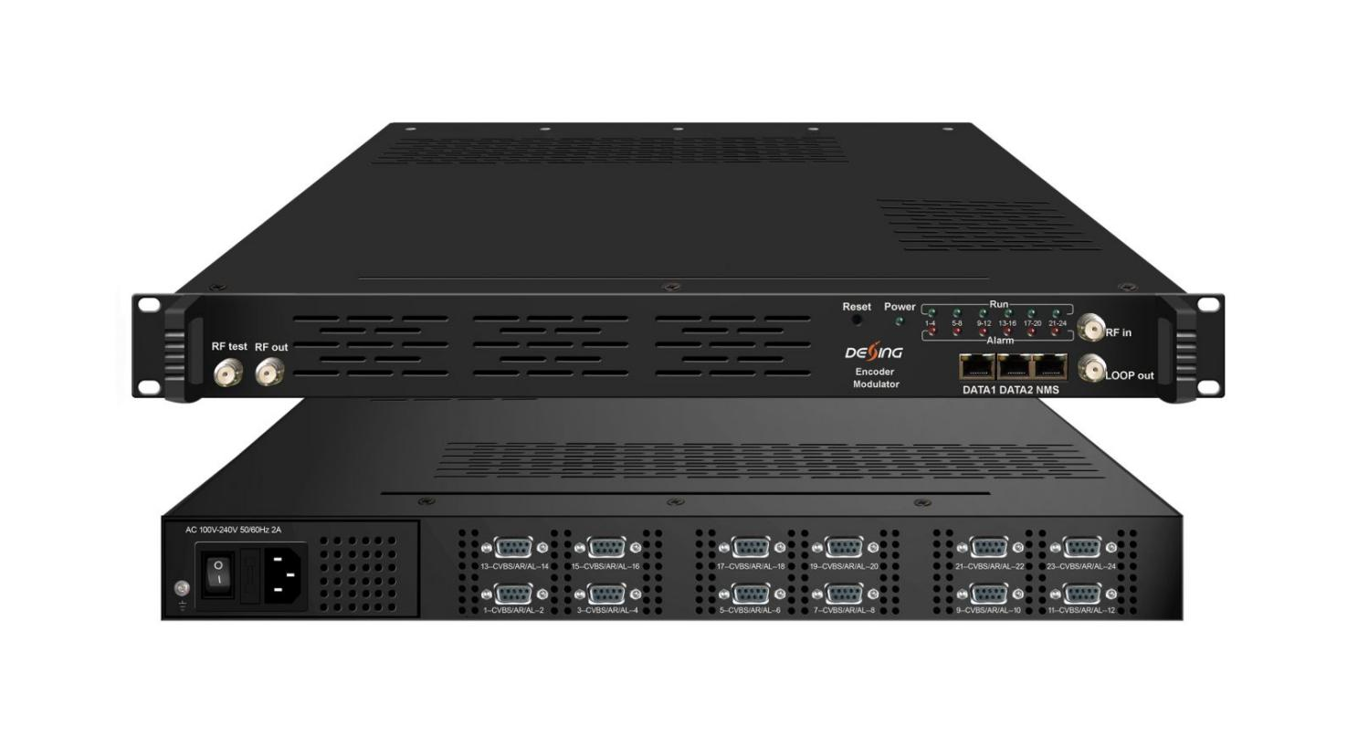8/12/24* CVBS/1 DVB-C/T/(T)/ISDBT Tuner ——> 4* DVB-C/T Digital RF
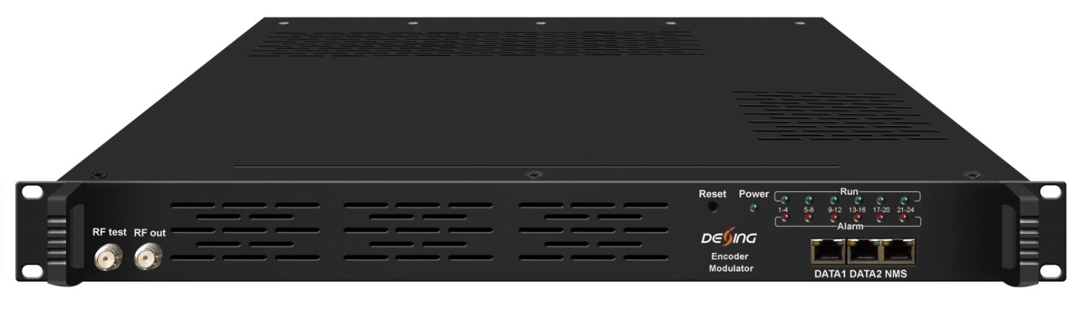
DVB-T RF out front Panel
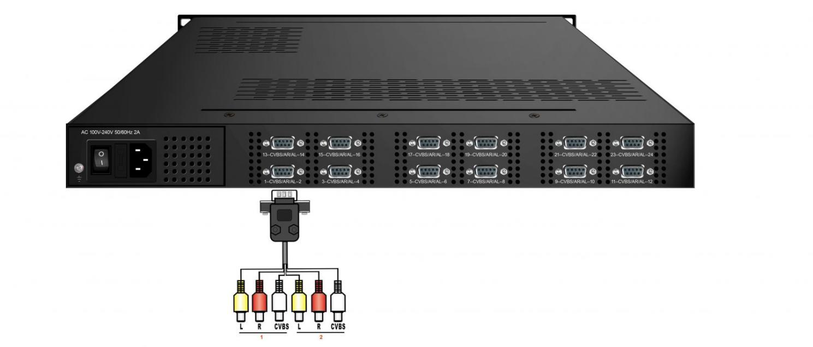
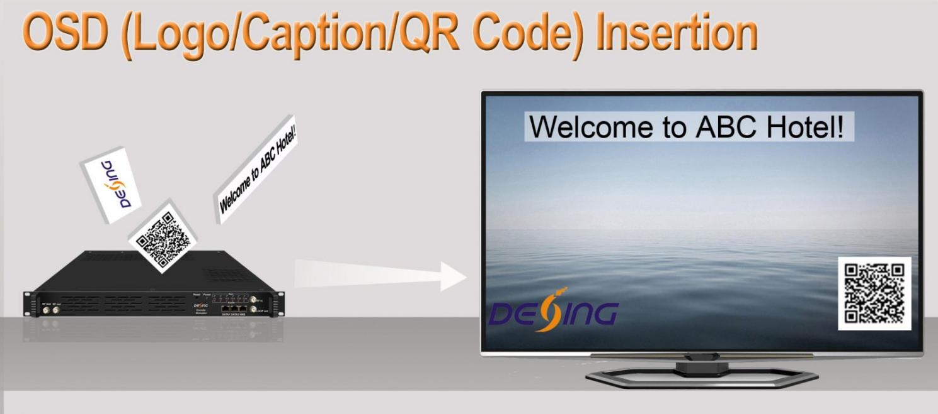

Product Overview
The FUQ-4653H/HA combines MPEG-2 encoding, multiplexing, and DVB-C/T/ISDBT modulation in a 1RU chassis. It processes 8-24 CVBS inputs, 128 IP streams, and delivers 4 RF outputs with adjustable levels. This web-managed solution supports PSI/SI editing and ETSI-compliant scrambling. Ideal for hotel TV systems, hospital networks, and small-scale CATV operators.
Key feature
Broadcast Security: ETSI-compliant scrambling (H/HA models) and OSD/QR code insertion (HA model) for content control.
Principle Chart
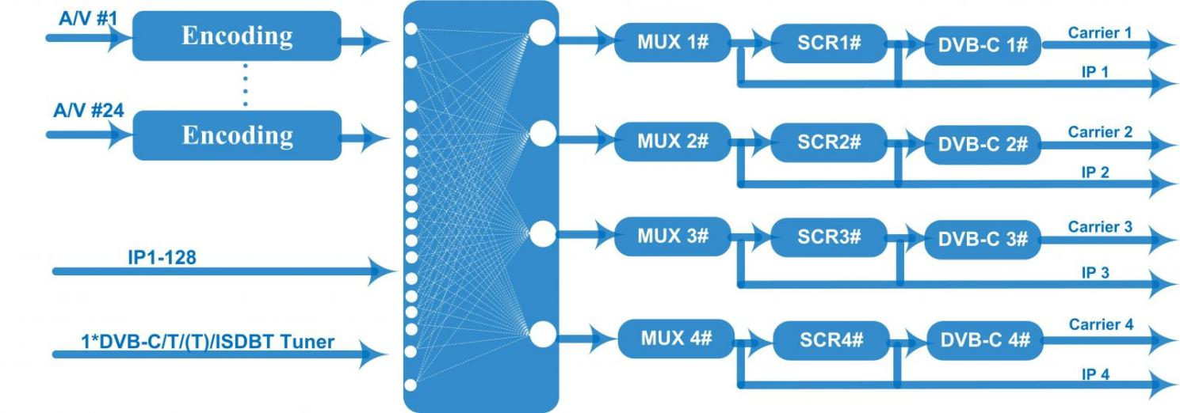
DVB-C RF output
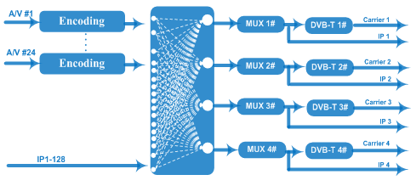
DVB-T RF output
Technical specification
Input | 8/12/16/20/24 CVBS inputs , RCA interface ,  1 DVB-C/T/(T)/ISDBT Tuner for remux, F type interface (only for DVB-C RF out)  128 IP input over UDP and RTP, DATA1 and DATA2,RJ45
Tuner Section | DVB-C | Standard |  |  | J.83A(DVB-C), J.83B, J.83C
Tuner Section | DVB-C | Frequency In |  |  | 60 MHz~890 MHz
Tuner Section | DVB-C | Constellation |  |  | 16/32/64/128/256 QAM
Tuner Section | DVB-T/(T) | Frequency In |  |  | 60 MHz~890 MHz
Tuner Section | DVB-T/(T) | Bandwidth |  |  | 6/7/8 M bandwidth
Tuner Section | ISDB-T | Frequency In |  |  | 60 MHz~890 MHz
Video | Resolution | 720×480_60i, 544×480_60i, 352×480_60i  352×240_60i,320×240_60i,176×240_60i, 176×120_60i
Video | Resolution | 720×576_50i,704×576_50i,640×576_50i, 352×288_50i  320×288_50i, 176×288_50i, 176×144_50i
Video | Encoding | MPEG-2
Video | Bit-rate | 0.5Mbps~8Mbps each channel
Video | Rate Control | CBR, VBR
Video | GOP Structure | GOP_0_B, GOP_1_B, GOP_2_B, GOP_3_B
Video | Advanced Pretreatment | De-interlacing, noise reduction
Audio | Encoding | MPEG-1 Layer 2, AC3 (2.0)
Audio | Sampling rate | 48KHz
Audio | Resolution | 24-bit
Audio | Bit-rate | 64Kbps,128Kbps,192kbps,256kbps,320kbps,384kbps each channel
Multiplexing | Maximum PID  Remapping | 180 input per channel
Multiplexing | Function | PID remapping ( automatically or manually)
Multiplexing | Function | Accurate PCR adjusting
Multiplexing | Function | Generate PSI/ SI table automatically
Scrambling  (Only for DVB-C RF out) | Maximum simulcrypt CA | 4
Scrambling  (Only for DVB-C RF out) | Standard | ETR289, ETSI 101 197, ETSI 103 197
Scrambling  (Only for DVB-C RF out) | Connection | Local/remote connection
Modulation | DVB-C | RF out |  | 4*RF DVB-C out (4 carriers combined output)
Modulation | DVB-C | Standard |  | EN300 429/ITU-T J.83A/B
Modulation | DVB-C | MER |  | ≥40db
Modulation | DVB-C | RF frequency |  | 50~960MHz, 1KHz step
Modulation | DVB-C | RF output level |  | -25 ~ -1 dBm, 1dBm step
Modulation | DVB-C | Symbol Rate |  | 5.0Msps~7.0Msps, 1ksps stepping
Modulation | DVB-C | Constellation |  | 16/32/64/128/256QAM
Modulation | DVB-C | Constellation |  | J.83A |  | J.83B
Modulation | DVB-C |  |  | 16/32/64/128/256QAM |  | 64/256 QAM
Modulation | DVB-C | Bandwidth |  | 8M |  | 6M
Modulation | DVB-T | RF out |  | 4*RF DVB-T out (4 carriers combined output)
Modulation | DVB-T | Standard |  | EN300744
Modulation | DVB-T | FFT mode |  | 2K,
Modulation | DVB-T | Bandwidth |  | 6M, 7M, 8M
Modulation | DVB-T | Constellation |  | QPSK, 16QAM, 64QAM
Modulation | DVB-T | Guard Interval |  | 1/4, 1/8, 1/16, 1/32
Modulation | DVB-T | FEC |  | 1/2, 2/3, 3/4, 5/6, 7/8
Modulation | DVB-T | MER |  | ≥42 dB
Modulation | DVB-T | RF frequency |  | 50~960MHz, 1KHz step
Modulation | DVB-T | RF output level |  | -28~ -3 dBm, 1 dBm step
Stream output | RF output (F type interface)
Stream output | 4 IP MPTS output over UDP/RTP, 1*1000M Base-T Ethernet interface
System function | Network management (WEB)
System function | English language
System function | Ethernet software upgrade
Miscellaneous | Dimension (W×L×H) |  | 482mm×410mm×44mm
Miscellaneous | Environment |  | 0~45℃(work)；-20~80℃（Storage）
Miscellaneous | Power requirements |  | AC 110V± 10%, 50/60Hz, AC 220 ± 10%, 50/60Hz

Order Information
 | FU-4653H  (DVB-C RF out) | FU-4653H  (DVB-T RF out) | FU-4653HA  (DVB-C RF out) | FU-4653HA  (DVB-T RF out)
Scrambling Function | √ |  | √
DVB-C/T/(T)/ISDBT Tuner Input | √ |  | √
OSD Insertion Function |  |  | √ | √

About Us
FMUSER is a company specializing in broadcasting and television transmission systems and integrating hotel IPTV systems. The company was established in 2009 and has served over 180 countries worldwide. More than 20,000 television stations, radio stations, and hotel clients from different.

Contact:Tomleequan Email：sales@fmuser.com whatsapp: +8613922702227

