FMUSER FUQ-4653L-KA-8 8ch Encoder Multiplexing CVBS Input to IP-ASI Output MPEG-2 MPEG1 Layer II AC3 PAL-NTSC Digital Distribution Headend
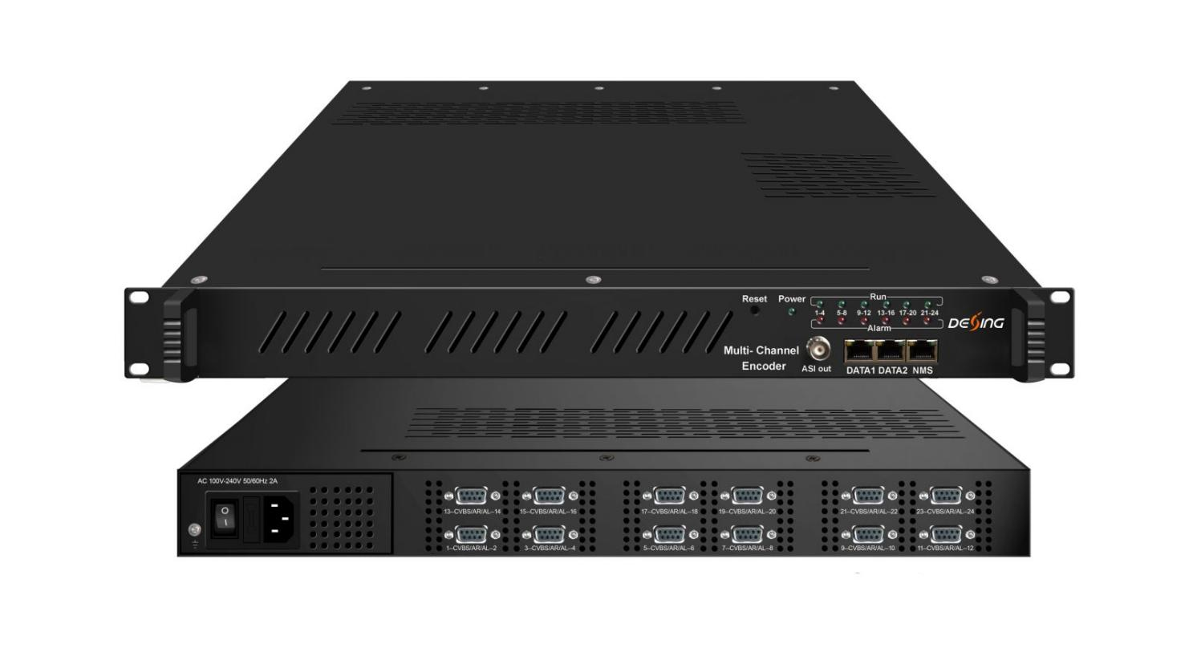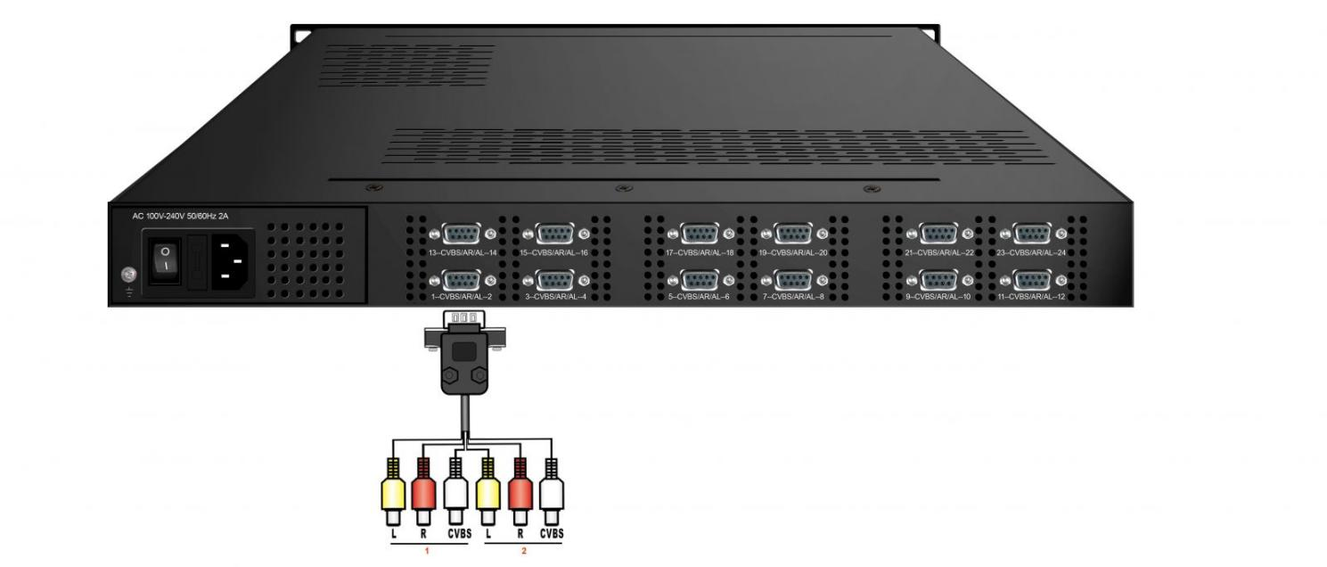
Product Overview
The FUQ-4653B/FUQ-4653AB Encoder processes 8/12/24 CVBS inputs to deliver IP and ASI outputs with encoding and multiplexing. It converts signals by encoding video in MPEG-2 and audio in MPEG1 Layer II/AC3, supporting PAL/NTSC formats. Control is via web-based management for configuration and updates. Ideal for digital head-end systems in broadcasting and cable TV applications.
Key feature
For FUQ-4653AB: Adds QR Code, Caption, and Logo insertion capabilities
Principle Chart

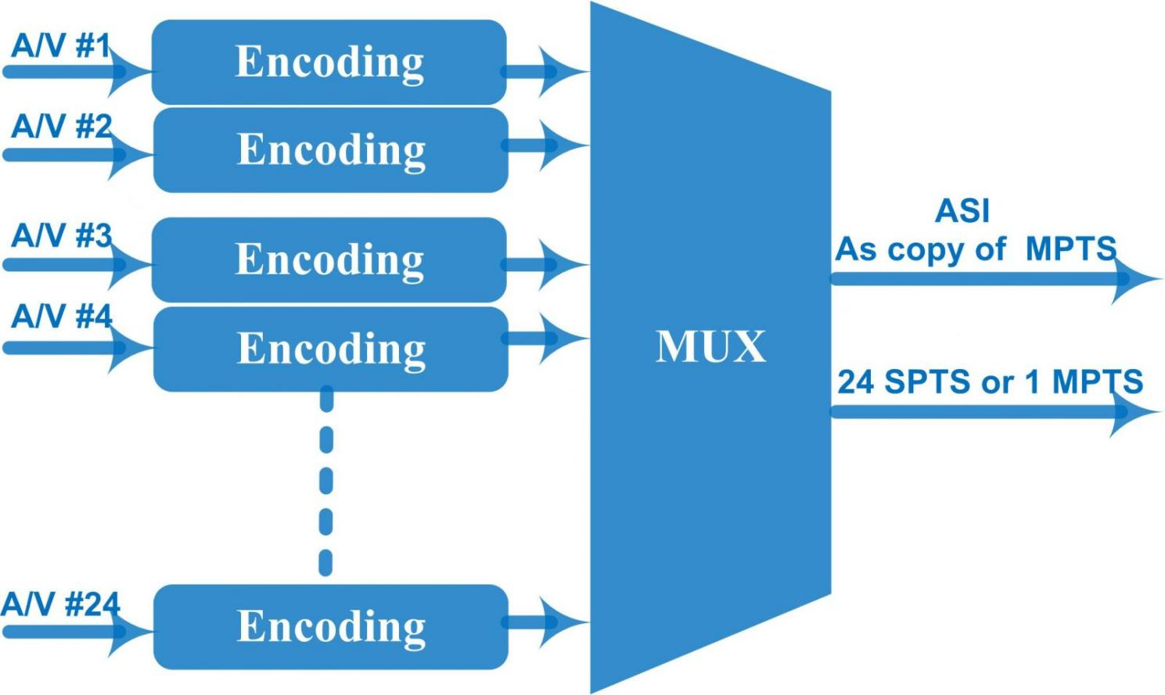

Technical specification
Input | 8/12/24CVBS inputs , RCA interface
Video | Resolution | 720×480_60i, 544×480_60i, 352×480_60i  352×240_60i, 320×240_60i,176×240_60i, 176×120_60i
Video | Resolution | 720×576_50i, 704×576_50i, 640×576_50i, 352×288_50i, 320×288_50i, 176×288_50i, 176×144_50i
Video | Encoding | MPEG-2
Video | Bit-rate | 0.5Mbps~8Mbps each channel
Video | Rate Control | CBR/VBR
Video | GOP Structure | GOP_0_B, GOP_1_B, GOP_2_B, GOP_3_B
Video | Advanced Pretreatment | De-interlacing, noise reduction
Audio | Encoding | MPEG-1 Layer 2, AC3(2.0)
Audio | Sampling rate | 48KHz
Audio | Resolution | 24-bit
Audio | Bit-rate | 64Kbps,128Kbps,192kbps,256kbps,320kbps,384kbps each channel
Multiplexing | Function | PID remapping (automatically or manually)
Multiplexing | Function | Accurate PCR adjusting
Multiplexing | Function | Generate PSI/ SI table automatically
Stream output | 1 ASI as copy of MPTS  IP (MPTS/SPTS) output over UDP/RTP/RTSP  8/12 CVBS inputs with 8/12 SPTS and 1 MPTS output  24×CVBS inputs with 24 SPTS or 1 MPTS output
System function | Network management (WEB)
System function | Chinese and English language
System function | Ethernet software upgrade
Miscellaneous | Dimension(W×L×H) |  | 482mm×410mm×44mm
Miscellaneous | Approx weight |  | 8kg
Miscellaneous | Environment |  | 0~45℃(work)；-20~80℃（Storage）
Miscellaneous | Power requirements |  | AC 110V± 10%, 50/60Hz, AC 220 ± 10%, 50/60Hz
Miscellaneous | Power consumption |  | 20W

Order Information
 | FU-4653K/KA-8 | FU-4653K/KA-12 | FU-4653K/KA-24
8CVBS Input | √
12CVBS Input |  | √
24CVBS Input |  |  | √

About Us
FMUSER is a company specializing in broadcasting and television transmission systems and integrating hotel IPTV systems. The company was established in 2009 and has served over 180 countries worldwide. More than 20,000 television stations, radio stations, and hotel clients from different.

Contact:Tomleequan Email：sales@fmuser.com whatsapp: +8613922702227

