FMUSER FUQ-4653U 4K Encoder Modulator Dual HDMI 2.0 2xASI 32xIP Inputs DVB-C-T ASI-IP Outputs H.265 HEVC Encoding IPTV Broadcast Headend
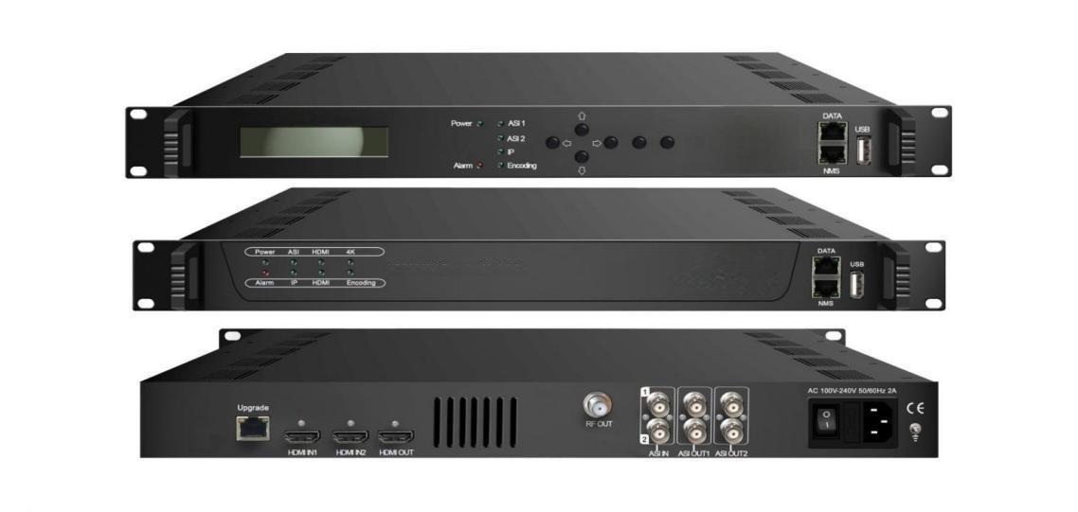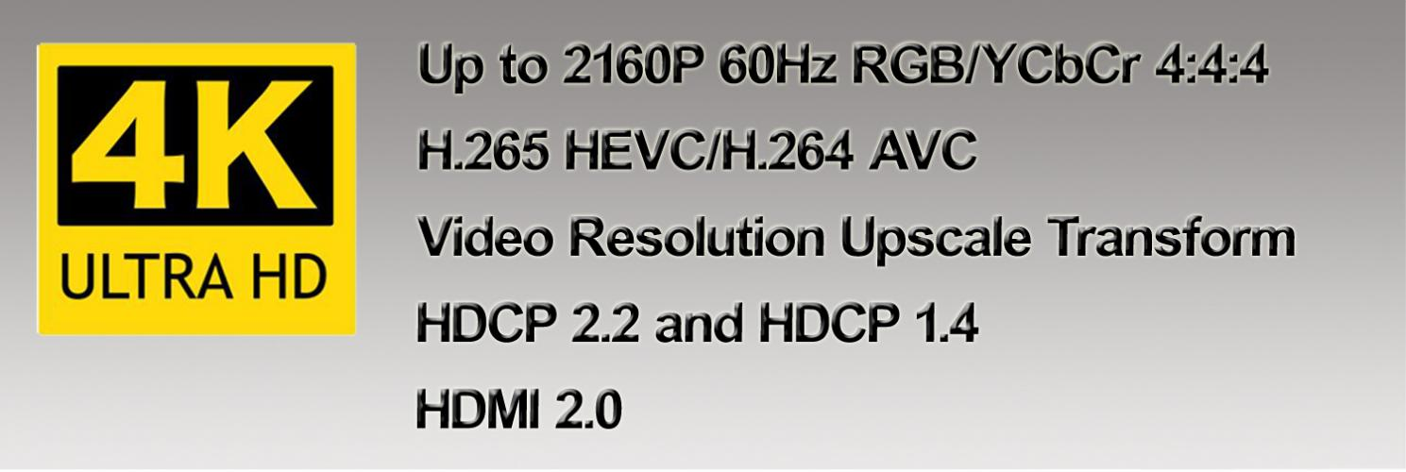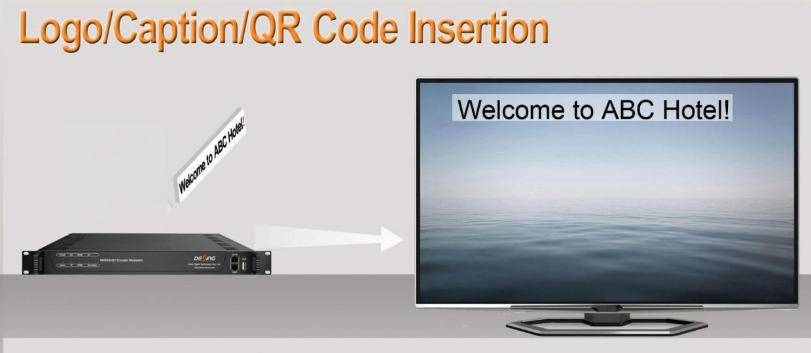

Product Overview
The FMUSER FUQ-4653U is a professional 4K encoder modulator supporting dual HDMI 2.0, 2xASI, and 32xIP inputs with DVB-C/T RF, ASI, and IP outputs. It performs H.265/HEVC encoding and DVB modulation in a 1U rack-mountable chassis. The device features web-based NMS for remote control and supports PSI/SI table generation. Ideal for digital terrestrial television (DTT) headends and IPTV distribution systems requiring 4K UHD processing.
Key feature
Flexible Audio: MPEG-1 Layer 2 and LC-AAC audio encoding options
Specifications

Input | 1×HDMI input (2.0) with 2 HDMI port, HDCP 2.2/1.4
Input | 2 ASI input, BNC interface
Input | 32 IP input over UDP and RTP protocol
Video Input | Resolution |  |  |  | Chroma
Video Input | 3840×2160_60P,3840×2160_59.94P, 3840×2160_50P,3840×2160_30P, 3840×2160_29.96P,3840×2160_25P,  3840×2160_24P,1920×1080_60P,  1920×1080_59.94P,1920×1080_50P, 1920×1080_30P ,1920×1080_25P 1920×1080_24P, |  |  |  | RGB, YCbCr 4:4:4, YCbCr 4:2:2,  YCbCr 4:2:0 (2160P_50/60Hz only)
Video Encoding | Encoding |  | H.265/HEVC, H.264/AVC
Video Encoding | Chroma |  | 4:2:2, 4:2:0
Video Encoding | Bit-rate |  | 1Mbps~23Mbps
Video Encoding | Rate Control |  | CBR
Audio Encoding | Encoding |  | MPEG-1 Layer 2, LC-AAC
Audio Encoding | Sampling rate |  | 48KHz
Audio Encoding | Bit-rate |  | 64Kbps~256Kbps each channel
Multiplexing | 2 ASI input multiplexed with local 1 channel of TS
Multiplexing | PID remapping (automatically or manually)
Multiplexing | Accurate PCR adjusting
Multiplexing | Generate PSI/SI table automatically
Modulator Section | DVB-C | Standard |  | J.83A, J.83B
Modulator Section | DVB-C | MER |  | ≥43dB
Modulator Section | DVB-C | RF frequency |  | 50~960MHz, 1KHz step
Modulator Section | DVB-C | RF output level |  | -25.0~ -1 dbm, 0.1db step
Modulator Section | DVB-C | Symbol rate |  | 5.0 - 7.0 Msps
Modulator Section | DVB-C |  |  | J.83A |  | J.83B
Modulator Section | DVB-C | Constellation |  | 16/32/64/128/ 256 QAM |  | 64/ 256 QAM
Modulator Section | DVB-C | Bandwidth |  | 8M |  | 6M
Modulator Section | DVB-C | RF out |  | 1*RF DVB-C out
Modulator Section | DVB-T | Standard |  | EN300744
Modulator Section | DVB-T | FFT mode |  | 2K/4K/8K
Modulator Section | DVB-T | Bandwidth |  | 6M, 7M, 8M
Modulator Section | DVB-T | Constellation |  | QPSK, 16QAM, 64QAM
Modulator Section | DVB-T | Guard Interval |  | 1/4, 1/8, 1/16, 1/32
Modulator Section | DVB-T | Code rate |  | 1/2, 2/3, 3/4, 5/6, 7/8
Modulator Section | DVB-T | MER |  | ≥42dB
Modulator Section | DVB-T | RF frequency |  | 50~960MHz, 1KHz step
Modulator Section | DVB-T | RF output level |  | -28~ -3dbm, 0.1db step
Modulator Section | DVB-T | RF out |  | 1*RF DVB-T out
Stream output | 1*ASI output through 4 BNC interfaces
Stream output | 1 MPTS over UDP/RTP, 1000M/100M Base-T Ethernet interface (unicast/ multicast)
System function | 2 versions of front panel:  Option1: with LCD and Keyboard;  Option2 without LCD or Keyboard.
System function | LCD/keyboard operating(optional), web NMS supporting
System function | Ethernet software & hardware upgrade
Miscellaneous | Dimension (W× L× H) |  |  | 482mm×455mm×44mm
Miscellaneous | Approx weight |  |  | 4kg
Miscellaneous | Temperature |  |  | 0~45℃(work), -20~80℃（Storage）
Miscellaneous | Power |  |  | AC 100V-220V±10%, 50/60Hz
Miscellaneous | Consumption |  |  | 25W

Principle Chart
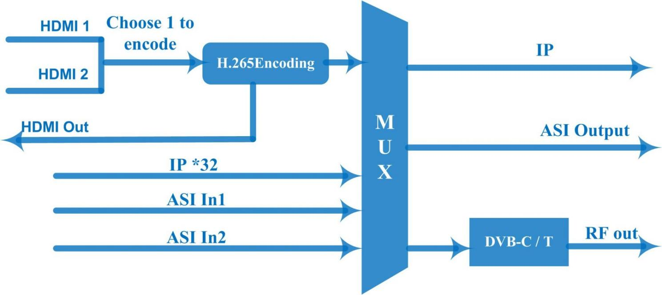

Resolution Upscale

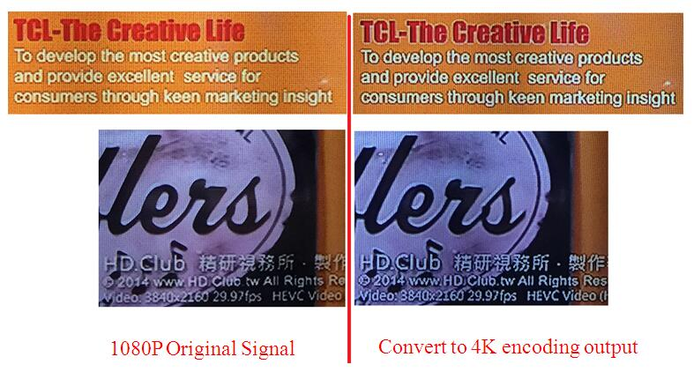

About Us
FMUSER is a company specializing in broadcasting and television transmission systems and integrating hotel IPTV systems. The company was established in 2009 and has served over 180 countries worldwide. More than 20,000 television stations, radio stations, and hotel clients from different.

Contact:Tomleequan Email：sales@fmuser.com whatsapp: +8613922702227

