FMUSER FUQ-4653XY Encoder Modulator 24 CVBS & 128 IP Inputs DVB-C-T SD MPEG-2 H.264 Integrated Multiplexing Scrambling for CATV IPTV
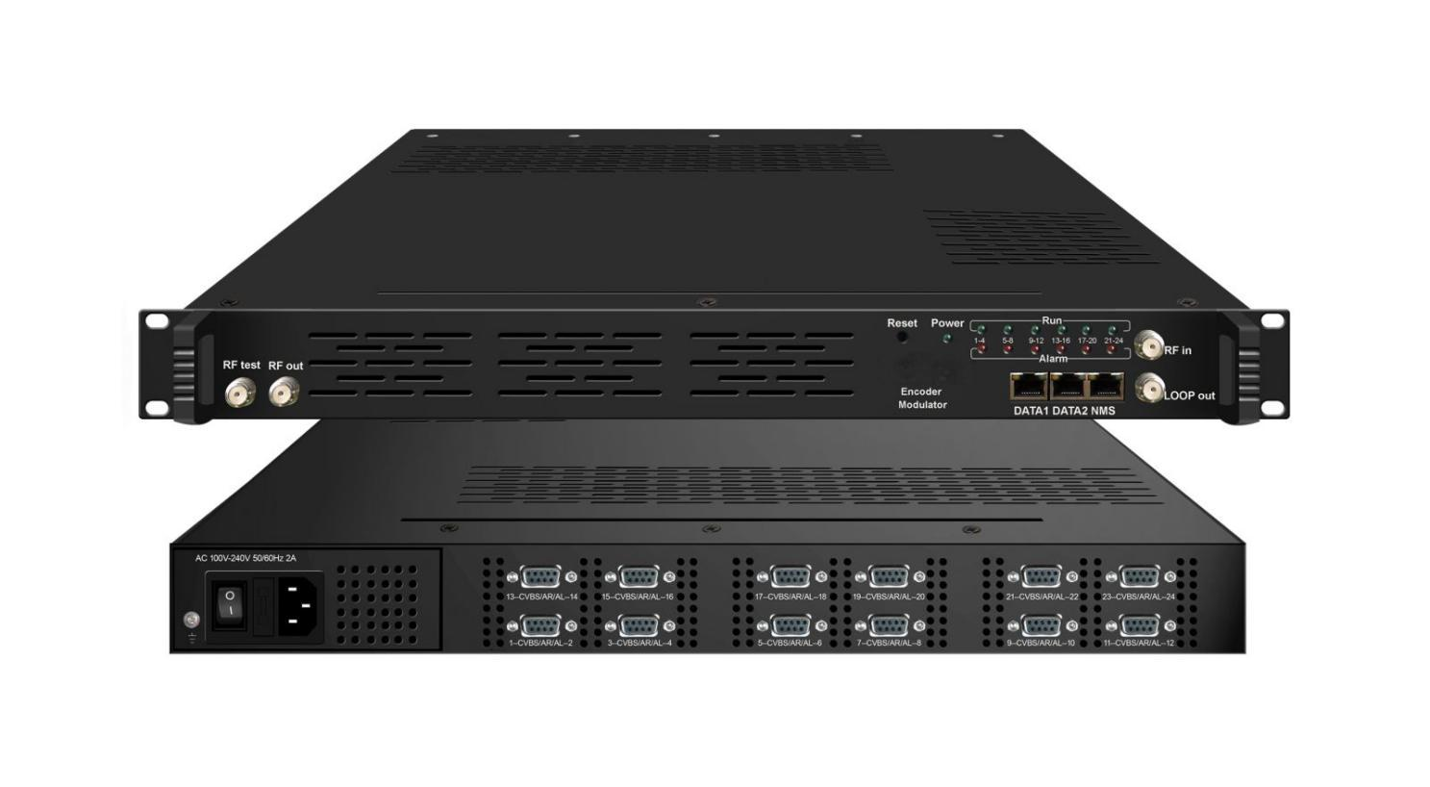

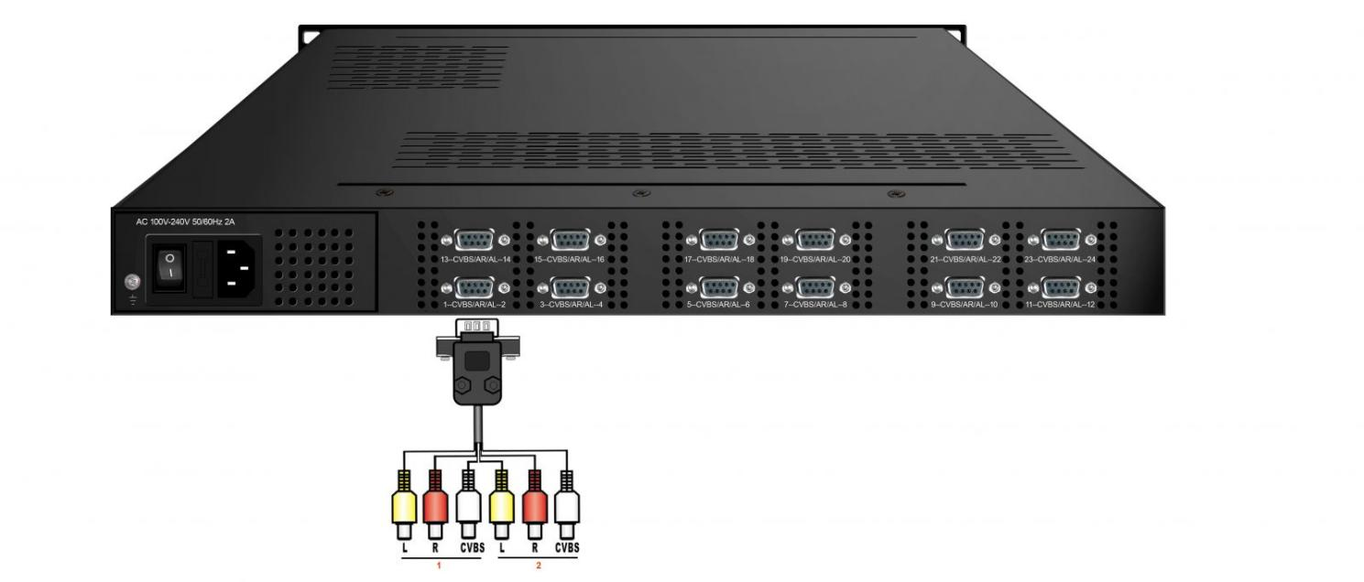

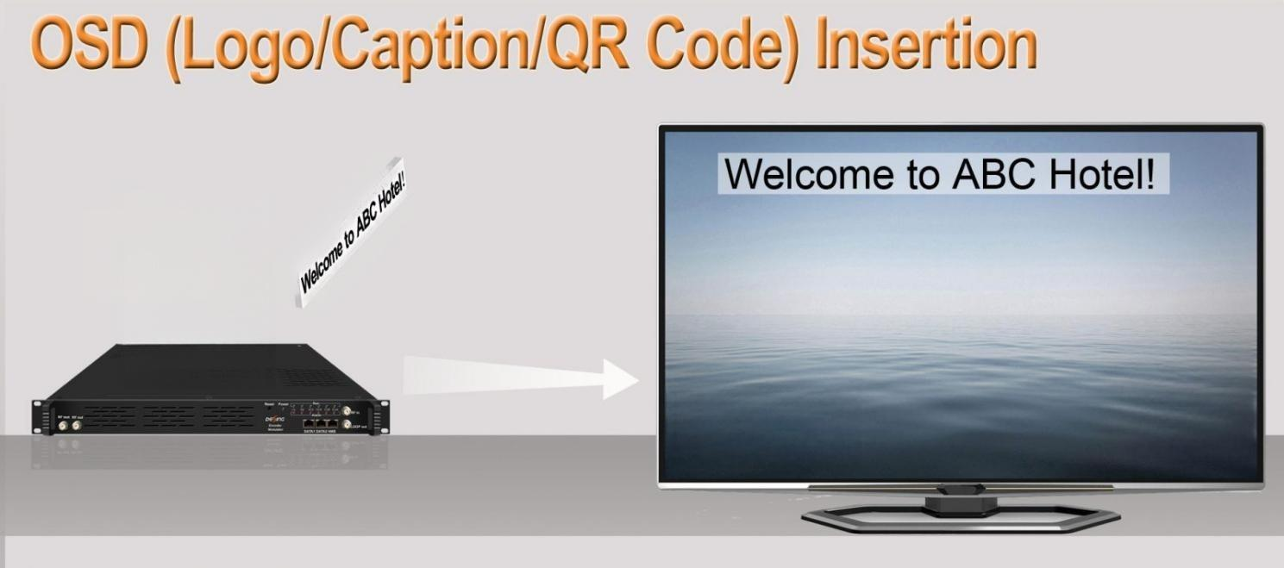
Product Overview
The FMUSER FUQ-4653LM integrates SD encoding, multiplexing, scrambling, and modulation, supporting up to 24 CVBS inputs, an optional DVB-C/T/ISDBT/S/S2 tuner, and 128 IP inputs via Data1 (GE) and Data2 (FE) ports. It processes signals through encoding and modulation, delivering 4 DVB-C/T RF outputs and 4 MPTS IP streams. Managed via a web interface, this device is ideal for CATV headends and hospitality TV systems.
Key feature
- Supports multi-format encoding with MPEG-2/H.264 video and MPEG1 Layer 2/LC-AAC/HE-AAC audio for up to 24 CVBS inputs.
- Integrates optional DVB-C/T/ISDBT/S/S2 tuner and 128 UDP/RTP IP inputs via dual Ethernet ports.
- Delivers 4 DVB-C/T RF outputs (50-960MHz) and 4 MPTS IP streams over UDP/RTP.
- Features advanced signal control including PID remapping, PCR adjustment, PSI/SI editing, and logo/QR code insertion.
- Enables web-managed operations for remote configuration, scrambling control (DVB-C only), and firmware updates.
Principle Chart
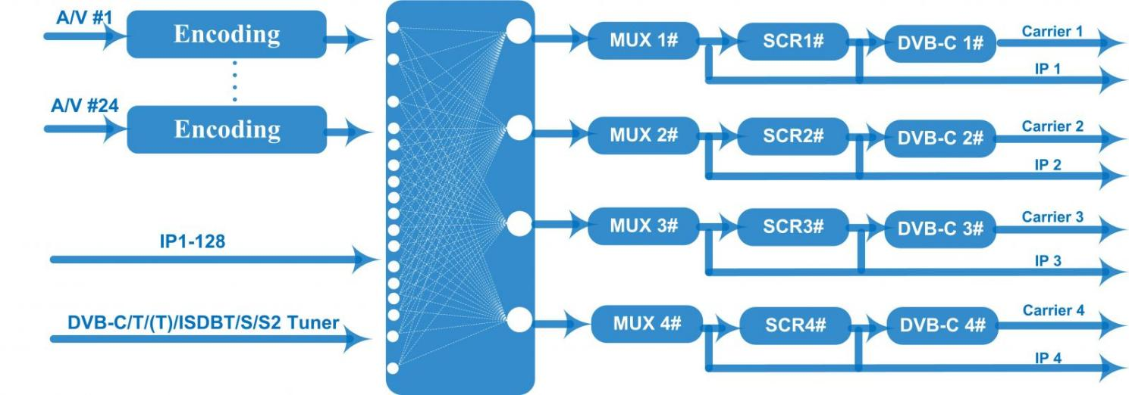
DVB-C RF out
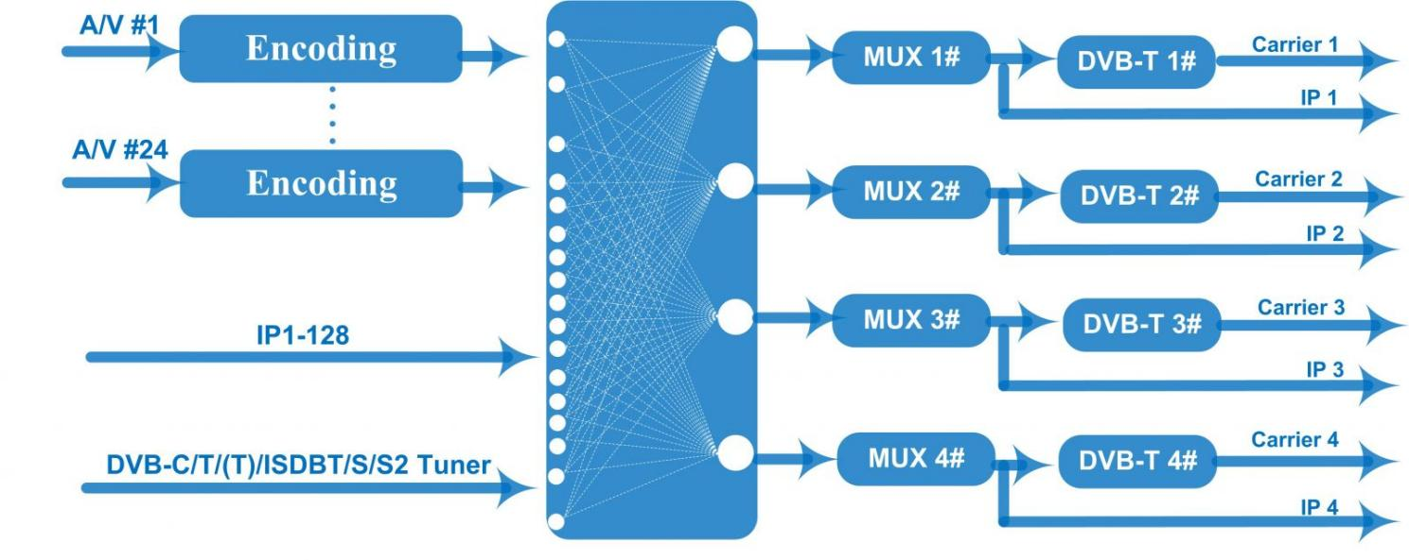

DVB-T RF out

Technical specification
Input | 8/12/16/24 CVBS inputs , RCA interface ,  1 DVB-C/T/(T)/ISDBT/S/S2 (Optional) Tuner for re-mux, F type interface  128 IP input over UDP and RTP through DATA1 and DATA2, RJ45
Video | Resolution | 720*576@50i |  | 720*576/352*288/320*240/320*180/  176*144/160*120/160*90@50Hz
Video | Resolution | 720*480@60i |  | 720*480/352*288/320*240/320*180/  176*144/160*120/160*90@60Hz
Video | Encoding | MPEG-2, MPEG4 AVC/H.264
Video | Bit-rate | 0.5~5Mbps
Video | Rate Control | CBR/VBR
Video | GOP Structure | IPPP, IBPBP, IBBPB, IBBBP
Video | Advanced Pretreatment | De-interlacing, noise reduction
Audio | Encoding | MPEG1 Layer 2, LC-AAC, HE-AAC
Audio | Sampling rate | 48KHz
Audio | Bits per sample | 32-bit
Audio | Bit-rate | 48Kbps~384Kbps (each channel)
Multiplexing | Maximum PID  Remapping | 128 PID input per channel
Multiplexing | Function | PID remapping ( automatically or manually)
Multiplexing | Function | Accurate PCR adjusting
Multiplexing | Function | Generate PSI/ SI table automatically
Scrambling (Only for DVB-C RF out) | Maximum simulcrypt CA | 4
Scrambling (Only for DVB-C RF out) | Standard | EN300 429/ITU-T J.83A/B
Scrambling (Only for DVB-C RF out) | Connection | Local/remote connection
Modulation | DVB-C | RF out |  | 4*RF DVB-C out (4 carriers combined output)
Modulation | DVB-C | Standard |  | EN300 429/ITU-T J.83A/B
Modulation | DVB-C | MER |  | ≥40dB
Modulation | DVB-C | RF frequency |  | 50~960MHz, 1KHz step
Modulation | DVB-C | RF output level |  | -25~-1dBm, 1dBm step
Modulation | DVB-C | Symbol Rate |  | 5.0Msps~7.0Msps, 1ksps step
Modulation | DVB-C | Constellation |  | 16/32/64/128/256QAM
Modulation | DVB-C | Constellation |  | J.83A | J.83B
Modulation | DVB-C |  |  | 16/32/64/128/256QAM | 64/256 QAM
Modulation | DVB-C | Bandwidth |  | 8M | 6M
Modulation | DVB-T | RF out |  | 4*RF DVB-T out (4 carriers combined output)
Modulation | DVB-T | Standard |  | EN300744
Modulation | DVB-T | MER |  | ≥42 dB
Modulation | DVB-T | RF frequency |  | 50~960MHz, 1KHz step
Modulation | DVB-T | RF output level |  | -28~ -3 dBm, 0.1dBm step
Modulation | DVB-T | FFT mode |  | 2K,
Modulation | DVB-T | Constellation |  | QPSK, 16QAM, 64QAM
Modulation | DVB-T | Bandwidth |  | 6M, 7M, 8M
Modulation | DVB-T | Guard Interval |  | 1/4, 1/8, 1/16, 1/32
Modulation | DVB-T | FEC |  | 1/2, 2/3, 3/4, 5/6, 7/8
Stream output | RF output (F type interface)
Stream output | 4 IP MPTS output over UDP/RTP through Data1 (1000M Base-T Ethernet interface)
System function | Network management (WEB)
System function | Ethernet software upgrade
Miscellaneous | Dimension (W×L×H) |  | 482mm×410mm×44mm
Miscellaneous | Approx weight |  | 8kg
Miscellaneous | Environment |  | 0~45℃(work)；-20~80℃（Storage）
Miscellaneous | Power requirements |  | AC 110V± 10%, 50/60Hz, AC 220 ± 10%, 50/60Hz

Order Information
 | FU-4653HB-8  (DVB-C RF out) | FU-4653B-8  (DVB-T RF out) | FU-4653HB-12  (DVB-C RF out) | FU-4653HB-12  (DVB-T RF out) | FU-4653HB-24  (DVB-C RF out) | FU-4653HB-24  (DVB-T RF out)
8 CVBS Input | √ | √
12 CVBS Input |  |  | √ | √
24 CVBS Input |  |  |  |  | √ | √
Scrambling function | √ |  | √ |  | √

About Us
FMUSER is a company specializing in broadcasting and television transmission systems and integrating hotel IPTV systems. The company was established in 2009 and has served over 180 countries worldwide. More than 20,000 television stations, radio stations, and hotel clients from different.

Contact:Tomleequan Email：sales@fmuser.com whatsapp: +8613922702227

