FMUSER FUQ-4654C Encoder Modulator 1 HDMI CVBS SDI YPbPr Input 1 ASI Input DVB-S-S2 RF Output Web-Based NMS Satellite Broadcasting Headend System
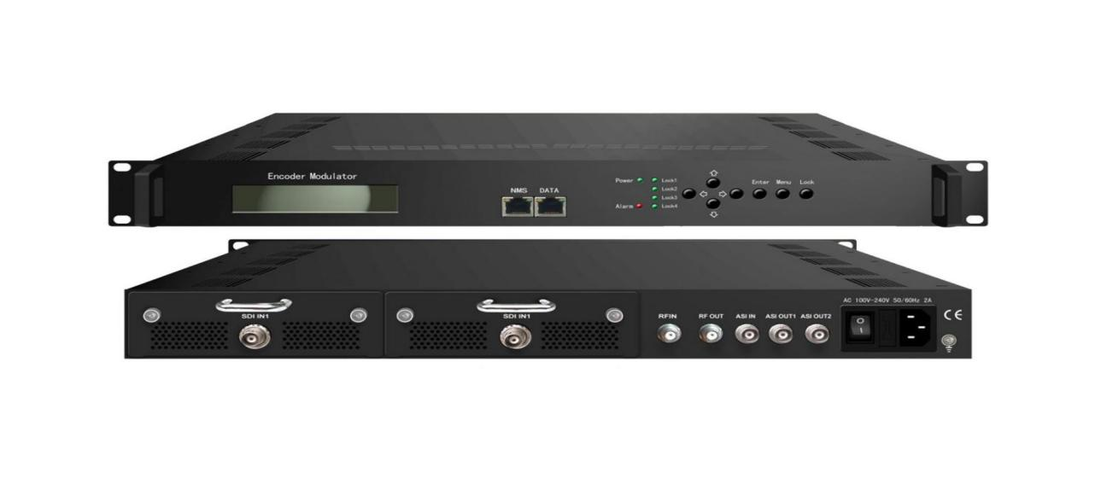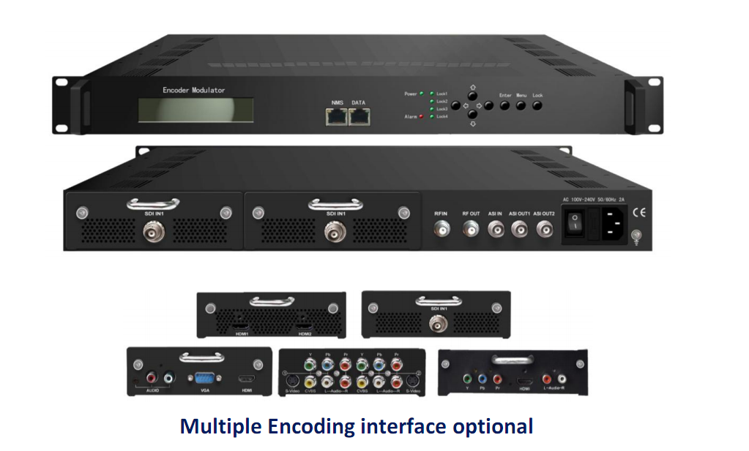
Product Overview
The FMUSER FUQ-4654C integrates encoding, multiplexing, and modulation to convert audio/video signals into DVB-S/S2 RF output. It features modular inputs for HDMI, CVBS, SDI, and YPbPr, with ASI input and outputs including ASI and IP. Controlled via web-based NMS, it is ideal for satellite broadcasting, headend systems, and flexible signal distribution.
Key feature
Web-based NMS management for remote control, firmware updates, VBR/CBR rate control, and low delay encoding
Principle Chart(Encoder Modulator)
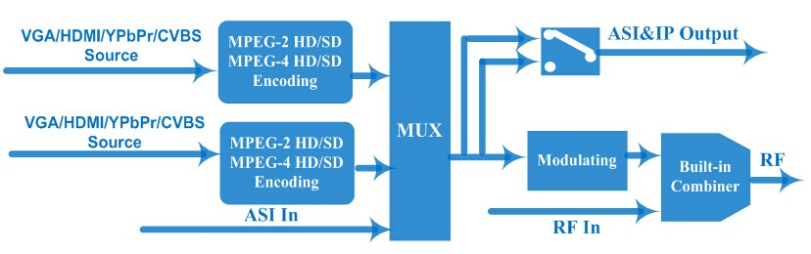

Principle Chart(Modulator)
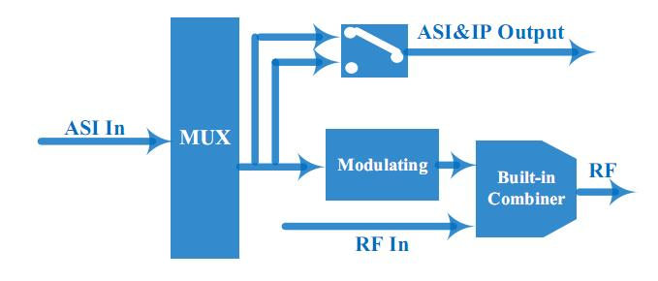

Technical Specification
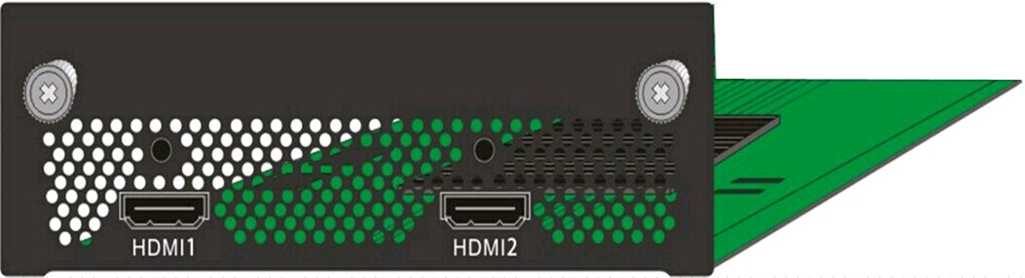HDMI Encoding Input | Video | Input | HDMI*1(1 for backup)
 | Video | Encoding | MPEG2; MPEG4 AVC/H.264
 | Video | Bitrate | 1-19.5Mbps
 | Video | Resolution | 1920*1080_60P, 1920*1080_50P,  (-for MPEG4 AVC/H.264 only)  1920*1080_60i, 1920*1080_50i,  1280*720_60p, 1280*720_50P  720*480_60i, 720*576_50i
 | Video | Low Delay | Normal, Mode 1, Mode 2
 | Video | Rate Control | VBR/CBR
 | Video | Chroma | 4:2:0
 | Video | Aspect Ratio | 16:9,4:3
 | Audio | Encoding | MPEG1 Layer II; LC-AAC; HE-AAC and Dolby Digital AC3 2.0 ( Optional)
 | Audio | Sample rate | 48KHz
 | Audio | Bitrate | 64/96/128/ 192/256/320kbps

HDMI Encoding Input  (OptionⅡ) | Video | Input | HDMI*1 (1 for backup)
 | Video | Encoding | MPEG4 AVC/H.264
 | Video | Bitrate | 1-19.5Mbps
 | Video | Resolution | 1920*1080_60P, 1920*1080_50P,  1920*1080_60i, 1920*1080_50i,  1280*720_60p, 1280*720_50P  720*480_60i, 720*576_50i
 | Video | Chroma | 4:2:0
 | Audio | Encoding | MPEG1 Layer II
 | Audio | Sample rate | 48KHz
 | Audio | Bitrate | 64/96/128/ 192/256/320kbps

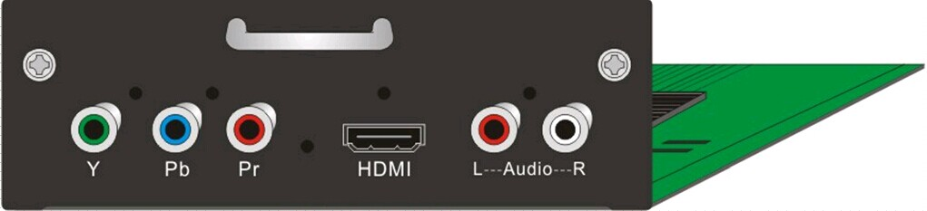  HDMI/YPbPr/CVBS 3-in-1 Encoding Input | Video  (HDMI) | Encoding | MPEG2; MPEG4 AVC/H.264
 | Video  (HDMI) | Input | HDMI*1
 | Video  (HDMI) | Bitrate | 1-19.5Mbps
 | Video  (HDMI) | Resolution | 1920*1080_60P, 1920*1080_50P,  -for MPEG4 AVC/H.264 only)  1920*1080_60i, 1920*1080_50i,  1280*720_60p, 1280*720_50P  720*480_60i, 720*576_50i
 | Video  (HDMI) | Low Delay | Normal, Mode 1, Mode 2
 | Video  (HDMI) | Rate Control | VBR/CBR
 | Video  (HDMI) | Chroma | 4:2:0
 | Video  (HDMI) | Aspect Ratio | 16:9,4:3
 | Audio  (HDMI) | Encoding | MPEG1 Layer II ,MPEG2-AAC, MPEG4-AAC  and Dolby Digital AC3 2.0( Optional)
 | Audio  (HDMI) | Input | HDMI*1
 | Audio  (HDMI) | Sample rate | 48KHz
 | Audio  (HDMI) | Bitrate | 64/96/128/ 192/256/320kbps
 | Video  (YpbPr/  CVBS) | Encoding | MPEG2; MPEG4 AVC/H.264
 | Video  (YpbPr/  CVBS) | Input | YpbPr*1 / CVBS *1
 | Video  (YpbPr/  CVBS) | Bitrate | 1-19.5Mbps
 | Video  (YpbPr/  CVBS) | Resolution | CVBS: 720x576_50i (PAL); 720x480_60i (NTSC)  YpbPr: 1920*1080_60i, 1920*1080_50i;  1920*1080_60p, 1920*1080_50p;  1280*720_60p, 1280*720_50P
 | Video  (YpbPr/  CVBS) | Low Delay | Normal, Mode 1, Mode 2
 | Video  (YpbPr/  CVBS) | Rate Control | VBR/CBR
 | Video  (YpbPr/  CVBS) | Chroma | 4:2:0
 | Video  (YpbPr/  CVBS) | Aspect Ratio | 16:9,4:3
 | Audio  (YpbPr/  CVBS) | Encoding | MPEG1 Layer II; MPEG2-AAC; MPEG4-AAC  and Dolby Digital AC3 2.0( Optional)
 | Audio  (YpbPr/  CVBS) | Interface | 1*Stereo/2*mono
 | Audio  (YpbPr/  CVBS) | Sample rate | 48KHz
 | Audio  (YpbPr/  CVBS) | Bit rate | 64/96/128/ 192/256/320kbps

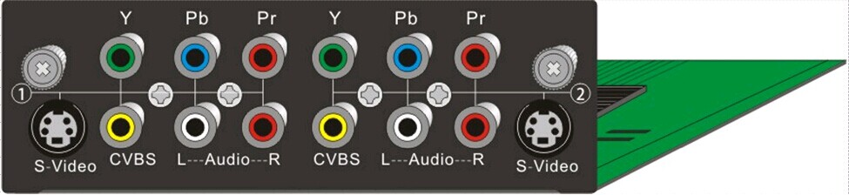2*(S-Video/YPbPr/CVBS) 3-in-1  Encoding Input | Video | Encoding | MPEG-2 & MPEG-4 AVC/H.264
 | Video | Input | S-Video/YPbPr/CVBS*2
 | Video | Bitrate | 1-19.5Mbps
 | Video | Resolution | 720*480_60i, 720*576_50i
 | Video | Low Delay | Normal, Mode 1, Mode 2(For option 1)
 | Video | Rate Control | VBR/CBR
 | Video | Chroma | 4:2:0
 | Video | Aspect Ratio | 16:9,4:3
 | Audio | Encoding | MPEG1 Layer II; LC-AAC; HE-AAC  and Dolby Digital AC3 2.0( Optional)
 | Audio | Sample rate | 48KHz
 | Audio | Bitrate | 64/96/128/ 192/256/320kbps

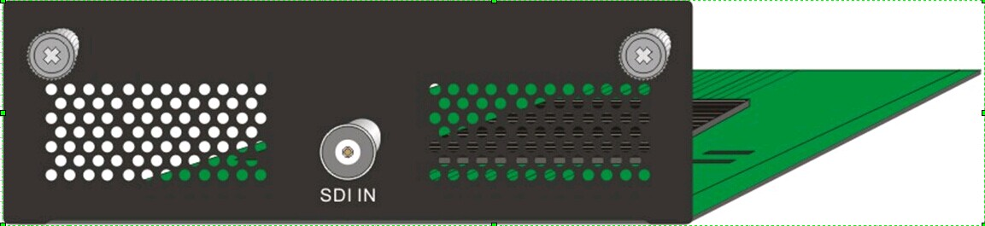SDI Encoding Input | Video | Encoding | MPEG2; MPEG4 AVC/H.264
 | Video | Input | SDI*1
 | Video | Bitrate | 1-19.5Mbps
 | Video | Resolution | 1920*1080_60P, 1920*1080_50P,  (-for MPEG4 AVC/H.264 only)  1920*1080_60i, 1920*1080_50i,  1280*720_60p, 1280*720_50P  720*480_60i, 720*576_50i
 | Video | Low Delay | Normal, Mode 1, Mode 2
 | Video | Rate Control | VBR/CBR
 | Video | Chroma | 4:2:0
 | Video | Aspect Ratio | 16:9,4:3
 | Audio | Encoding | MPEG1 Layer II; LC-AAC; HE-AAC  and Dolby Digital AC3 2.0 ( Optional)
 | Audio | Sample rate | 48KHz
 | Audio | Bitrate | 64/96/128/ 192/256/320kbps

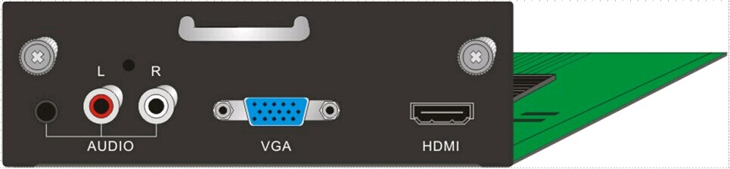VGA/HDMI  Encoding Input | Video  (HDMI) | Encoding | MPEG2; MPEG4 AVC/H.264
 | Video  (HDMI) | Input | HDMI*1
 | Video  (HDMI) | Bitrate | 1-19.5Mbps
 | Video  (HDMI) | Resolution | 1920*1080_60P, 1920*1080_50P,  (-for MPEG4 AVC/H.264 only)  1920*1080_60i, 1920*1080_50i,  1280*720_60p, 1280*720_50P  720*576-50i, 720*480-60i
 | Video  (HDMI) | Low Delay | Normal, Mode 1, Mode 2
 | Video  (HDMI) | Rate Control | VBR/CBR
 | Video  (HDMI) | Chroma | 4:2:0
 | Video  (HDMI) | Aspect Ratio | 16:9,4:3
 | Audio  (HDMI) | Encoding | MPEG1 Layer II; LC-AAC; HE-AAC  and Dolby Digital AC3 2.0 ( Optional)
 | Audio  (HDMI) | Sample rate | 48KHz
 | Audio  (HDMI) | Bitrate | 64/96/128/ 192/256/320kbps
 | Video  (VGA) | Encoding | MPEG2; MPEG4 AVC/H.264
 | Video  (VGA) | Input | VGA(SVGA/XGA/UXGA/SXGA)
 | Video  (VGA) | Bitrate | 1-19.5Mbps
 | Video  (VGA) | Resolution | 1920*1080_60P, 1280*720_60p
 | Video  (VGA) | Low Delay | Normal, Mode 1, Mode 2
 | Video  (VGA) | Rate Control | VBR/CBR
 | Video  (VGA) | Chroma | 4:2:0
 | Video  (VGA) | Aspect Ratio | 16:9,4:3
 | Audio  (VGA) | Encoding | MPEG1 Layer II; LC-AAC; HE-AAC  and Dolby Digital AC3 2.0 ( Optional)
 | Audio  (VGA) | Sample rate | 48KHz
 | Audio  (VGA) | Bit rate | 64/96/128/ 192/256/320kbps

Modulator Section | DVB-S/S2 | Constellation | DVB-S: QPSK  DVB-S2: QPSK, 8PSK
Modulator Section | DVB-S/S2 | FEC | 1/2,2/3,3/4,5/6,7/8 (DVB-S QPSK)
Modulator Section | DVB-S/S2 | FEC | 1/2,3/5,2/3,3/4,4/5,5/6,8/9,9/10  (DVB-S2 QPSK)
Modulator Section | DVB-S/S2 | FEC | 3/5,2/3,3/4,5/6,8/9,9/10  (DVB-S2 8PSK)
Modulator Section | DVB-S/S2 | RF output | 950.00-1050.00 MHz, 1Khz step
Modulator Section | DVB-S/S2 | Symbol rate | 0.05-40.0Msps  (DVB-S and DVB-S2 QPSK)
Modulator Section | DVB-S/S2 | Symbol rate | 0.05-26.0Msps(DVB-S2 8PSK)
Modulator Section | DVB-S/S2 | Roll Off | 0.35(DVB-S)
Modulator Section | DVB-S/S2 | Roll Off | 0.35, 0.25, 0.2(DVB-S2)

General | System | Local interface | LCD + control buttons
General | System | Remote management | Web NMS
General | System | Stream Out | 2 ASI out (BNC type);  IP (MPTS/SPTS) out (100M)
General | System | NMS interface | RJ45, 100M
General | System | Language | English
General | Physical Specification | Power supply | AC 100V~240V
General | Physical Specification | Dimensions | 482*300*44mm
General | Physical Specification | Weight | 4.5 kg
General | Physical Specification | Operation temperature | 0~45℃

Key Features
 | FU-4654B | FU-4654C | FU-4513E
Encode In | 2 encoding slots with different encoding boards available | 1 encoding slot with different encoding boards available | N/A
ASI In | 1 ASI input for re-mux | 1 ASI input for pass-through | 4 ASI inputs with 3 for backup
IP In | N/A | N/A | 1 IP Input over UDP (100M)
RF Range | 950 – 1050 MHz | 950 -2150 MHz | 950 -2150 MHz
Symbol Rate | QPSK: 0.05-40.0Msps  8PSK: 0.05-26.0Msps | 0.05-20.0Msps | 32APSK: 0.5~40Msps  16APSK/8PSK/QPSK: 0.5~45 Msps
Constellation | QPSK, 8PSK | QPSK, 8PSK | QPSK, 8PSK, 16APSK, 32APSK
Output Level | -30 dBm ~-10.0 dBm | -10.0 dBm ~-41.5 dBm | -10.0 dBm~-41.5 dBm
BISS Scramble | N/A | Support | Support
IP output | 1 IP over UDP (100M) | N/A | N/A
10MHz Ref Clock | N/A | Support | Support
24V RF Out | N/A | Support | Support
RF In for Mix | Support | N/A | N/A
SFN TS Transmission | N/A | N/A | Support

Application Case
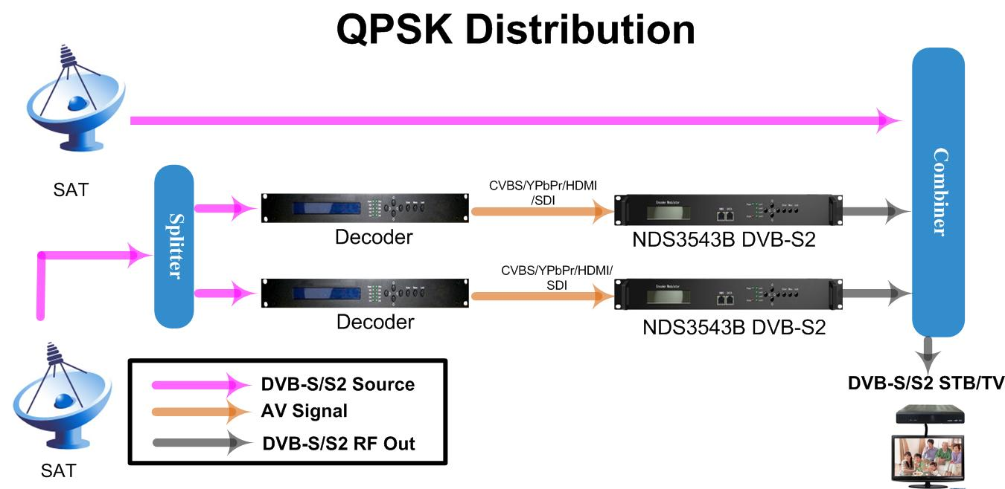

About Us
FMUSER is a company specializing in broadcasting and television transmission systems and integrating hotel IPTV systems. The company was established in 2009 and has served over 180 countries worldwide. More than 20,000 television stations, radio stations, and hotel clients from different.

Contact:Tomleequan Email：sales@fmuser.com whatsapp: +8613922702227

