FMUSER FUQ-4654E Encoder Modulator Multi-input SDI-HDMI-YPbPr-CVBS-ASI DVB-S2X RF Output HEVC H.265 Encoding APSK Modulation Low-Latency for Professional Broadcast
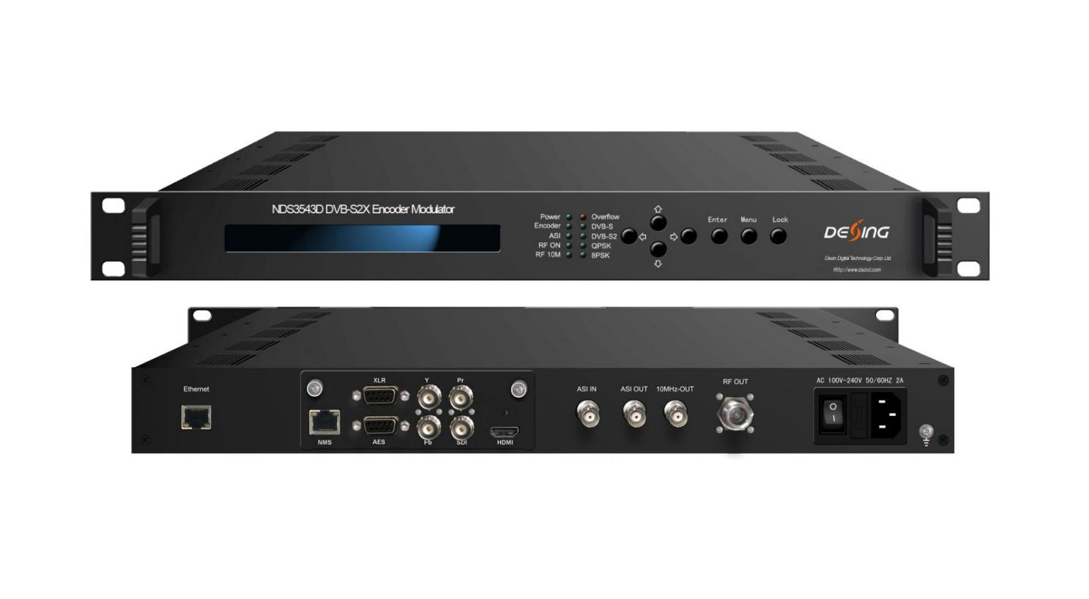Product Overview
The FUQ-4654E integrates DVB-S/S2/S2X encoding and modulation, featuring pluggable modules for SDI/HDMI/YPbPr/CVBS inputs and ASI input for re-muxing. It encodes SD/HD programs and modulates them to RF output with low-latency modes. Controlled via web-based NMS or front-panel, this encoder modulator suits TV stations and DSNG uplinks for efficient broadcast transmission.
Key feature
- Integrated pluggable modules for selecting HEVC/H.265, MPEG-4 AVC/H.264, or MPEG2 encoding.
- Supports multi-format I/O including SDI/HDMI/YPbPr/CVBS/ASI inputs and DVB-S/S2/S2X RF output (950–2150MHz).
- Features advanced modulation with configurable QPSK/8PSK/8APSK/16APSK/32APSK constellations and BISS encryption.
- Managed via Web NMS or front-panel with low-latency modes and 10MHz reference clock.

CID TEST SAMPLE ILLUSTRATION
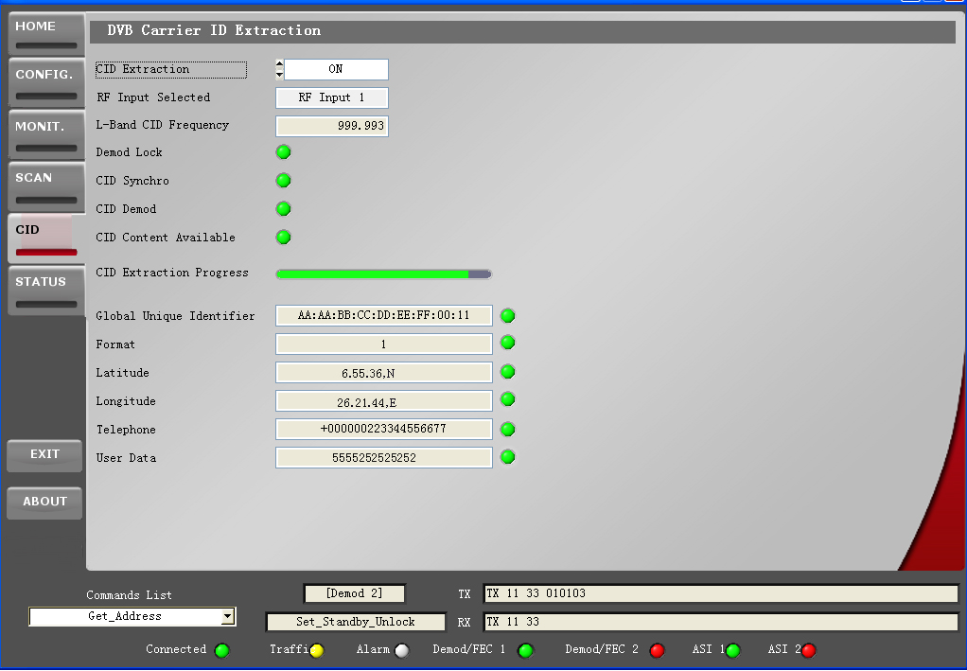

Principle Chart
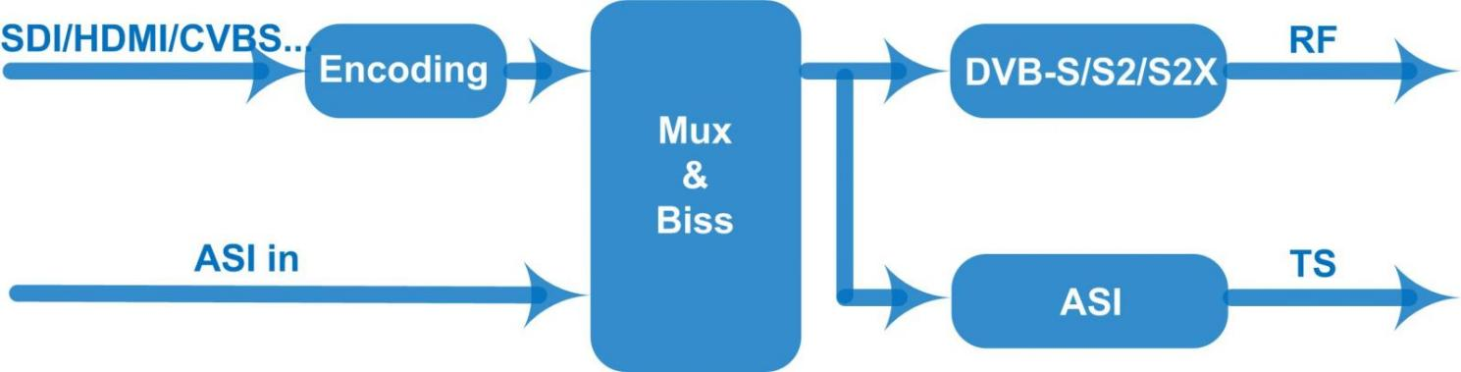

Technical Specifications

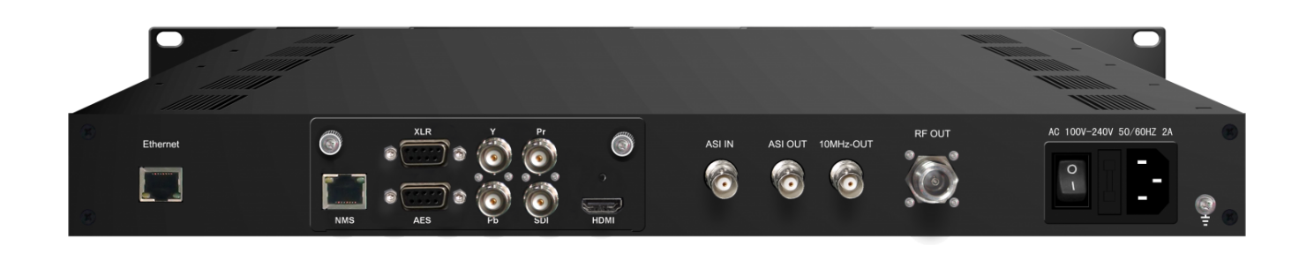
Single HDMI/SDI/YPbPr Input

*H.265/H.264 Video Encoding *Up to 4 stereo audio inputs *OSD Insertion

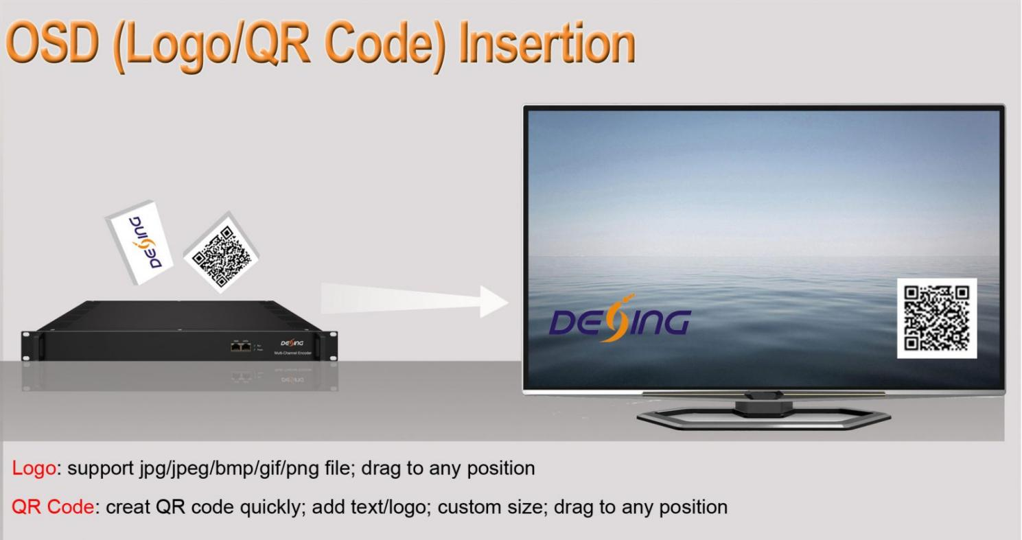
Video
Encoding |  | HEVC/H.265; MPEG-4 AVC/H.264
Input |  | HDMI/SDI/YPbPr
Resolution | Input |  |  | Output | Interface Applicable
Resolution | 1920×1080_60P,  1920×1080_60i,  1920×1080_59.94P,  1920×1080_59.94i |  |  | .  1920×1080_60P | .  HDMI  SDI
Resolution | 1920×1080_50P,  1920×1080_50i |  |  | 1920×1080_50P | .  HDMI  SDI
Resolution | 1280×720_60P,  1280×720_59.94P, |  |  | 1280×720_60P | .  HDMI  SDI
Resolution | 1280×720_50P |  |  | 1280×720_50P | .  HDMI  SDI
Resolution | 1920×1080_60i,  1920×1080_50i,  1280×720_60P,  1280×720_50P |  |  | 1920×1080_60i,  1920×1080_50i,  1280×720_60P,  1280×720_50P | YPbPr
Bit rate |  |  | 4Mbps~20Mbps (for MPEG-4 AVC/H.264)  0.5Mbps~20Mbps (HEVC/H.265)
Chroma |  |  | 4:2:0
Rate Control |  |  | CBR/VBR
GOP Structure |  |  | IBBP, IPPP
Advanced Pretreatment |  |  | De-interlacing, Noise Reduction, Sharpening
Audio
encoding | MPEG-1 Layer 2, LC-AAC, HE-AAC, HE-AAC V2, AC3 Passthrough
Input | Digital: HDMI/SDI/AES; Analog: XLR
Channel | AES/SDI: Up to 4 stereos  HDMI: 1 stereo  XLR: Up to 2 stereos
Sample rate | 48KHz
Bit rate | 48Kbps~384Kbps (MPEG-1 Layer 2 & LC-AAC)  24 Kbps~128 Kbps (HE-AAC)  18 Kbps~56 Kbps (HE-AAC V2)
Audio Gain | 0-255

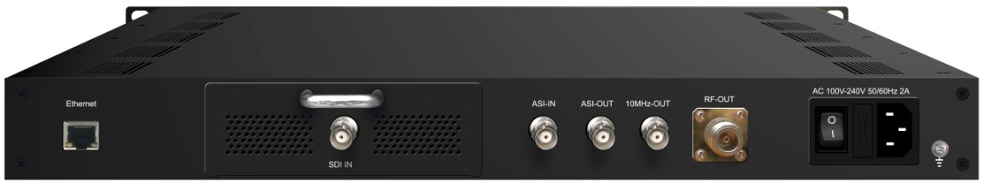
Single SDI Input
Video
Encoding | MPEG2; MPEG4 AVC/H.264
Input | SDI*1
Resolution | 1920*1080_60P, 1920*1080_50P, (-for MPEG4 AVC/H.264 only)  1920*1080_60i, 1920*1080_50i, 1280*720_60p, 1280*720_50P  720*480_60i, 720*576_50i
Audio
encoding | MPEG1 Layer II, MPEG2-AAC, MPEG4-AAC
Sample rate | 48KHz
Bit rate | 64kbps, 96kbps, 128kbps, 192kbps, 256kbps, 320kbps

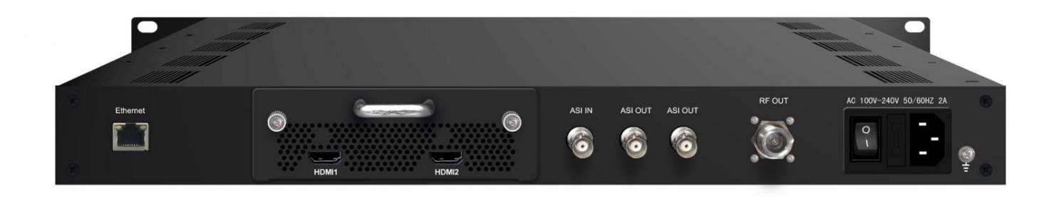
Single HDMI Input
Video
Encoding | MPEG2; MPEG4 AVC/H.264
Input | HDMI*1
Resolution | 1920*1080_60P, 1920*1080_50P, (-for MPEG4 AVC/H.264 only)  1920*1080_60i, 1920*1080_50i,  1280*720_60p, 1280*720_50P  720*480_60i, 720*576_50i
Audio
encoding | MPEG1 Layer II, MPEG2-AAC, MPEG4-AAC
Sample rate | 48KHz
Bit rate | 64kbps, 96kbps,128kbps, 192kbps, 256kbps, 320kbps

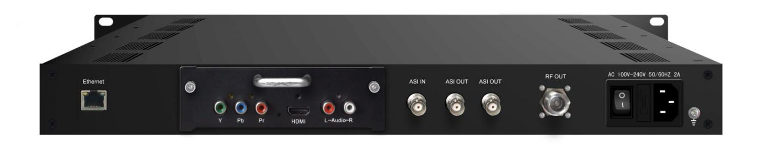
HDMI/YPbPr/CVBS 3-in-1 Input
Video (HDMI)
Encoding | MPEG2; MPEG4 AVC/H.264
Interface | HDMI*1
Resolution | 1920*1080_60P, 1920*1080_50P, (-for MPEG4 AVC/H.264 only)  1920*1080_60i, 1920*1080_50i, 1280*720_60p, 1280*720_50P
Audio (HDMI)
Encoding | MPEG1 Layer II; MPEG2-AAC; MPEG4-AAC
Interface | HDMI*1
Sample rate | 48KHz
Bit rate | 64/96/128/ 192/256/320kbps
Video (YPbPr/CVBS)
Encoding | MPEG2; MPEG4 AVC/H.264
Interface | YPbPr*1/CVBS *1
Resolution | CVBS: 720x576_50i (PAL); 720x480_60i (NTSC)  YPbPr: 1920*1080_60i, 1920*1080_50i; 1280*720_60p, 1280*720_50P
Audio (L/R)
Encoding | MPEG1 Layer II; MPEG2-AAC; MPEG4-AAC
Interface | 1*Stereo/2*mono
Sample rate | 48KHz
Bit rate | 64/96/128/ 192/256/320kbps

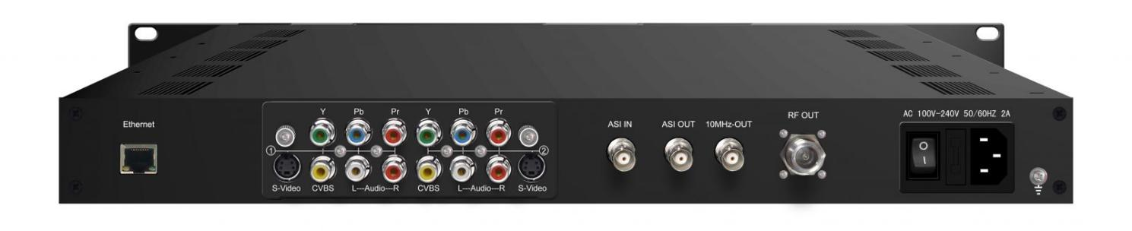
2*(S-Video + YPbPr + CVBS) Inputs
Video
Encoding | Option 1: MPEG-2 MP@ML(4:2:0)  Option 2: MPEG-2 & MPEG-4 AVC/H.264 (4:2:0)
Input | 2*S-Video/YPbPr/CVBS (RCA Type)
Resolution | 720*576 (PAL); 720*480 (NTSC)
Bit rate | Option 1: 1~19.50 Mbps; Option 2: 1~10.00 Mbps
Audio
encoding | Option 1: MPEG1 Layer II  Option 2: MPEG1 Layer II; LC-AAC; HE-AAC and Dolby Digital AC3 2.0( Optional)
Input | 2 Stereo/Mono
Sample rate | 48KHz
Bit rate | 64kbps, 96kbps,128kbps, 192kbps, 256kbps, 320kbps

Generals

Input Interface | 2*CVBS; 1*SDI; 1*HDMI; 1*(HDMI/SDI/YPbPr 3-in-1); 1*(HDMI/YPbPr/CVBS 3-in-1) input optional  ASI intput
Output | DVB-S/S2/S2X RF output ;  ASI output as mirror of RF
Modulation Section | Standard | DVB-S | DVB-S2 | DVB-S2X
Modulation Section | Outer coding | RS Coding | BCH Coding | BCH Coding
Modulation Section | Inner coding | Convolution | LDPC Coding | LDPC Coding
Modulation Section | Constellation | QPSK | QPSK,8PSK,  16APSK,32APSK | QPSK,8PSK,  8APSK, 16APSK, 32APSK
Modulation Section | FEC/ Convolution Rate | 1/2, 2/3, 3/4, 5/6, 7/8 | QPSK: 1/2, 3/5, 2/3, 3/4, 4/5, 5/6, 8/9, 9/10  8PSK: 3/5, 2/3, 3/4, 5/6, 8/9, 9/10  16APSK: 2/3, 3/4, 4/5, 5/6, 8/9, 9/10  32APSK: 3/4, 4/5, 5/6, 8/9, 9/10 | QPSK: 1/2, 3/5, 2/3, 3/4, 4/5, 5/6, 8/9, 9/10, 13/45, 9/20, 11/20  8PSK: 3/5, 2/3, 3/4, 5/6, 8/9, 9/10  , 23/36, 25/36, 13/18  8APSK: 5/9-L, 26/45-L  16APSK: 2/3, 3/4, 4/5, 5/6, 8/9, 9/10  , 1/2-L, 8/15-L, 5/9-L, 26/45, 3/5, 3/5-L, 28/45, 23/36 , 2/3-L, 25/36, 13/18, 7/9, 77/90  32APSK: 3/4, 4/5, 5/6, 8/9, 9/10, 2/3-L, 32/45, 11/15, 7/9
Modulation Section | Roll-off Factor | 0.2, 0.25, 0.35 | 0.2, 0.25, 0.35 | 0.05, 0.10, 0.15, 0.2, 0.25, 0.35
Modulation Section | Symbol Rate | 0.5~45Msps | 0.5~40Msps (32APSK);  0.5~45Msps  (QPSK/8PSK/16APSK) | 0.5~40Msps(32APSK);  0.5~45 Msps  (QPSK/8PSK /8APSK/16APSK)
Modulation Section | RF Range | 950-2150MHz
Modulation Section | Output level | +3dBm~-28.5dBm
BISS | Mode 1, Mode E
System | Local Control | LCD + control buttons
System | Remote Control | Web NMS
System | Low Latency Mode | Normal, Mode 1, Mode 2
System | Language | English
Physical Specification | Demission | 410×460×44mm (W*L*H)
Physical Specification | Temperature | 0~45℃(operation), -20~80℃(storage)
Physical Specification | Power Supply | AC 100-240V 50/60Hz 2A

Order Guide
 | FU-4654A | FU-4654C | FU-4654D
DVB-S/S2 | ● | ● | ●
DVB-S2X |  |  | ●
RF Output(950-2150MHz) |  | ● | ●
IF Output(50-200 MHz) | ●

About Us
FMUSER is a company specializing in broadcasting and television transmission systems and integrating hotel IPTV systems. The company was established in 2009 and has served over 180 countries worldwide. More than 20,000 television stations, radio stations, and hotel clients from different.

Contact:Tomleequan Email：sales@fmuser.com whatsapp: +8613922702227

