FMUSER FUQ-4655AB Encoder Modulator 12 HD-SDI Inputs 16 DVB-C Outputs DVB-C DVB-T ATSC ISDB-T Standards HD-SDI IP-RF Interfaces Encoding Multiplexing Scrambling Broadcast Headend System
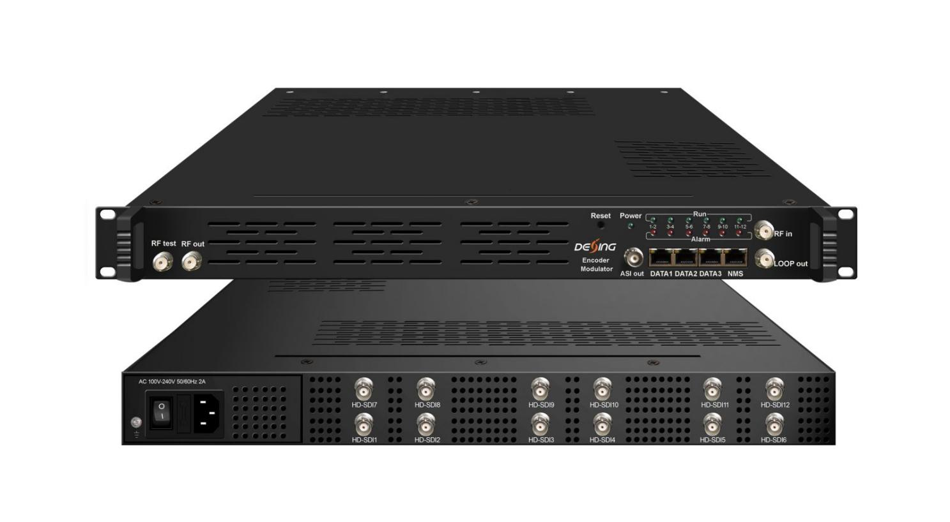Product Overview
The FUQ-4655XY is a high-integration encoder modulator combining encoding, multiplexing, scrambling, and modulation. It features 12 HD-SDI inputs, a DVB-C tuner, and up to 512 IP inputs via Data1 port, with DVB-C RF output supporting 16 carriers. Optional outputs include DVB-T, ATSC, or ISDB-T RF with fewer carriers and ASI mirroring. This device is ideal for broadcast studios, cable headends, and professional video distribution systems.
Key feature
Includes optional ASI output and web-based management for remote control.

Principle Chart
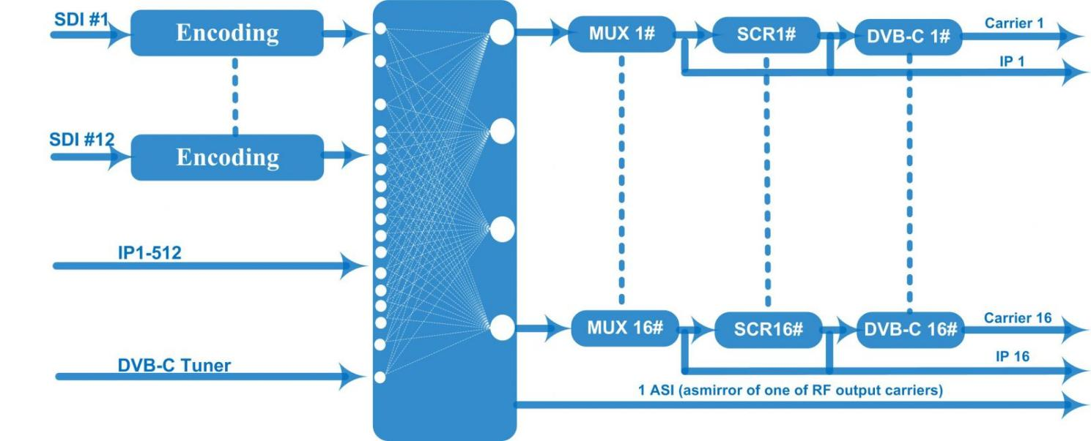
DVB-C Principle Chart
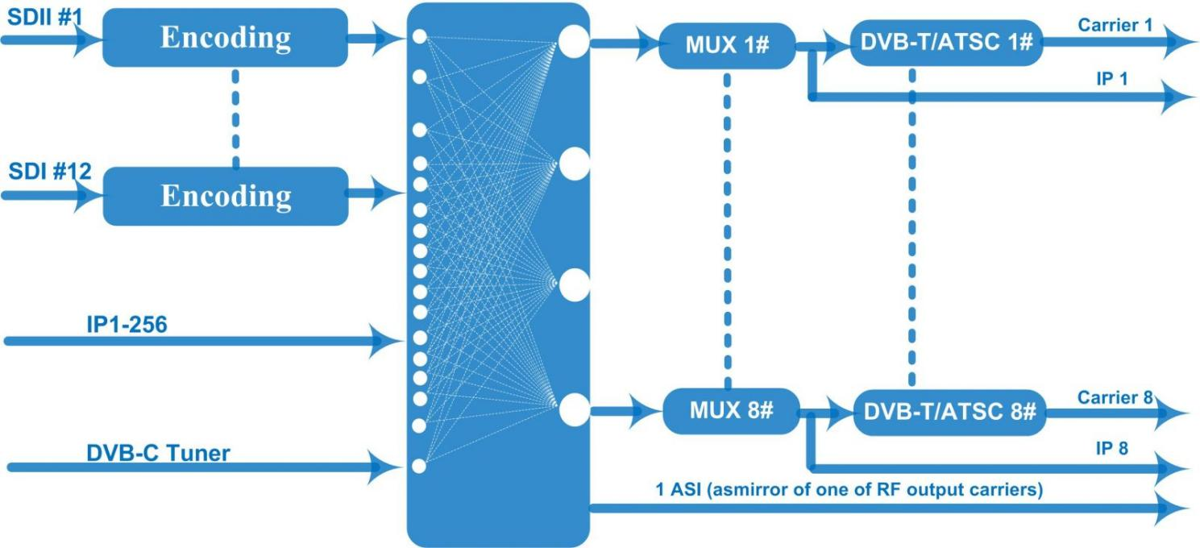
DVB-T/ATSC Principle Chart
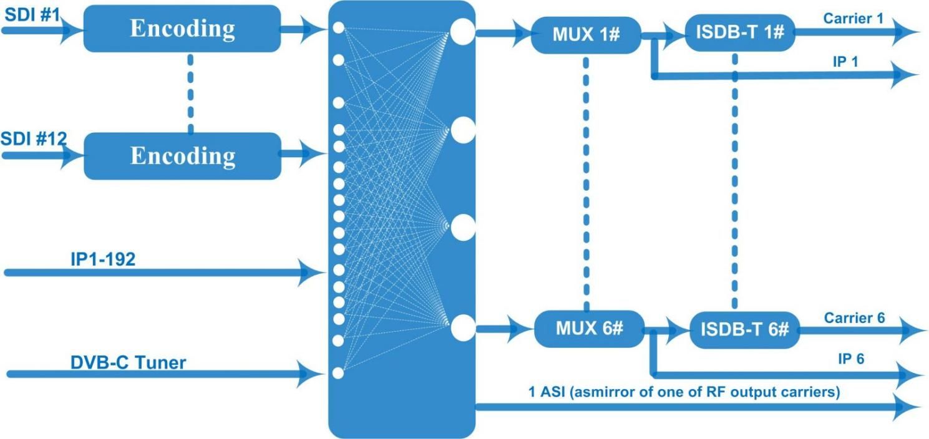
ISDB-T Principle Chart

Technical specification
Input | 12 HD-SDI inputs with CC  1 DVB-C (ATSC optional)Tuner for re-mux, F type interface  512 IP input over UDP and RTP, DATA1, RJ45—DVB-C RF out  256 IP input over UDP and RTP, DATA1, RJ45—DVB-T/ATSC RF out  192 IP input over UDP and RTP, DATA1, RJ45—ISDB RF out
Video | Resolution | Input |  | 1920*1080_60p, 1920*1080_50p,1920*1080_60i, 1920*1080_50i, 1280*720_60p, 1280*720_50P,  720*480_60i, 720*576_50i
Video | Resolution | Output |  | 1920*1080_60p, 1920*1080_50p,1920*1080_60i, 1920*1080_50i, 1440*1080_60i, 1440*1080_50i,  1280*720_60p, 1280*720_50P, 720*576_50p,  720*576_50i, 720*576_30p, 720*576_25p,  720*480_60p, 720*480_60i,720*480_30p, 720*480_25p,320*240_60p,320*240_50p,  320*240_30p, 320*240_25p,320*180_60p, 320*180_50p, 320*180_30p, 320*180_25p,  960*540_50i, 704*576_50i,704*480_60i, 640*576_50i  640*480_60i, 544*576_50i,544*480_60i,
Video | Encoding | MPEG2 & MPEG4 AVC/H.264
Video | Bit-rate | 0.8~19Mbps for H.264 encoding  1~19Mbps for MPEG-2 encoding
Video | Rate Control | CBR/VBR
Video | GOP Structure | GOP B Frame: 0-3, GOP P Frame: 0-6
Video | Advanced Pretreatment | De-interlacing, noise reduction
Audio | Encoding | MPEG1 Layer II, MPEG2-AAC, MPEG4-AAC,  Dolby Digital AC3 (2.0) encoding (Optional),  AC3 (2.0/5.1) passthrough
Audio | Sampling rate | 48KHz
Audio | Bit-rate | 64Kbps-320kbps each channel
Multiplexing | Maximum PID  Remapping | 256 input per channel
Multiplexing | Function | PID remapping ( automatically or manually)
Multiplexing | Function | Accurate PCR adjusting
Multiplexing | Function | Generate PSI/ SI table automatically
Scrambling | Maximum simulcrypt CA | 4
Scrambling | Standard | ETR289, ETSI 101197, ETSI 103197
Scrambling | Connection | Local/remote connection
Modulation | DVB-C | QAM Channel: 16 non-adjacent carriers output (maximum bandwidth 192MHz)  Standard: EN300 429/ITU-T J.83A/B  MER: ≥40db  RF frequency: 50~960MHz, 1KHz step  RF output level: -20~+10dbm, 0.1db step  Symbol Rate: 5.0Msps~7.0Msps, 1ksps stepping
Modulation | DVB-C |  |  |  | J.83A | J.83B
Modulation | DVB-C | Constellation |  |  | 16/32/64/128/256QAM | 64/256 QAM
Modulation | DVB-C | Bandwidth |  |  | 8M | 6M
Modulation | DVB-T | Standard |  |  | EN300744
Modulation | DVB-T | FFT mode |  |  | 2K, 4K, 8K
Modulation | DVB-T | Bandwidth |  |  | 6M, 7M, 8M
Modulation | DVB-T | Constellation |  |  | QPSK, 16QAM, 64QAM
Modulation | DVB-T | Guard Interval |  |  | 1/4, 1/8, 1/16, 1/32
Modulation | DVB-T | FEC |  |  | 1/2, 2/3, 3/4, 5/6, 7/8
Modulation | DVB-T | MER |  |  | ≥42 dB
Modulation | DVB-T | RF frequency |  |  | 50~960MHz, 1KHz step
Modulation | DVB-T | RF out |  |  | 8 non-adjacent carriers output (maximum bandwidth 192MHz)
Modulation | DVB-T | RF output level |  |  | -20~+10 dBm, 0.1db step
Modulation | ATSC | Standard |  |  | ATSC A/53
Modulation | ATSC | Bandwidth |  |  | 6M
Modulation | ATSC | Constellation |  |  | 8VSB
Modulation | ATSC | FEC |  |  | RS(208 188)+Trellis
Modulation | ATSC | MER |  |  | ≥40dB
Modulation | ATSC | ACL |  |  | -55 dBc
Modulation | ATSC | RF frequency |  |  | 50~960MHz, 1KHz step
Modulation | ATSC | RF out |  |  | 8 non-adjacent carriers output (maximum bandwidth 192MHz)
Modulation | ATSC | RF output level |  |  | -20~+10dbm (for all carriers), 0.5db stepping
Modulation | ISDB-T | Standard |  |  | ARIB STD-B31
Modulation | ISDB-T | Bandwidth |  |  | 6M
Modulation | ISDB-T | Constellation |  |  | QPSK, 16QAM, 64QAM
Modulation | ISDB-T | Guard Interval |  |  | 1/32, 1/16, 1/8, 1/4
Modulation | ISDB-T | Transmission Mode |  |  | 2K, 4K, 8K
Modulation | ISDB-T | Code rate |  |  | 1/2, 2/3, 3/4, 5/6, 7/8
Modulation | ISDB-T | MER |  |  | ≥40dB
Modulation | ISDB-T | RF frequency |  |  | 50~960MHz, 1KHz step
Modulation | ISDB-T | RF out |  |  | 6 non-adjacent carriers output (maximum bandwidth 192MHz)
Modulation | ISDB-T | RF output level |  |  | -20dBm~+10dBm, 0.1dB stepping
Stream output | 1 ASI output as mirror of one of RF output carriers-Optional  16 MPTS output over UDP and RTP/RTSP as mirror of 16 DVB-C carriers,  8 MPTS output over UDP and RTP/RTSP as mirror of 8 DVB-T/ATSC carriers(Optional)  6 MPTS output over UDP and RTP/RTSP as mirror of 6 ISDB-T carriers(Optional)  1*1000M Base-T Ethernet interface
System function | Network management (WEB)
System function | Chinese and English language
System function | Ethernet software upgrade
Miscellaneous | Dimension (W×L×H) |  | 482mm×440mm×44mm
Miscellaneous | Environment |  | 0~45℃(work)；-20~80℃（Storage）
Miscellaneous | Power requirements |  | AC 110V± 10%, 50/60Hz, AC 220 ± 10%, 50/60Hz

Ordering Information
 | IP input | IP output | RF carriers | Scrambling
DVB-C | 512 | 16 | 16 | √
DVB-T | 256 | 8 | 8 | ×
ATSC | 256 | 8 | 8 | ×
ISDB-T | 192 | 6 | 6 | ×

About Us
FMUSER is a company specializing in broadcasting and television transmission systems and integrating hotel IPTV systems. The company was established in 2009 and has served over 180 countries worldwide. More than 20,000 television stations, radio stations, and hotel clients from different.

Contact:Tomleequan Email：sales@fmuser.com whatsapp: +8613922702227

