FUQ-4655AB Encoder 12 HD-SDI & 32 IP Inputs MPEG-2 H.264 Encoding 1 MPTS 12 SPTS UDP-RTP Streaming for CATV Satellite Terrestrial TV
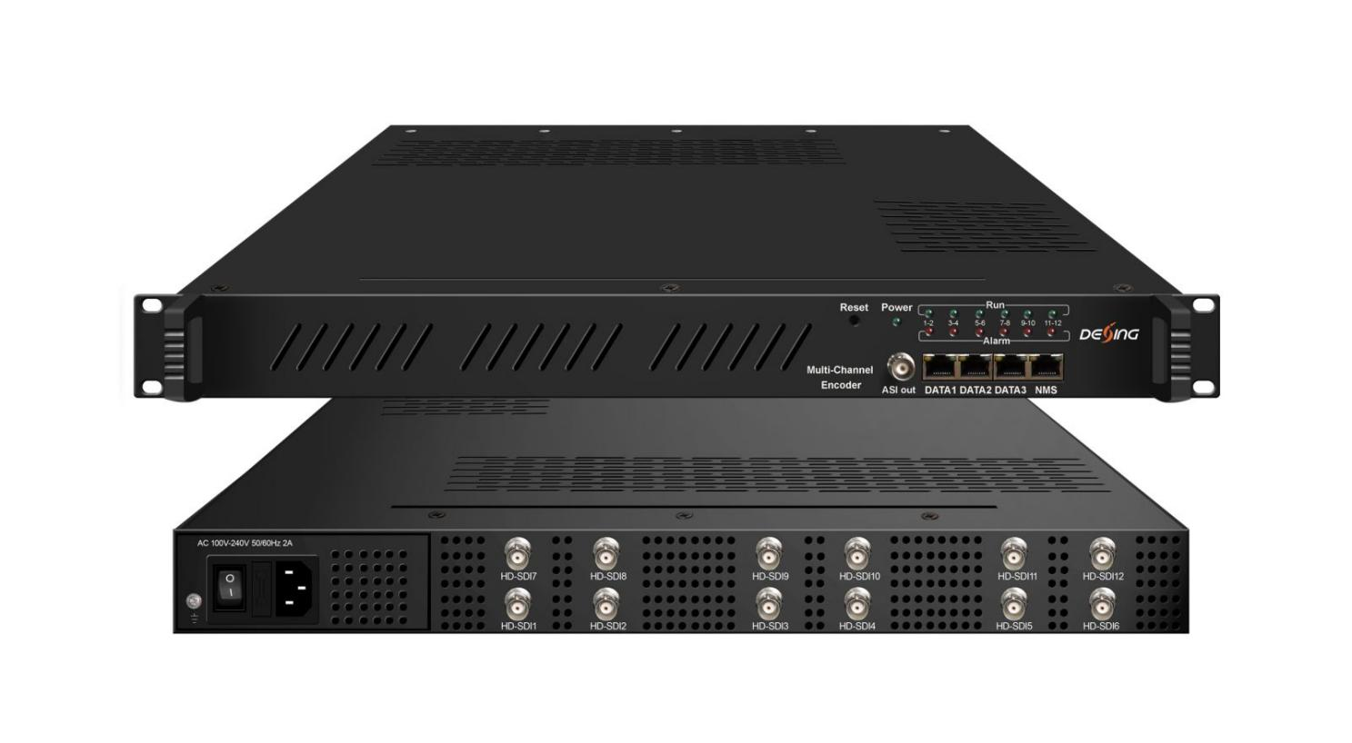Product Overview
The FUQ-4655AB encoder processes signals with 12 HD-SDI inputs and 32 IP inputs, outputting 1 MPTS and 12 SPTS over UDP/RTP/RTSP. It encodes video in MPEG-2 or MPEG-4 AVC/H.264 and handles Dolby Digital AC3 audio. Managed via a web interface, this unit is optimized for CATV, satellite, and terrestrial digital TV systems.
Key feature
Supports 12 HD-SDI inputs for MPEG-2 or MPEG-4 AVC/H.264 encoding with EIA608/EIA708 closed captioning.
Handles audio encoding including MPEG1 Layer II, MPEG2-AAC, MPEG4-AAC, and Dolby Digital AC3 (2.0) with passthrough.
Provides 32 IP inputs over UDP/RTP and outputs 1 MPTS/12 SPTS via DATA1/DATA2 ports.
Enables PID remapping, PCR adjusting, and PSI/SI table editing/inserting.
Features web-based management for configuration and updates.
Principle Chart

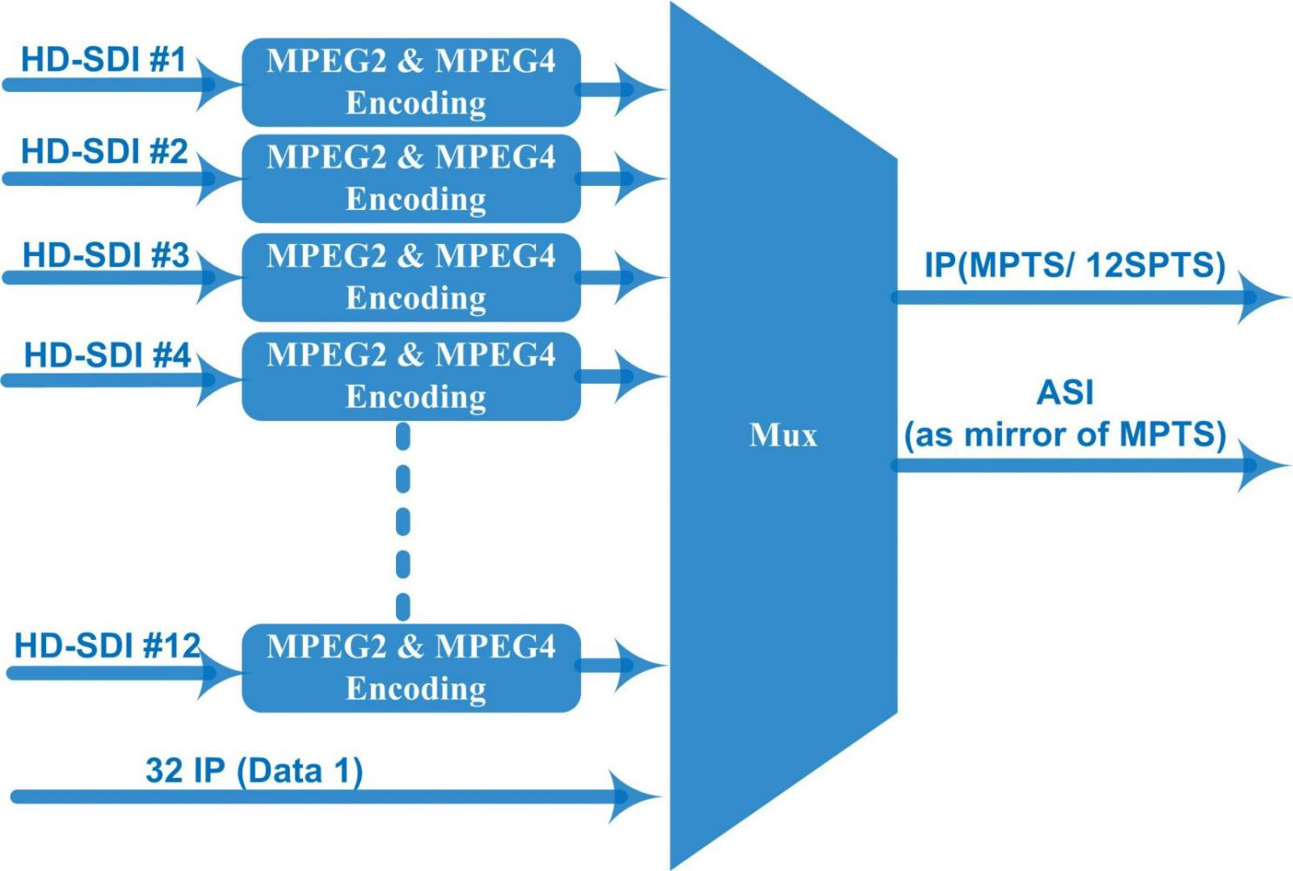
Technical Specification

Input | 12 HD-SDI inputs with CC (EIA608/EIA708)  32 IP input over UDP and RTP through DATA 1 port
Video | Resolution | Input |  | 1920*1080_60p, 1920*1080_50p,1920*1080_60i, 1920*1080_50i, 1280*720_60p, 1280*720_50P,  720*480_60i, 720*576_50i
Video | Resolution | Output |  | 1920*1080_60p, 1920*1080_50p,1920*1080_60i, 1920*1080_50i, 1440*1080_60i, 1440*1080_50i,  1280*720_60p, 1280*720_50P, 720*576_50p,  720*576_50i, 720*576_30p, 720*576_25p,  720*480_60p, 720*480_60i,720*480_30p, 720*480_25p,320*240_60p,320*240_50p,  320*240_30p, 320*240_25p,320*180_60p, 320*180_50p, 320*180_30p, 320*180_25p,  960*540_50i, 704*576_50i,704*480_60i, 640*576_50i  640*480_60i, 544*576_50i,544*480_60i,
Video | Encoding | MPEG2 & MPEG4 AVC/H.264
Video | Bit-rate | 0.8~19Mbps for H.264 encoding  1~19Mbps for MPEG-2 encoding
Video | Rate Control | CBR/VBR
Video | GOP Structure | GOP B Frame: 0-3, GOP P Frame: 0-6
Audio | Encoding | MPEG1 Layer II, MPEG2-AAC, MPEG4-AAC,  Dolby Digital AC3 (2.0) encoding,  AC3 (2.0/5.1) passthrough
Audio | Sampling rate | 48KHz
Audio | Bit-rate | 64Kbps-320kbps each channel
Multiplexing | Maximum PID  Remapping | 180 input per channel
Multiplexing | Function | PID remapping ( automatically or manually)
Multiplexing | Function | Accurate PCR adjusting
Multiplexing | Function | Generate PSI/ SI table automatically
Stream output | 1 MPTS and 12 SPTS IP output over UDP and RTP/RTSP, 2*1000M Base-T Ethernet interface, Data 1 and Data 2  1 ASI output as mirror of MPTS-Optional
System function | Network management (WEB)
System function | Ethernet software upgrade
Miscellaneous | Dimension (W×L×H) |  | 482mm×440mm×44mm
Miscellaneous | Environment |  | 0~45℃(work)；-20~80℃（Storage）
Miscellaneous | Power requirements |  | AC 110V± 10%, 50/60Hz, AC 220 ± 10%, 50/60Hz

About Us
FMUSER is a company specializing in broadcasting and television transmission systems and integrating hotel IPTV systems. The company was established in 2009 and has served over 180 countries worldwide. More than 20,000 television stations, radio stations, and hotel clients from different.

Contact:Tomleequan Email：sales@fmuser.com whatsapp: +8613922702227

