FMUSER FUQ-4655BC Encoder Modulator 24 CVBS & 512 IP Inputs 16 RF Outputs MPEG-2 Encoding DVB-C-DVB-T-ATSC-ISDB-T Multiplexing Scrambling CATV Headend Hotel TV System
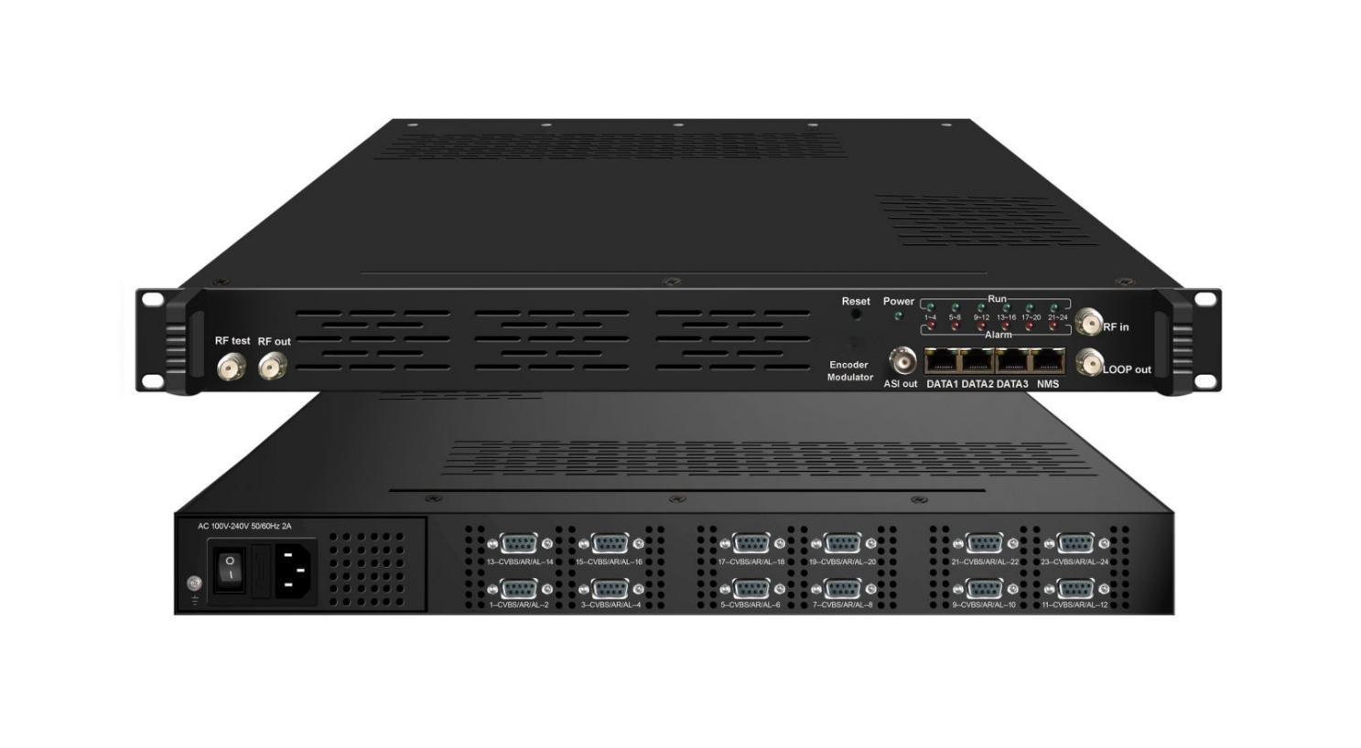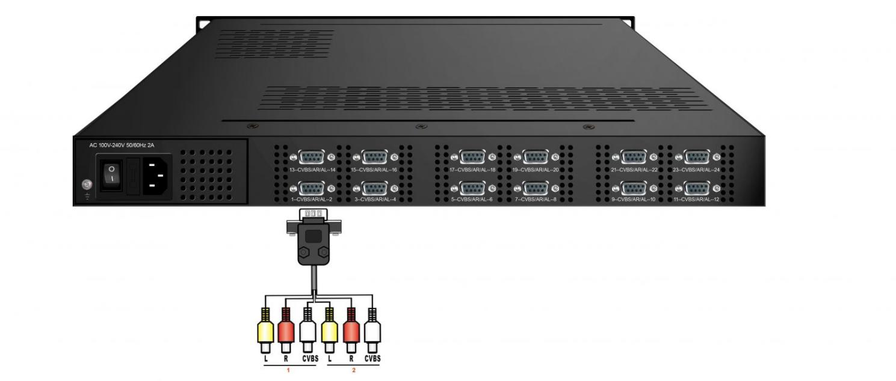

Product Overview
The FMUSER FUQ-4655BC is a professional SD encoder modulator integrating encoding, multiplexing, scrambling, and modulation, with 24 CVBS inputs and IP streaming via the DATA1 port. It processes signals using MPEG-2 video encoding and MPEG-1 Layer 2 or DD AC3 audio encoding, outputting DVB-C, DVB-T/ATSC, or ISDB-T signals. Featuring web-based management for control and updates, it is ideal for small CATV headends and broadcast systems, enabling efficient signal distribution.
Key feature
Comprehensive multiplexing with PID remapping, PCR adjusting, and PSI/SI editing.
Principle Chart
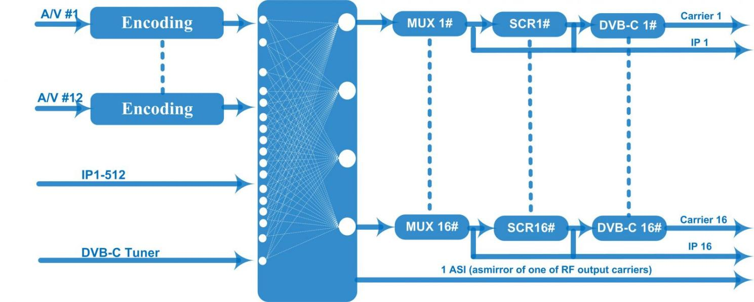
DVB-C Principle Chart
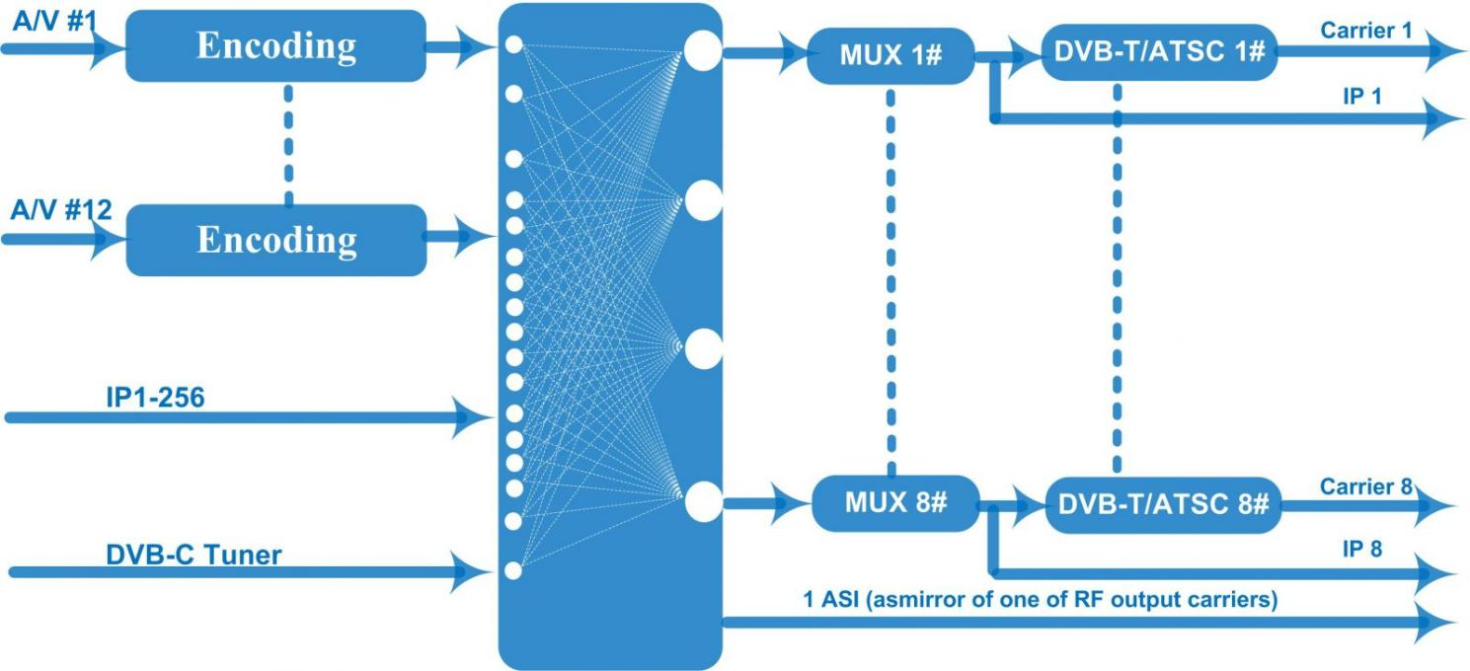
DVB-T Principle Chart
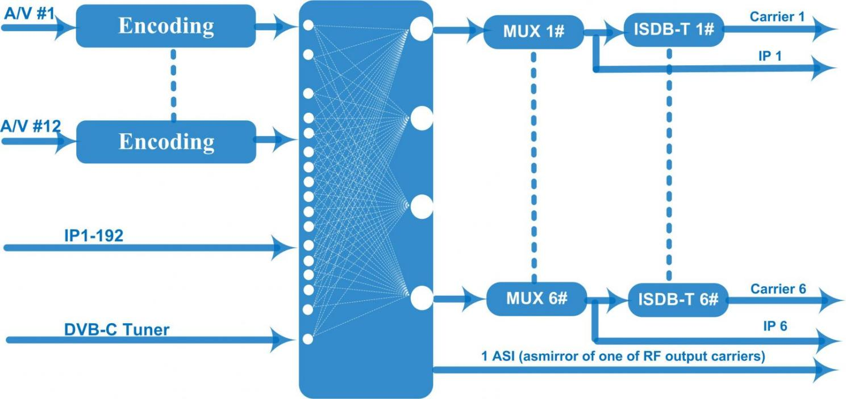
ISDB-T Principle Chart

Technical specification
Input | 24 CVBS inputs  1 DVB-C(ATSC optional) Tuner for re-mux, F type interface  512 IP input over UDP and RTP, DATA1, RJ45—DVB-C RF out  256 IP input over UDP and RTP, DATA1, RJ45—DVB-T/ATSC RF out  192 IP input over UDP and RTP, DATA1, RJ45—ISDB RF out
Video | Resolution | 720×480_60i, 544×480_60i, 352×480_60i  352×240_60i,320×240_60i,176×240_60i, 176×120_60i
Video | Resolution | 720×576_50i,704×576_50i,640×576_50i, 352×288_50i  320×288_50i, 176×288_50i, 176×144_50i
Video | Encoding | MPEG-2
Video | Bit-rate | 0.5Mbps~8Mbps per channel
Video | Rate Control | CBR/VBR
Video | GOP Structure | IP, IBP, IBBP, IBBBP
Video | Advanced Pretreatment | De-interlacing, noise reduction
Audio | Encoding | MPEG-1 Layer 2, DD AC3 (2.0)
Audio | Sampling rate | 48KHz
Audio | Resolution | 24-bit
Audio | Bit-rate | 64Kbps,128Kbps,192kbps,256kbps,320kbps,384kbps each channel
Multiplexing | Maximum PID  Remapping | 180 input per channel
Multiplexing | Function | PID remapping ( automatically or manually)
Multiplexing | Function | Accurate PCR adjusting
Multiplexing | Function | Generate PSI/ SI table automatically
Scrambling | Maximum simulcrypt CA | 4
Scrambling | Standard | ETR289, ETSI 101 197, ETSI 103 197
Scrambling | Connection | Local/remote connection
Modulation | DVB-C | QAM Channel |  | 16 non-adjacent carriers output (maximum bandwidth
Modulation | DVB-C | Standard |  | EN300 429/ITU-T J.83A/B
Modulation | DVB-C | MER |  | ≥40db
Modulation | DVB-C | RF frequency |  | 50~960MHz, 1KHz step
Modulation | DVB-C | RF output level |  | -20~+10dbm (87~107 dbµV), 0.1db step
Modulation | DVB-C | Symbol Rate |  | 5.0Msps~7.0Msps, 1ksps stepping
Modulation | DVB-C |  |  | J.83A | J.83B
Modulation | DVB-C | Constellation |  | 16/32/64/128/256QAM | 64/256 QAM
Modulation | DVB-C | Bandwidth |  | 8M | 6M
Modulation | DVB-T | Standard |  | EN300744
Modulation | DVB-T | FFT mode |  | 2K,4K, 8K
Modulation | DVB-T | Bandwidth |  | 6M, 7M, 8M
Modulation | DVB-T | Constellation |  | QPSK, 16QAM, 64QAM
Modulation | DVB-T | Guard Interval |  | 1/4, 1/8, 1/16, 1/32
Modulation | DVB-T | FEC |  | 1/2, 2/3, 3/4, 5/6, 7/8
Modulation | DVB-T | MER |  | ≥42 dB
Modulation | DVB-T | RF frequency |  | 50~960MHz, 1KHz step
Modulation | DVB-T | RF out |  | 8 non-adjacent carriers DVB-T out (maximum bandwidth 192MHz)
Modulation | DVB-T | RF output level |  | -20~ +10 dBm (77~97 dbµV), 0.1db step
Modulation | ATSC | Standard |  | ATSC A/53
Modulation | ATSC | Bandwidth |  | 6M
Modulation | ATSC | Constellation |  | 8VSB
Modulation | ATSC | FEC |  | RS(208 188)+Trellis
Modulation | ATSC | MER |  | ≥40dB
Modulation | ATSC | ACL |  | -55 dBc
Modulation | ATSC | RF frequency |  | 50~960MHz, 1KHz step
Modulation | ATSC | RF out |  | 8 non-adjacent carriers output (maximum bandwidth 192MHz)
Modulation | ATSC | RF output level |  | -20~+10dbm (for all carriers), 0.5db stepping
Modulation | ISDB-T | Standard |  | ARIB STD-B31
Modulation | ISDB-T | Bandwidth |  | 6M
Modulation | ISDB-T | Constellation |  | QPSK, 16QAM, 64QAM
Modulation | ISDB-T | Guard Interval |  | 1/32, 1/16, 1/8, 1/4
Modulation | ISDB-T | Transmission Mode |  | 2K, 4K, 8K
Modulation | ISDB-T | Code rate |  | 1/2, 2/3, 3/4, 5/6, 7/8
Modulation | ISDB-T | MER |  | ≥40dB
Modulation | ISDB-T | RF frequency |  | 50~960MHz, 1KHz step
Modulation | ISDB-T | RF out |  | 6 non-adjacent carriers output (maximum bandwidth 192MHz)
Modulation | ISDB-T | RF output level |  | -20dBm~+10dBm, 0.1dB stepping
Stream output | 1 ASI output as mirror of one of RF output carriers-Optional  16 MPTS output over UDP and RTP/RTSP as mirror of 16 DVB-C carriers,  8 MPTS output over UDP and RTP/RTSP as mirror of 8 DVB-T/ATSC carriers(Optional)  6 MPTS output over UDP and RTP/RTSP as mirror of 6 ISDB-T carriers(Optional)  1*1000M Base-T Ethernet interface
System function | Network management (WEB)
System function | Chinese and English language
System function | Ethernet software upgrade
Miscellaneous | Dimension (W×L×H) |  | 482mm×440mm×44mm
Miscellaneous | Environment |  | 0~45℃(work)；-20~80℃（Storage）
Miscellaneous | Power requirements |  | AC 110V± 10%, 50/60Hz, AC 220 ± 10%, 50/60Hz

Ordering Information
 | IP input | IP output | RF carriers | Scrambling
DVB-C | 512 | 16 | 16 | √
DVB-T | 256 | 8 | 8 | ×
ATSC | 256 | 8 | 8 | ×
ISDB-T | 192 | 6 | 6 | ×

About Us
FMUSER is a company specializing in broadcasting and television transmission systems and integrating hotel IPTV systems. The company was established in 2009 and has served over 180 countries worldwide. More than 20,000 television stations, radio stations, and hotel clients from different.

Contact:Tomleequan Email：sales@fmuser.com whatsapp: +8613922702227

