FMUSER FUQ-4655K Encoder Modulator 12 HDMI Inputs 256 IP Inputs MPEG2 H.264 Encoding DVB-C-DVB-T-ATSC-ISDB-T Modulation Web Management CATV Headend Application 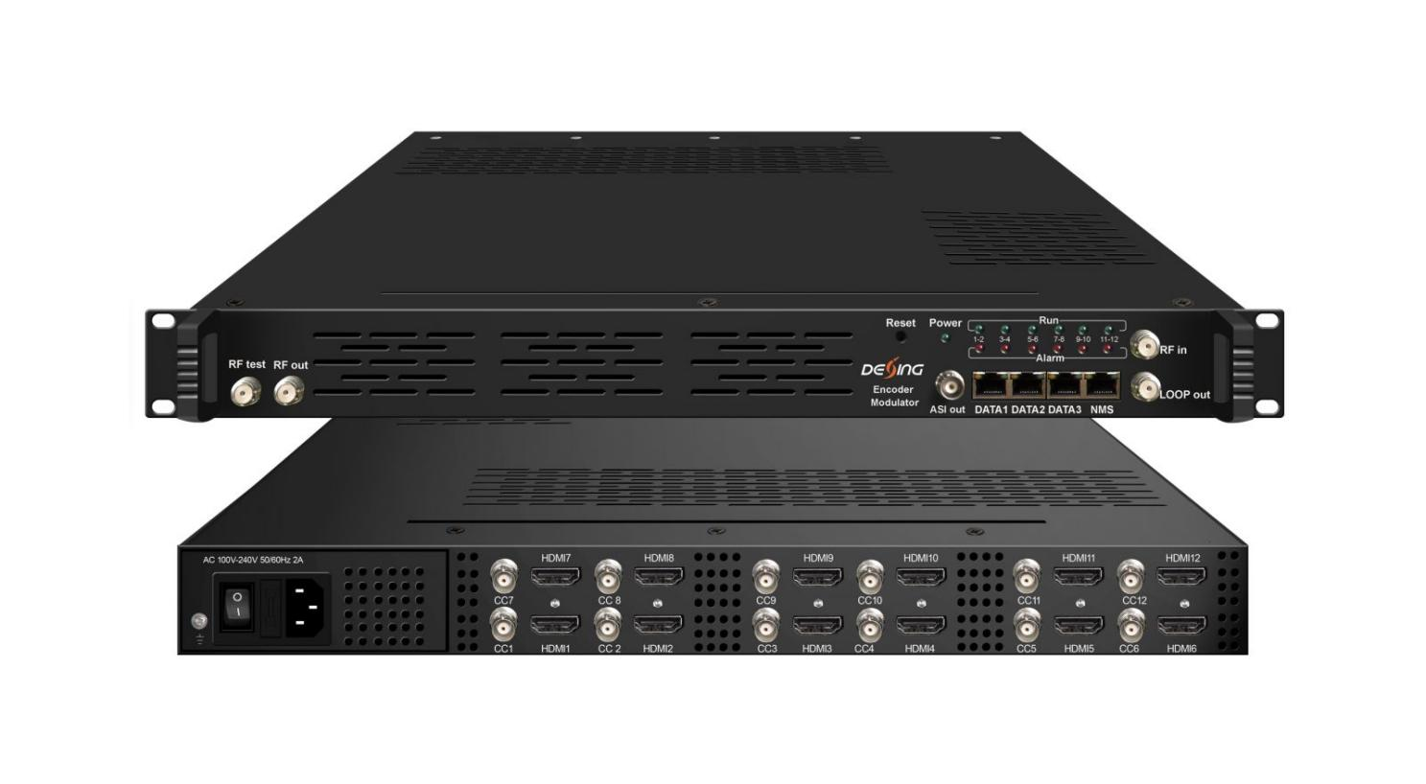Product Overview
The FMUSER FUQ-4655L Encoder Modulator integrates encoding, multiplexing, scrambling, and modulating functions. It processes signals from 12 HDMI inputs and IP inputs, encoding to MPEG2 or H.264, and outputs via RF for DVB-C, DVB-T/ATSC, or ISDB-T standards. Managed through web-based interface for control and updates. Ideal for small CATV headend systems, broadcasting, and IP streaming applications.
Key feature
Supports 12 HDMI inputs with MPEG2 & H.264 encoding, Features DVB-C, DVB-T/ATSC, and ISDB-T modulation for RF output, Integrated multiplexing and scrambling with PID remapping, Provides IP I/O over UDP/RTP/RTSP protocols, Web-based management for easy control

Principle Chart
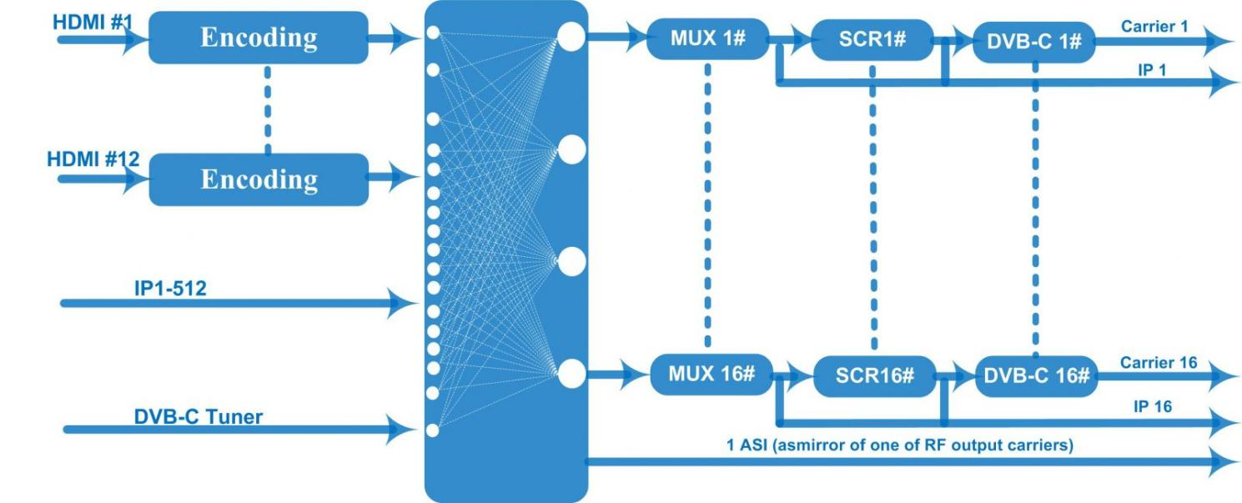
DVB-C Principle Chart
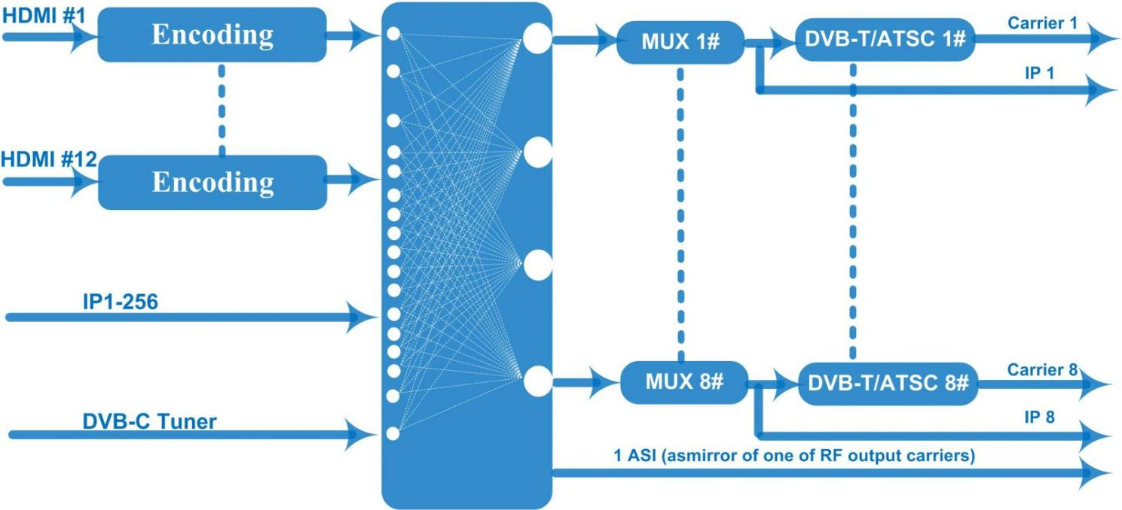
DVB-T/ATSC Principle Chart
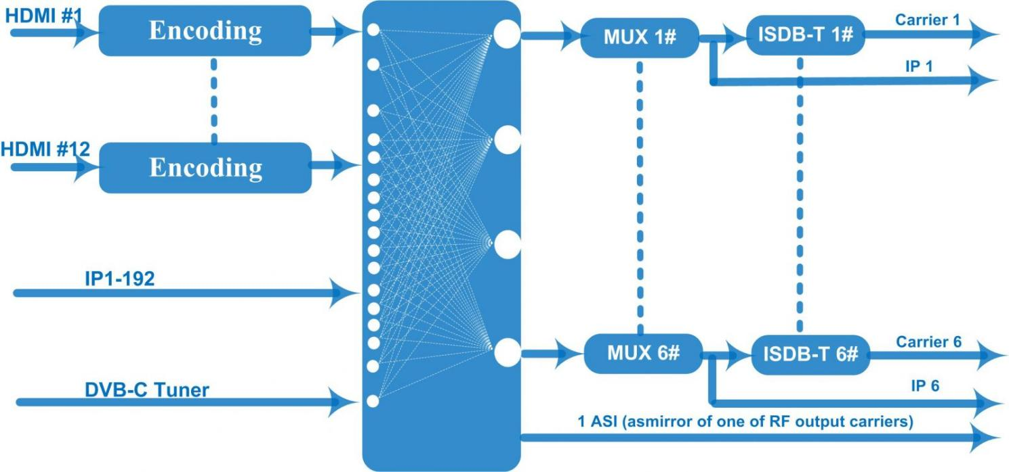
ISDB-T Principle Chart
Technical specification
Input | 12 HDMI inputs  12 CC(closed caption) input, BNC interface  1 DVB-C(ATSC optional) Tuner for re-mux, F type interface  512 IP input over UDP and RTP, DATA1, RJ45—DVB-C RF out  256 IP input over UDP and RTP, DATA1, RJ45—DVB-T/ATSC RF out  192 IP input over UDP and RTP, DATA1, RJ45—ISDB RF out
Video | Resolution | Input |  | 1920*1080_60p, 1920*1080_50p,1920*1080_60i, 1920*1080_50i, 1280*720_60p, 1280*720_50P,  720*480_60i, 720*576_50i
Video | Resolution | Output |  | 1920*1080_60p, 1920*1080_50p,1920*1080_60i, 1920*1080_50i, 1440*1080_60i, 1440*1080_50i,  1280*720_60p, 1280*720_50P, 720*576_50p,  720*576_50i, 720*576_30p, 720*576_25p,  720*480_60p, 720*480_60i,720*480_30p, 720*480_25p,320*240_60p,320*240_50p,  320*240_30p, 320*240_25p,320*180_60p, 320*180_50p, 320*180_30p, 320*180_25p,  960*540_50i, 704*576_50i,704*480_60i, 640*576_50i  640*480_60i, 544*576_50i,544*480_60i,
Video | Encoding | MPEG2 & MPEG4 AVC/H.264
Video | Bit-rate | 0.8~19Mbps for H.264 encoding  1~19Mbps for MPEG-2 encoding
Video | Rate Control | CBR/VBR
Video | GOP Structure | GOP B Frame: 0-3, GOP P Frame: 0-6
Video | Advanced Pretreatment | De-interlacing, noise reduction
Audio | Encoding | MPEG1 Layer II, MPEG2-AAC, MPEG4-AAC,  Dolby Digital AC3 (2.0) encoding (Optional),  AC3 (2.0/5.1) passthrough
Audio | Sampling rate | 48KHz
Audio | Bit-rate | 64Kbps-320kbps each channel
Multiplexing | Maximum PID  Remapping | 180 input per channel
Multiplexing | Function | PID remapping ( automatically or manually)
Multiplexing | Function | Accurate PCR adjusting
Multiplexing | Function | Generate PSI/ SI table automatically
Scrambling | Maximum simulcrypt CA | 4
Scrambling | Standard | ETR289, ETSI 101197, ETSI 103197
Scrambling | Connection | Local/remote connection
Modulation | DVB-C | QAM Channel: 16 non-adjacent carriers output (maximum bandwidth 192MHz)  Standard: EN300 429/ITU-T J.83A/B  MER: ≥40db  RF frequency: 50~960MHz, 1KHz step  RF output level: -20~+10dbm, 0.1db step  Symbol Rate: 5.0Msps~7.0Msps, 1ksps stepping
Modulation | DVB-C |  |  |  | J.83A | J.83B
Modulation | DVB-C | Constellation |  |  | 16/32/64/128/256QAM | 64/256 QAM
Modulation | DVB-C | Bandwidth |  |  | 8M | 6M
Modulation | DVB-T | Standard |  |  | EN300744
Modulation | DVB-T | FFT mode |  |  | 2K,4K, 8K
Modulation | DVB-T | Bandwidth |  |  | 6M, 7M, 8M
Modulation | DVB-T | Constellation |  |  | QPSK, 16QAM, 64QAM
Modulation | DVB-T | Guard Interval |  |  | 1/4, 1/8, 1/16, 1/32
Modulation | DVB-T | FEC |  |  | 1/2, 2/3, 3/4, 5/6, 7/8
Modulation | DVB-T | MER |  |  | ≥42 dB
Modulation | DVB-T | RF frequency |  |  | 50~960MHz, 1KHz step
Modulation | DVB-T | RF out |  |  | 8 non-adjacent carriers output (maximum bandwidth 192MHz)
Modulation | DVB-T | RF output level |  |  | -20~ +10 dBm, 0.1db step
Modulation | ATSC | Standard |  |  | ATSC A/53
Modulation | ATSC | Bandwidth |  |  | 6M
Modulation | ATSC | Constellation |  |  | 8VSB
Modulation | ATSC | FEC |  |  | RS(208 188)+Trellis
Modulation | ATSC | MER |  |  | ≥40dB
Modulation | ATSC | ACL |  |  | -55 dBc
Modulation | ATSC | RF frequency |  |  | 50~960MHz, 1KHz step
Modulation | ATSC | RF out |  |  | 8 non-adjacent carriers output (maximum bandwidth 192MHz)
Modulation | ATSC | RF output level |  |  | -20~+10dbm (for all carriers), 0.5db stepping
Modulation | ISDB-T | Standard |  |  | ARIB STD-B31
Modulation | ISDB-T | Bandwidth |  |  | 6M
Modulation | ISDB-T | Constellation |  |  | QPSK, 16QAM, 64QAM
Modulation | ISDB-T | Guard Interval |  |  | 1/32, 1/16, 1/8, 1/4
Modulation | ISDB-T | Transmission Mode |  |  | 2K, 4K, 8K
Modulation | ISDB-T | Code rate |  |  | 1/2, 2/3, 3/4, 5/6, 7/8
Modulation | ISDB-T | MER |  |  | ≥40dB
Modulation | ISDB-T | RF frequency |  |  | 50~960MHz, 1KHz step
Modulation | ISDB-T | RF out |  |  | 6 non-adjacent carriers output (maximum bandwidth 192MHz)
Modulation | ISDB-T | RF output level |  |  | -20dBm~+10dBm, 0.1dB stepping
Stream output | 1 ASI output as mirror of one of RF output carriers-Optional  16 MPTS output over UDP and RTP/RTSP as mirror of 16 DVB-C carriers,  8 MPTS output over UDP and RTP/RTSP as mirror of 8 DVB-T/ATSC carriers(Optional)  6 MPTS output over UDP and RTP/RTSP as mirror of 6 ISDB-T carriers(Optional)  1*1000M Base-T Ethernet interface
System function | Network management (WEB)
System function | Chinese and English language
System function | Ethernet software upgrade
Miscellaneous | Dimension (W×L×H) |  | 482mm×440mm×44mm
Miscellaneous | Environment |  | 0~45℃(work)；-20~80℃（Storage）
Miscellaneous | Power requirements |  | AC 110V± 10%, 50/60Hz, AC 220 ± 10%, 50/60Hz
Ordering Information
 | IP input | IP output | RF carriers | Scrambling
DVB-C | 512 | 16 | 16 | √
DVB-T | 256 | 8 | 8 | ×
ATSC | 256 | 8 | 8 | ×
ISDB-T | 192 | 6 | 6 | ×

About Us
FMUSER is a company specializing in broadcasting and television transmission systems and integrating hotel IPTV systems. The company was established in 2009 and has served over 180 countries worldwide. More than 20,000 television stations, radio stations, and hotel clients from different.

Contact:Tomleequan Email：sales@fmuser.com whatsapp: +8613922702227

