FMUSER FUQ-4655L Multi-Channel Encoder 12 HDMI & 32 IP Inputs MPEG-2 MPEG-4 AVC-H.264 Encoding PID Remapping for CATV Satellite Terrestrial TV 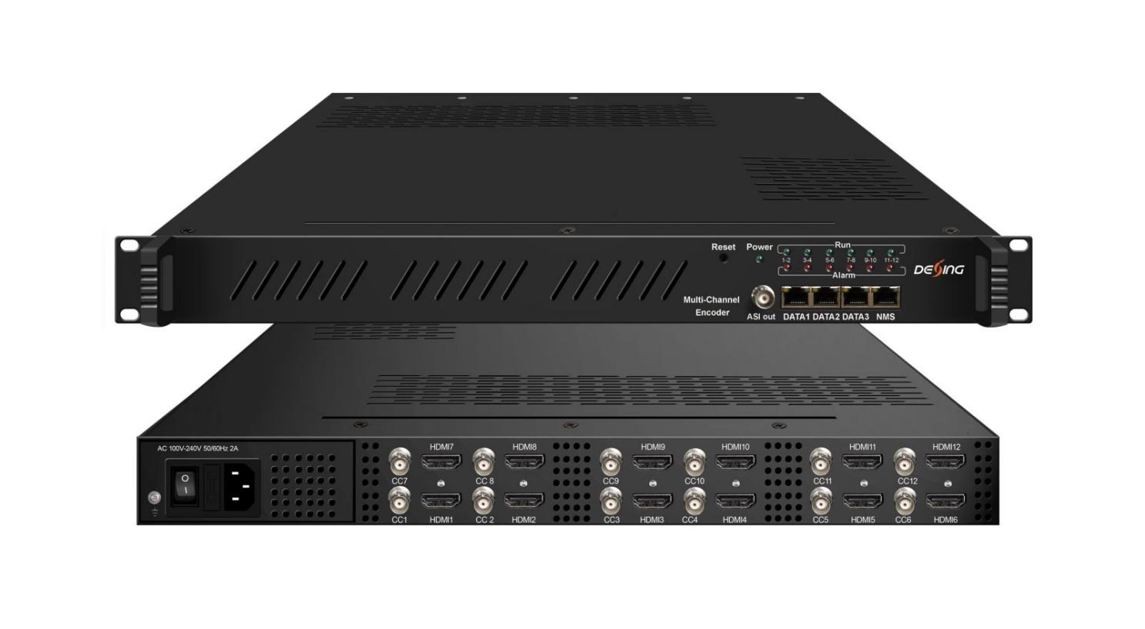Product Overview
The FMUSER FUQ-4655R is a multi-channel encoder with 12 HDMI inputs, 12 CC inputs, and 32 IP inputs via UDP/RTP. It encodes video using MPEG-2 and MPEG-4 AVC/H.264 standards, and supports audio formats including MPEG1 Layer II and Dolby Digital AC3. Ideal for CATV, satellite, and terrestrial TV broadcasting systems.
Key feature
Supports 12 HDMI inputs with MPEG-2 and MPEG-4 AVC/H.264 encoding for HD video up to 1080p-60.
Includes 12 dedicated CC input ports for closed captioning support.
Offers flexible audio encoding with MPEG1 Layer II, MPEG2-AAC, MPEG4-AAC, and optional Dolby Digital AC3.
Enables IP streaming with 32 inputs/outputs via UDP/RTP, supporting 1 MPTS and 12 SPTS streams.
Principle Chart
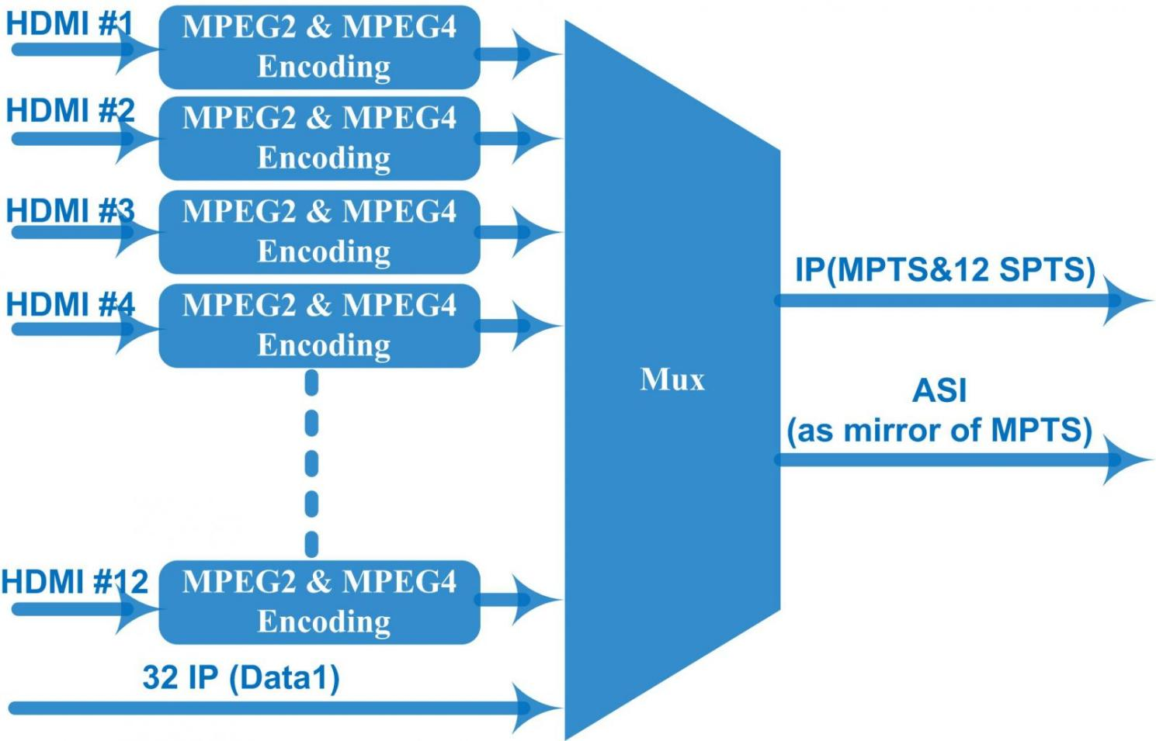

Technical specification
Input | 12 HDMI inputs  12 CC (closed caption) input, BNC interface  32 IP input over UDP and RTP through DATA 1 port
Video | Resolution | Input |  | 1920*1080_60p, 1920*1080_50p,1920*1080_60i, 1920*1080_50i, 1280*720_60p, 1280*720_50P,  720*480_60i, 720*576_50i
Video | Resolution | Output |  | 1920*1080_60p,1920*1080_50p,1920*1080_60i, 1920*1080_50i,1440*1080_60i, 1440*1080_50i,  1280*720_60p,1280*720_50P, 720*576_50p,  720*576_50i, 720*576_30p, 720*576_25p,  720*480_60p, 720*480_60i,720*480_30p, 720*480_25p,320*240_60p,320*240_50p,  320*240_30p, 320*240_25p,320*180_60p, 320*180_50p, 320*180_30p, 320*180_25p, 960*540_50i, 704*576_50i,704*480_60i, 640*576_50i  640*480_60i, 544*576_50i,544*480_60i,
Video | Encoding | MPEG2 & MPEG4 AVC/H.264
Video | Bit-rate | 0.8~19Mbps for H.264 encoding  1~19Mbps for MPEG-2 encoding
Video | Rate Control | CBR/VBR
Video | GOP Structure | GOP B Frame: 0-3, GOP P Frame: 0-6
Video | Advanced Pretreatment | De-interlacing, noise reduction
Audio | Encoding | MPEG1 Layer II, MPEG2-AAC, MPEG4-AAC,  Dolby Digital AC3 (2.0) encoding (Optional),  AC3 (2.0/5.1) passthrough
Audio | Sampling rate | 48KHz
Audio | Resolution | 24-bit
Audio | Bit-rate | 64Kbps-320kbps each channel
Multiplexing | Maximum PID  Remapping | 180 input per channel
Multiplexing | Function | PID remapping ( automatically or manually)
Multiplexing | Function | Accurate PCR adjusting
Multiplexing | Function | Generate PSI/ SI table automatically
Stream output | 1 MPTS and 12 SPTS IP output over UDP and RTP/RTSP, 2*1000M Base-T Ethernet interface, Data 1 and Data 2  1 ASI output as mirror of MPTS-Optional
System function | Network management (WEB)
System function | Ethernet software upgrade
Miscellaneous | Dimension (W×L×H) |  | 482mm×440mm×44mm
Miscellaneous | Environment |  | 0~45℃(work)；-20~80℃（Storage）
Miscellaneous | Power requirements |  | AC 110V± 10%, 50/60Hz, AC 220 ± 10%, 50/60Hz

Technical Comparison
 | FU-4655K | FU-4655KF | FU-4653L
Chipset | Vixs | Fujitsu | Hisilicon
Video Channel | 2/4/6/8/10/12×HDMI optional | 4/8/12/16/20/24×HDMI optional | 4/8/12/16/20/24×HDMI optional
Video Encode | MPEG2 & MPEG4 AVC/H.264 | MPEG-4 AVC/H.264 | MPEG-4 AVC/H.264
CC Input | 12 CC input ports | N/A | N/A
IP Input | 32 ×IP | 32× IP | N/A
Video Bit Rate | 0.8~19Mbps for H.264 encoding  1~19Mbps for MPEG-2 encoding | 0.8~19Mbps each channel | 1Mbps~13Mbps each channel  (Bit rate is with a high fluctuation, suitable for cable system, not suitable for satellite uplink)
GOP | GOP B Frame: 0-3, GOP P Frame: 0-6 | IBBP | GOP Size=25 (without B Frame)
Resolution | Up to 1080p-60  (Resolution and frame rate downscale convertion) | Up to 1080p-60  (1080i/720p to 576p/480p downscale conversion) | Up to 1080P-30  (1080i/p-60/50 to 1080p-30/25 auto downscale convertion)
Audio Encode | MPEG1 Layer II, MPEG2-AAC, MPEG4-AAC,  Dolby Digital AC3 (2.0) encoding (Optional),  AC3 pass through | MPEG1 Layer II,  (MPEG-2 AAC, MPEG-4 AAC Optional) AC3 pass through | MPEG-1 Layer II
Audio Gain | Yes | Yes | Yes
OSD Function | N/A | N/A | Yes
ASI output | Option as required | Option as required | Option as required
IP output | SPTS and 1MPTS | SPTS and 1MPTS | SPTS and 1MPTS(for 4/8/12 channel) SPTS or 1MPTS(for 16/20/24 channel)

About Us
FMUSER is a company specializing in broadcasting and television transmission systems and integrating hotel IPTV systems. The company was established in 2009 and has served over 180 countries worldwide. More than 20,000 television stations, radio stations, and hotel clients from different.

Contact:Tomleequan Email：sales@fmuser.com whatsapp: +8613922702227

