FMUSER FUQ-46610F IP Gateway 16 Tuner Inputs 2 ASI Inputs DVB-S-S2-S2X DVB-C-T ATSC ISDB-T to 512 SPTS 16 MPTS IP Outputs BISS Descrambling Web Management Broadcast Headend 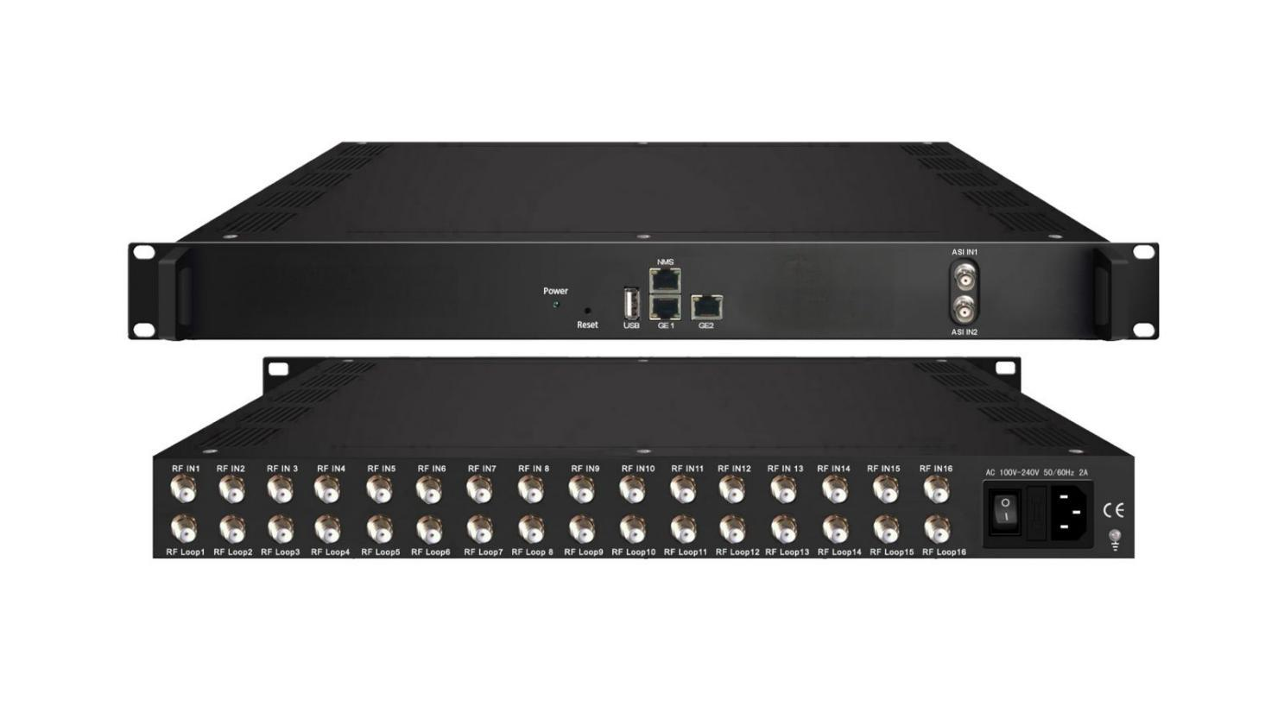

Product overview
The FUQ-46610F is a professional IP gateway converting 16 tuner inputs (supporting DVB-S/S2/S2X, DVB-C/T, ATSC, or ISDB-T) or 2 ASI feeds into IP streams. It processes signals into 512 SPTS (PID-filtered) or 16 MPTS (Null PKT filtered) outputs via dual Gigabit Ethernet ports with BISS descrambling. The 1RU rack-mount unit features web-based control and DiSEqC switching. Ideal for broadcast headend digitization, IPTV distribution, and multi-standard signal aggregation in terrestrial/satellite systems.
Key feature
Web-based management for remote signal monitoring and control
Working Principle

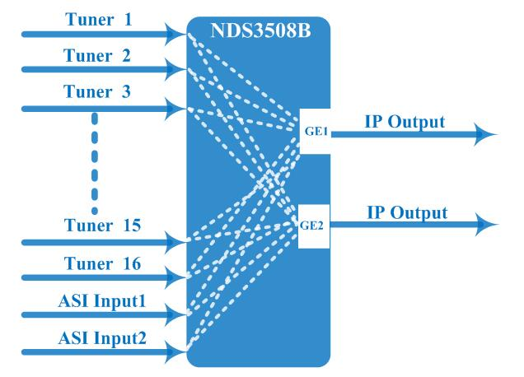

Specifications
Input |  | Optional 1:16 tuners input +2 ASI input---SPTS output  Optional 2:14 tuners input +2 ASI input --- MPTS output  Optional 3:16 tuners input --- MPTS output
Tuner Section | Multi-mode tuners switchable  (New Type) | DVB-C | Frequency In |  | 60~890MHz
Tuner Section | Multi-mode tuners switchable  (New Type) | DVB-C | Standard |  | J.83A(DVB-C), J.83B, J.83C
Tuner Section | Multi-mode tuners switchable  (New Type) | DVB-C | Constellation |  | 16/32/64/128/256 QAM
Tuner Section | Multi-mode tuners switchable  (New Type) | DVB-T/(T) | Frequency In |  | 60~890MHz
Tuner Section | Multi-mode tuners switchable  (New Type) | DVB-T/(T) | Bandwidth |  | 6/7/8 M bandwidth
Tuner Section | Multi-mode tuners switchable  (New Type) | ISDB-T | Frequency In |  | 60~890MHz
Tuner Section | Version 1 | DVB-S | Frequency In |  | 950-2150MHz
Tuner Section | Version 1 | DVB-S | Symbol rate |  | 1~45 Msps
Tuner Section | Version 1 | DVB-S | FEC |  | 1/2, 2/3, 3/4, 5/6, 7/8
Tuner Section | Version 1 | DVB-S | Constellation |  | QPSK
Tuner Section | Version 1 | DVB-S2 | Frequency In |  | 950-2150MHz
Tuner Section | Version 1 | DVB-S2 | Symbol rate |  | 1~45 Msps
Tuner Section | Version 1 | DVB-S2 | FEC |  | 1/2, 3/5, 2/3, 3/4, 4/5, 5/6, 8/9, 9/10
Tuner Section | Version 1 | DVB-S2 | Constellation |  | QPSK, 8PSK
Tuner Section | Version 2  (New Type) | DVB-S | Frequency In |  | 950~2150MHz
Tuner Section | Version 2  (New Type) | DVB-S | Symbol rate |  | 0.5~45Msps
Tuner Section | Version 2  (New Type) | DVB-S | Signal Strength |  | - 65- -25dBm
Tuner Section | Version 2  (New Type) | DVB-S | FEC |  | 1/2, 2/3, 3/4, 5/6, 7/8
Tuner Section | Version 2  (New Type) | DVB-S | Constellation |  | QPSK
Tuner Section | Version 2  (New Type) | DVB-S | Max input bitrate |  | ≤125 Mbps
Tuner Section | Version 2  (New Type) | DVB-S2 | Frequency In |  | 950~2150MHz
Tuner Section | Version 2  (New Type) | DVB-S2 | Symbol rate |  | QPSK/8PSK /16APSK :0.5~45 Msps  32APSK: 0.5~34Msps;
Tuner Section | Version 2  (New Type) | DVB-S2 | FEC |  | QPSK: 1/2, 3/5, 2/3, 3/4, 4/5, 5/6, 8/9, 9/10  8PSK: 3/5, 2/3, 3/4, 5/6, 8/9, 9/10  16APSK: 2/3, 3/4, 4/5, 5/6, 8/9, 9/10  32APSK: 3/4, 4/5, 5/6, 8/9, 9/10
Tuner Section | Version 2  (New Type) | DVB-S2 | Constellation |  | QPSK, 8PSK, 16APSK, 32APSK
Tuner Section | Version 2  (New Type) | DVB-S2 | Max input bitrate |  | ≤125 Mbps
Tuner Section | Version 2  (New Type) | DVB-S2X | Frequency In |  | 950~2150MHz
Tuner Section | Version 2  (New Type) | DVB-S2X | Symbol rate |  | QPSK/8PSK /16APSK :0.5~45 Msps  8APSK: 0.5~40Msps  32APSK: 0.5~34Msps
Tuner Section | Version 2  (New Type) | DVB-S2X | FEC |  | QPSK: 1/2, 3/5, 2/3, 3/4, 4/5, 5/6, 8/9, 9/10, 13/45, 9/20, 11/20  8PSK: 3/5, 2/3, 3/4, 5/6, 8/9, 9/10  8APSK: 5/9-L, 26/45-L  16APSK: 2/3, 3/4, 4/5, 5/6, 8/9, 9/10, 1/2-L, 8/15-L, 5/9-L, 26/45, 3/5, 3/5-L, 28/45, 23/36 , 2/3-L, 25/36, 13/18, 7/9, 77/90  32APSK: 3/4, 4/5, 5/6, 8/9, 9/10, 2/3-L, 32/45, 11/15, 7/9
Tuner Section | Version 2  (New Type) | DVB-S2X | Constellation |  | QPSK, 8PSK, 8APSK, 16APSK, 32APSK
Tuner Section | Version 2  (New Type) | DVB-S2X | Max input bitrate |  | ≤125 Mbps
Tuner Section |  | ATSC | Frequency In |  | 54~858MHz
Tuner Section |  | ATSC | Bandwidth |  | 6M bandwidth
Tuner Section |  | ATSC | Constellation |  | 8VSB
BISS Descrambling |  | Mode 1, Mode E (Up to 850Mbps) (descramble individual program)
Output |  | 512 SPTS IP mirrored output over UDP and RTP/RTSP protocol through GE1 and GE2 port (IP address and port number of GE1 and GE2 are different) , Unicast and Multicast
 |  | 16 MPTS IP output (for Tuner/ASI passthrough) over UDP and RTP/RTSP protocol through GE1 and GE2 port, Unicast and Multicast
System |  | Web based management
 |  | Ethernet software upgrade
Miscellaneous |  | Dimension |  | 482mm×410mm×44mm (W×L×H)
 |  | Approx weight |  | 3.6kg
 |  | Environment |  | 0~45℃(work)；-20~80℃（Storage）
 |  | Power requirements |  | 100~240VAC, 50/60Hz
 |  | Power consumption |  | 20W

Tuner Input Options:
- 8 DVB-C Tuners + 8 ATSC Tuners
- 8 DVB-C Tuners + 8 DVB-T/(T) Tuners
- 8 DVB-S2/S2X Tuners + 8 DVB-T/(T) Tuners
- 8 DVB-S2/S2X Tuners + 8 ISDB-T Tuners
- 16 DVB-S/S2/S2X/DVB-C/T/(T) /ISDB-T/ATSC Tuners

About Us
FMUSER is a company specializing in broadcasting and television transmission systems and integrating hotel IPTV systems. The company was established in 2009 and has served over 180 countries worldwide. More than 20,000 television stations, radio stations, and hotel clients from different.

Contact:Tomleequan Email：sales@fmuser.com whatsapp: +8613922702227

