FMUSER FUQ-46610K TV Processor 6-Channel Analog-Digital Input DVB-C-T-ATSC-ISDB-T Output Web-Managed RF Headend System 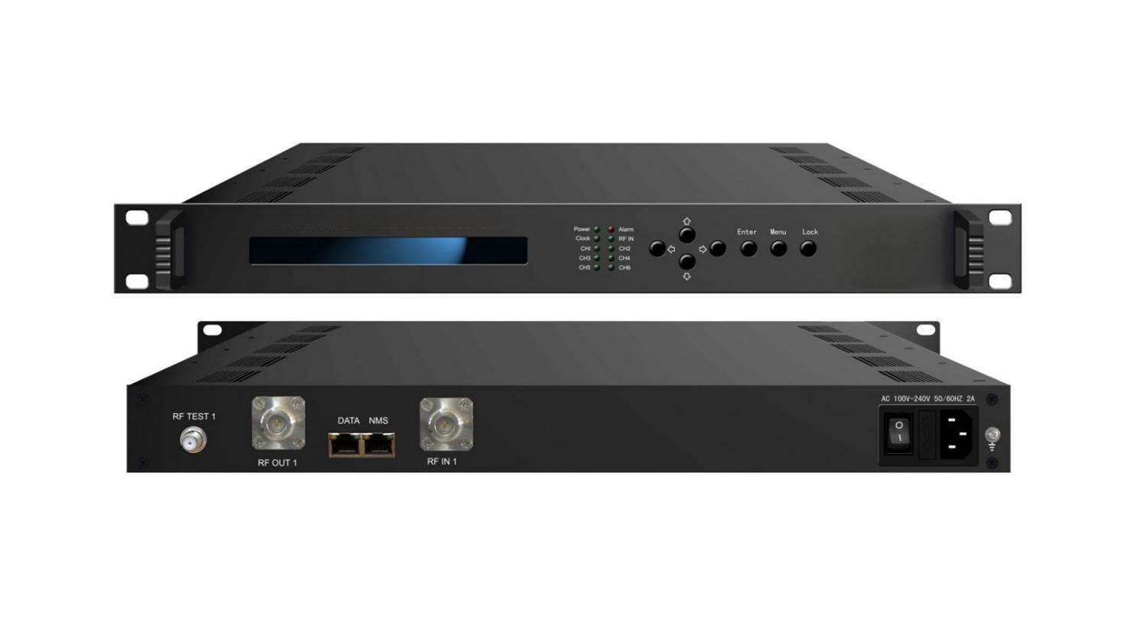Application Sample
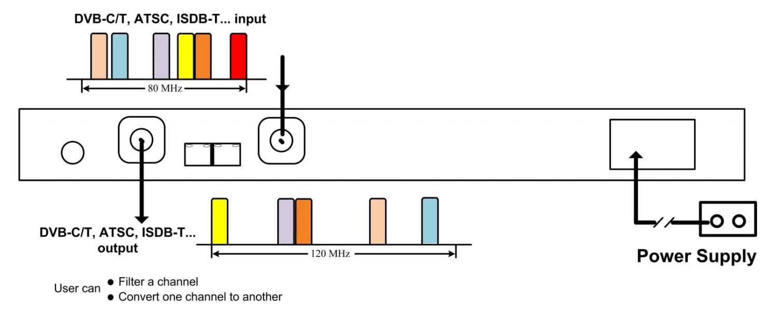

Product overview
The FMUSER FUQ-46610K processes 6 channels of analog/digital signals via 470-860MHz RF input and delivers 48-960MHz RF output. It converts between DVB-C/T, ATSC, and ISDB-T standards with configurable 6M/8M bandwidth. This 1RU rack-mount unit features WEB-based management for remote control and firmware updates. Ideal for cable headend modernization and multi-standard broadcast systems requiring flexible signal conversion.
Key feature
Web interface for remote management and system upgrades
Technical Specifications

Input | 1*RF IN with up to 6 frequencies
Input | RF range: 470-860MHz, 80M bandwidth for start-end channel
Output | 1*RF OUT with up to 6 frequencies - N Type, 50Ω  1* RF TEST - F Type
Output | RF range | 48~960MHz, 1KHz step, 110M bandwidth for start-end channel
Output | RF ATT | -25~-2 dBm, 0.5dBm step
Output | Shoulder level | ≥57dB (for single channel), ≥54dB (for 6 channels)
Output | Image rejection | >70dB
Output | Spurious in band | <-55dBc
Standard | 6M/8M channel bandwidth, DVB-C/T, ATSC, ISDB-T, PAL, NTSC, etc
System | WEB-server manage
System | WEB system upgrade
General | Dimensions (W*L*H) |  | 482mm×410mm×44mm
General | Weight |  | 4 kg
General | Temperature |  | 0~45℃(Running), -20~80℃(Storage)
General | Power Supply |  | AC 220V±10%,50/60Hz
General | Consumption |  | 27W

Performance Reference

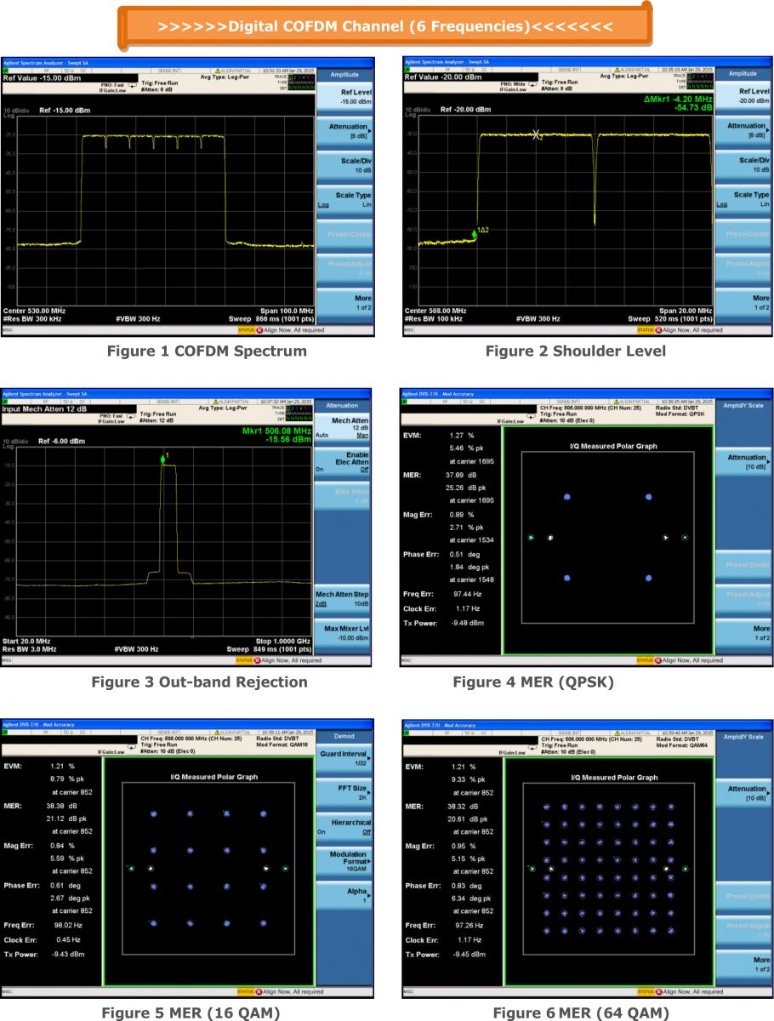

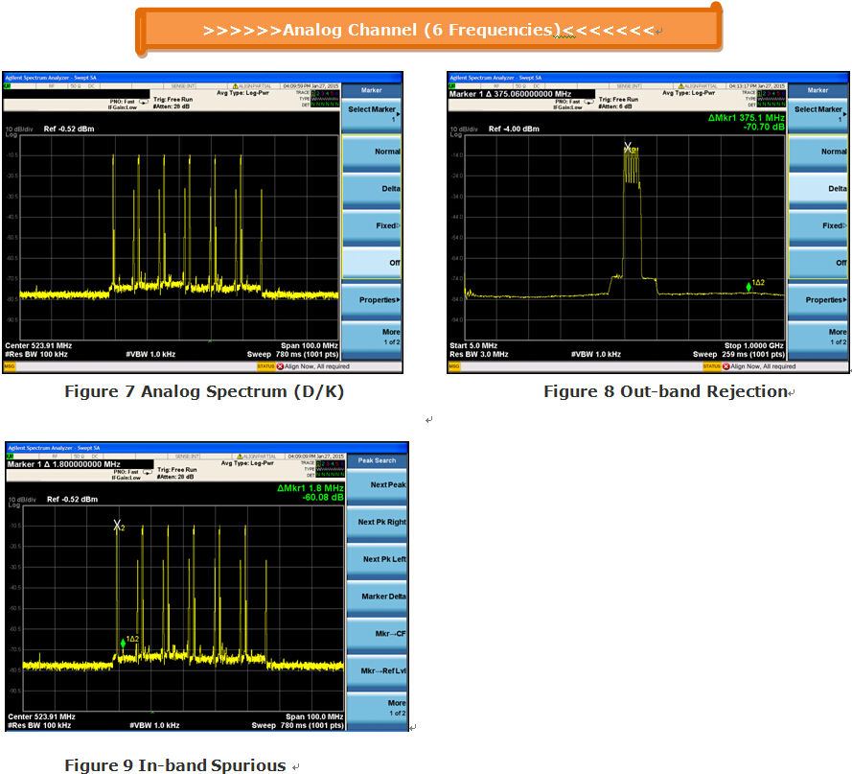

About Us
FMUSER is a company specializing in broadcasting and television transmission systems and integrating hotel IPTV systems. The company was established in 2009 and has served over 180 countries worldwide. More than 20,000 television stations, radio stations, and hotel clients from different.

Contact:Tomleequan Email：sales@fmuser.com whatsapp: +8613922702227

