FMUSER FUQ-4665 HD-SD Encoder Modulator 4 Input Channels HDMI-YPbPr-CVBS to DVB-T-C-ATSC RF MPEG-2 MPEG-4 AVC H.264 Encoding USB Record Playback Broadcast Headend
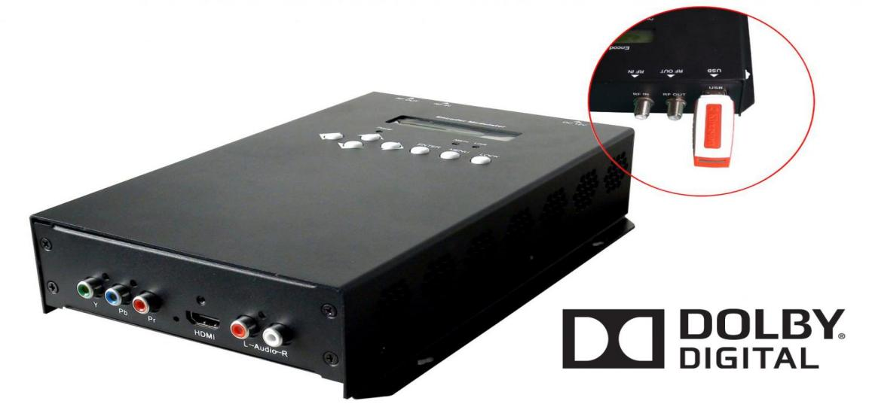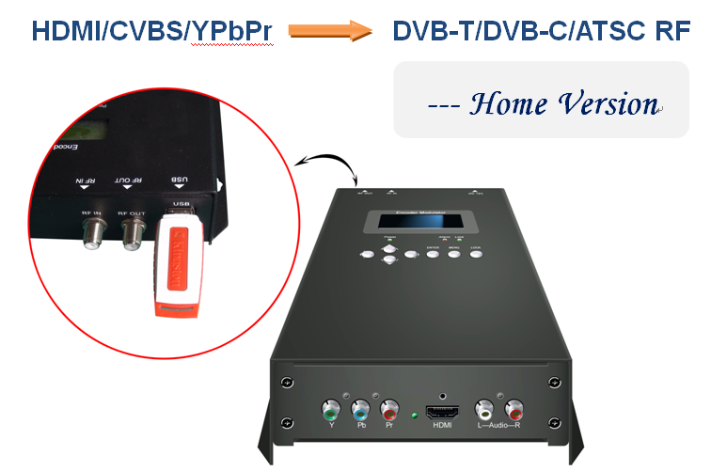
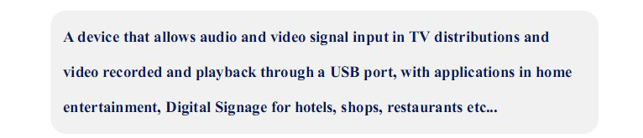

Product Overview
The FUQ-4665 performs MPEG-2/MPEG-4 AVC encoding and DVB-T/C/ATSC modulation with HDMI/YPbPr/CVBS inputs. It processes HD/SD signals into digital RF output (30-960MHz) with USB record/playback capability. This 1RU rack-mount unit supports NMS control via Ethernet. Ideal for digital terrestrial broadcasting and multi-screen headend systems requiring low-latency conversion.

Key feature
Dolby Digital AC3 2.0 audio pass-through via HDMI input

Principle Chart
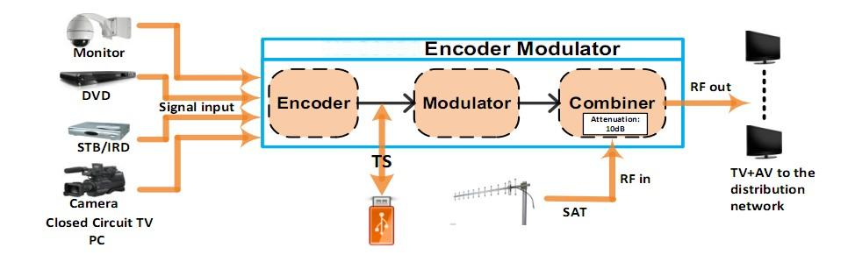

Technical Specifications

Encoding Section
HDMI | Video | Encoding | MPEG-2, MPEG-4 AVC/H.264
HDMI | Video | Interface | HDMI*1
HDMI | Video | Resolution | 1920*1080_60P,1920*1080_50P à (for MPEG-4 AVC/H.264 only)  1920*1080_60i, 1920*1080_50i;  1280*720_60p, 1280*720_50P
HDMI | Video | Bit rate | 0.500~19.500 Mbps
HDMI | Audio | Encoding | MPEG1 Layer II, MPEG2-AAC, MPEG4-AAC;  DD AC3 2.0 (Optional)  AC3 Passthrough
HDMI | Audio | Interface | HDMI
HDMI | Audio | Sample rate | 48KHz
HDMI | Audio | Bit rate | 64, 96,128, 192, 256, 320, 384kbps
YPbPr/  CVBS | Video | Encoding | MPEG-2, MPEG-4 AVC/H.264
YPbPr/  CVBS | Video | Interface | CVBS *1, YPbPr*1
YPbPr/  CVBS | Video | Resolution | CVBS: 720x576_50i (PAL);  720x480_60i (NTSC)  YPbPr: 1920*1080_60i, 1920*1080_50i;  1280*720_60p, 1280*720_50P
YPbPr/  CVBS | Video | Bit rate | 0.500~19.500 Mbps
YPbPr/  CVBS | Audio | Encoding | MPEG1 Layer II, MPEG2-AAC, MPEG4-AAC;  DD AC3 2.0 (Optional)
YPbPr/  CVBS | Audio | Interface | 1 Stereo /2 mono
YPbPr/  CVBS | Audio | Sample rate | 48KHz
YPbPr/  CVBS | Audio | Bit rate | 64, 96,128, 192, 256, 320, 384kbps

DVB-T Modulator Section
Standard |  |  | DVB-T COFDM
Bandwidth |  |  | 6M, 7M, 8M
Constellation |  |  | QPSK, 16QAM, 64QAM,
Code rate |  |  | 1/2, 2/3, 3/4, 5/6, 7/8.
Guard Interval |  |  | 1/32, 1/16, 1/8, 1/4
Transmission Mode: |  |  | 2K, 8K
MER |  |  | ≥42dB
RF frequency |  |  | 30~960MHz, 1KHz step
RF output level |  |  | -16~ -36 dBm (71~91 dbµV), 0.1db step
DVB-C Modulator Section (Option)
Standard | J.83A (DVB-C) |  |  |  | J.83B | J.83C
Constellation | 16/32/64/128 /256 QAM |  |  |  | 64/ 256 QAM | 64/ 256 QAM
Bandwidth | 8M |  |  |  | 6M | 6M
MER | ≥43dB
RF frequency | 30~960MHz, 1KHz step
RF level | -16~ -36dbm(71~91 dbµV), 0.1db step
Symbol rate | 5000-9000 Ksps
ATSC Modulator Section (Option)
Standard |  | ATSC A/53
MER |  | ≥42dB
RF frequency |  | 30~960MHz, 1KHz step
RF output level |  | -16~ -36 dBm (71~91 dbµV), 0.1db step
Constellation |  | 8VSB
System
Management |  |  |  | Local control: LCD + control buttons
Language |  |  |  | English
LCN Insertion |  |  |  | yes
General
Power supply |  |  |  | DC 12V
Dimensions |  |  |  | 144*238*52mm
Weight |  |  |  | Approx 1kg
Operation temperature |  |  |  | 0~45℃

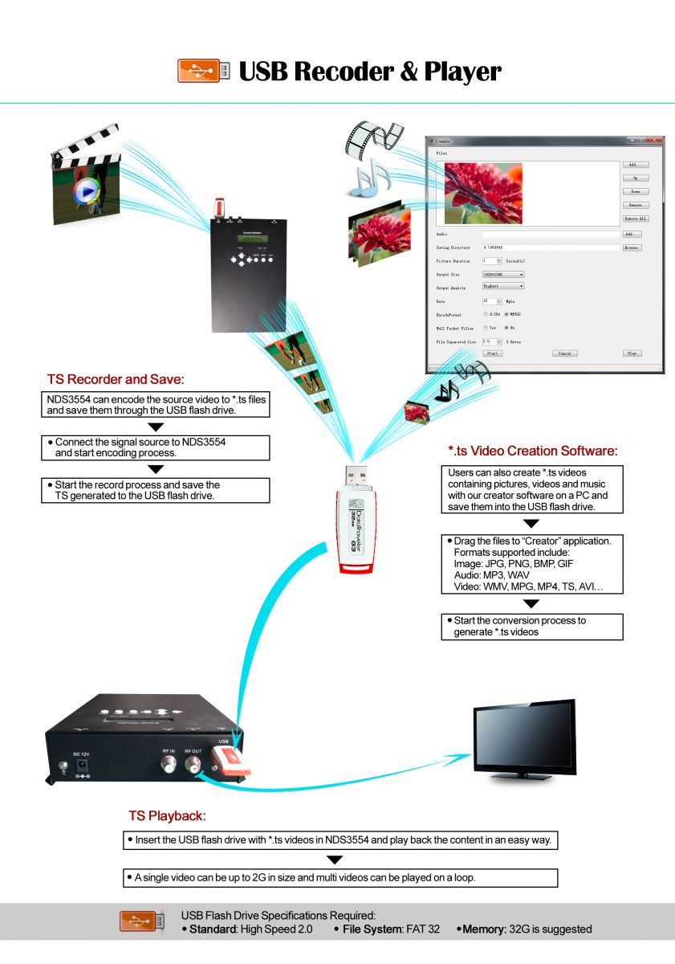

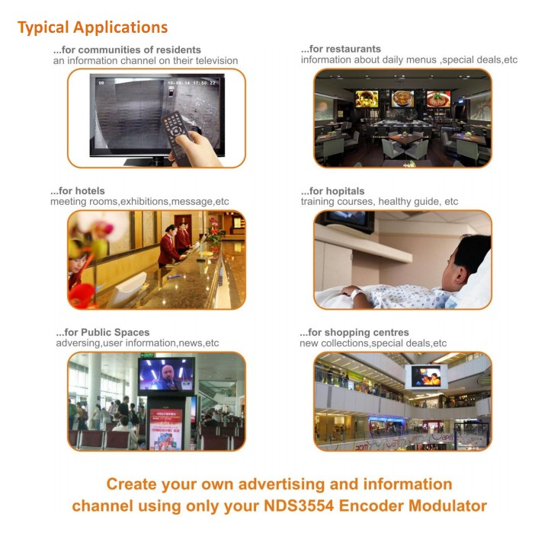

Technical Compare

Main Features | FMUSER FU-4665/FU-4667 | Competing Products
Encode | l MPEG2 HD/SD; MPEG4 HD/SD | l MPEG2 SD
Record TS to USB memory | l Yes (FU-4665&FU-4667) | l No
*.ts files play-mode | l Both Multi/Single files loop  l Support HD&SD video play | l Single file loop  l Support only SD video play
TS Creator.exe | l HD video to HD video transform  l Null Packet Filter, effect bitrate up to 90%  l Support output video size, rate, and format control | l HD video to SD video downscale  l No Null Packet Filter, effect bit rate only around 50%
Single video length | l 2-3 Hours HD/SD | l 40 Minutes SD
Low Delay | l Supported | l Not supported
DD AC3 (2.0) audio encode | l Supported | l Not supported

Internal Test Report of Latency

The values cover the progress from Encoding to Decoding

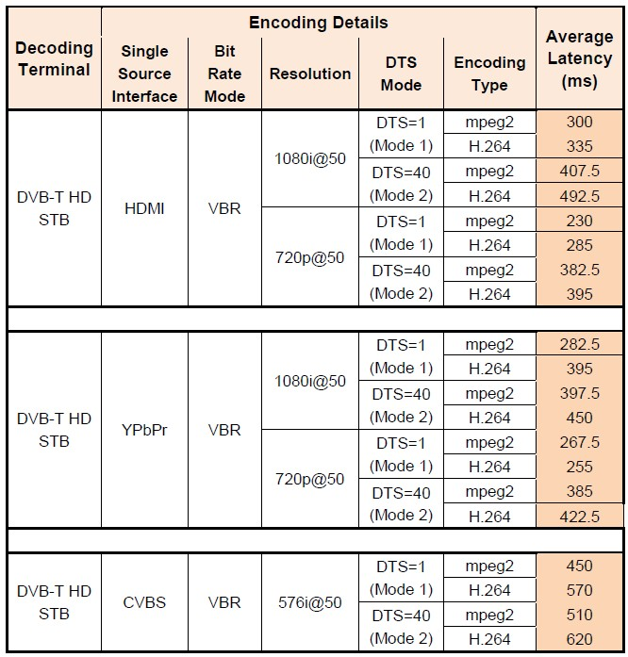

About Us
FMUSER is a company specializing in broadcasting and television transmission systems and integrating hotel IPTV systems. The company was established in 2009 and has served over 180 countries worldwide. More than 20,000 television stations, radio stations, and hotel clients from different.

Contact:Tomleequan Email：sales@fmuser.com whatsapp: +8613922702227

