FMUSER FUQ-4667 Encoder Modulator 1 In 1 Out HDMI-DVB-C DVB-T ISDB-T ATSC Multi-Standard H.265-H.264 4K Encoding Modulation Streaming for Broadcast Hospitality
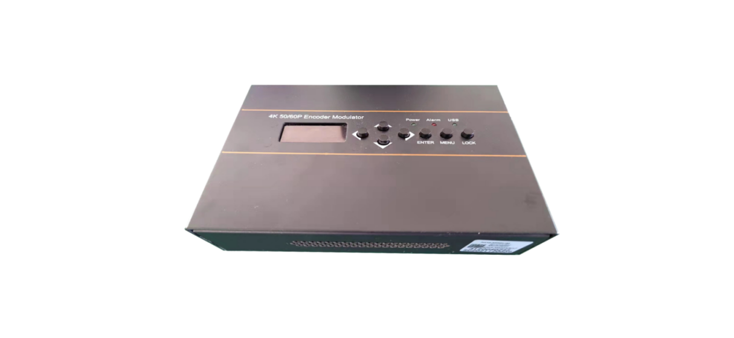New Comer! 
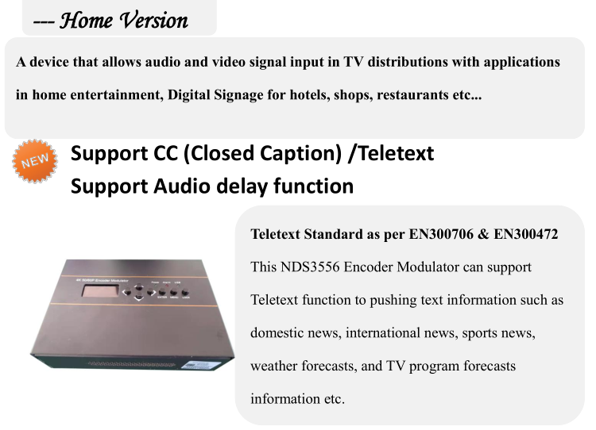
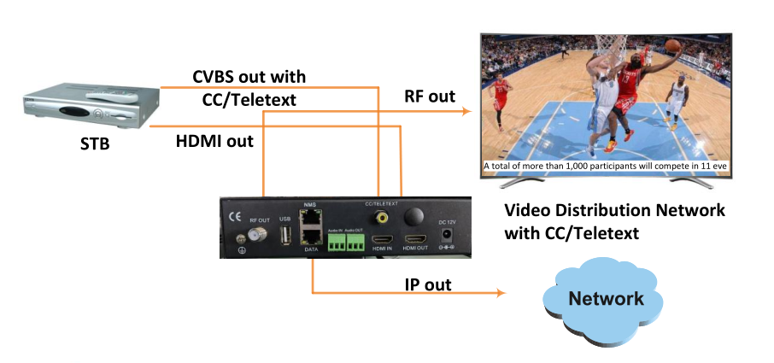
Product overview
The FMUSER FUQ-4667 encoder modulator converts HDMI inputs into DVB-C, DVB-T, ISDB-T, or ATSC RF outputs or IP streams using H.265 or H.264 encoding. It processes signals for 4K resolution with modulation to broadcast standards. This unit features an LCD screen for control, USB port for TS recording, and OSD insertion. Ideal for TV distribution, digital signage, and IP video applications.
Key feature
Includes Management Tools such as OSD insertion, TS recording via USB, and LCD screen control.
System Connection
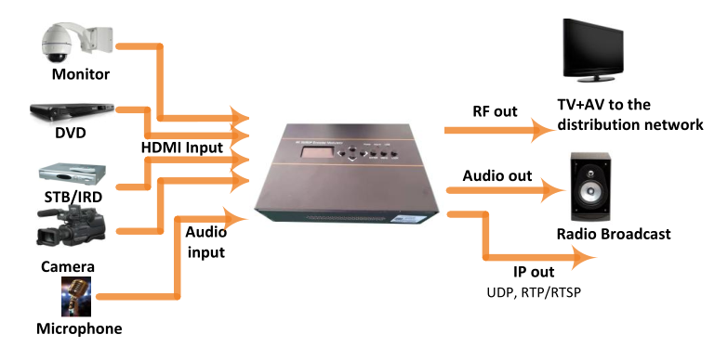

Appearance and Description
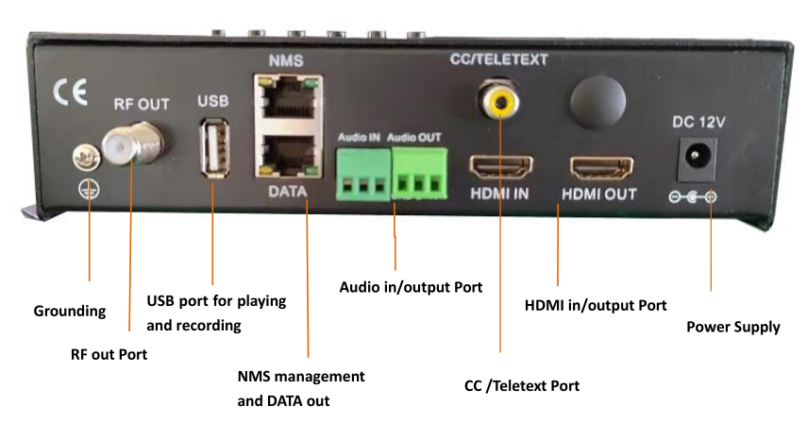

Technical Specifications

HDMI Encoding Section
Video | Encoding | HEVC/ H.265 , MPEG 4 AVC/H.264
Video | Interface | HDMI*1. HDMI loop out*1
Video | Resolution | 3840*2160_60/50P(H.265 only),  1920*1080_60/59.94/50P,  1280*720_60/59.94/50P,
Video | Chroma | Input:4:4:4/4:2:2; output:4:2:0
Video | Bitrate | 2Mbps~20Mbps
Video | Rate Control | CBR/VBR
Video | GOP Structure | IBBP, IPPP
Audio | Encoding Format | MPEG-1 Layer 2,  LC-AAC, HE-AAC, HE-AAC V2;  AC3 Pass-through
Audio | Sample rate | 32KHz,44.1KHz,48KHz
Audio | Bit-rate | 48Kbps~384Kbps (MPEG-1 Layer 2 & LC-AAC)  24 Kbps~128 Kbps (HE-AAC)  18 Kbps~56 Kbps (HE-AAC V2)

IP output
IP out over UDP (Unicast/multicast), RTP/RTSP, (RJ45, 100M/1000M self-adaptive)
DVB-C Modulator Section
Standard |  |  | J.83A (DVB-C), J.83B
MER |  |  | ≥40dB
RF frequency |  |  | 100-1000MHz, 1KHz step
RF output level |  |  | -20~ -5dBm, 1dB step
Symbol rate |  |  | 5.000~7.000Msps adjustable
 | J.83A |  |  | J.83B
Constellation | 16/32/64/128/ 256 QAM |  |  | 64/ 256 QAM
Bandwidth | 8M |  |  | 6M
DVB-T Modulator Section
Standard |  | DVB-T COFDM
Bandwidth |  | 6M, 7M, 8M
Constellation |  | QPSK, 16QAM, 64QAM
Code rate |  | 1/2, 2/3, 3/4, 5/6, 7/8
Guard Interval |  | 1/32, 1/16, 1/8, 1/4
Transmission Mode: |  | 2K, 8K
MER |  | ≥35dB
RF frequency |  | 100-900MHz, 1KHz step
RF output level |  | -63~ -16dBm, 1dB step
ISDB-T Modulator Section
Standard |  | ARIB STD-B31
Constellation |  | QPSK, 16QAM, 64QAM
Guard Interval |  | 1/32, 1/16, 1/8, 1/4
Transmission Mode |  | 2K, 4K, 8K
Code rate |  | 1/2, 2/3, 3/4, 5/6, 7/8
RF frequency |  | 100~900MHz, 1KHz step
RF output level |  | -63~ -16dBm, 1dB step
ATSC Modulator Section
Standard |  | ATSC A/53
Constellation |  | 8 VSB
RF output level |  | -63~-16dBm (44~91 dBµV), 1dB step
MER |  | ≥35dB
RF frequency |  | 100~900MHz, 1KHz step
RF output level |  | -63~ -16dBm, 1dB step
System
Management |  | Web-GUI, LED+Keyboard
Language |  | English
Upgrade |  | Web update
General
Power supply |  | DC 12V
Dimensions |  | 203*144*52mm
Weight |  | < 1kg

About Us
FMUSER is a company specializing in broadcasting and television transmission systems and integrating hotel IPTV systems. The company was established in 2009 and has served over 180 countries worldwide. More than 20,000 television stations, radio stations, and hotel clients from different.

Contact:Tomleequan Email：sales@fmuser.com whatsapp: +8613922702227

