FMUSER FUQ-4667XX 1-Ch HDMI Input Encoder Modulator 1080p60 H.265-H.264 Encoding DVB-C-T ATSC ISDB-T Multi-Standard RF-IP Output for TV Distribution and Digital Signage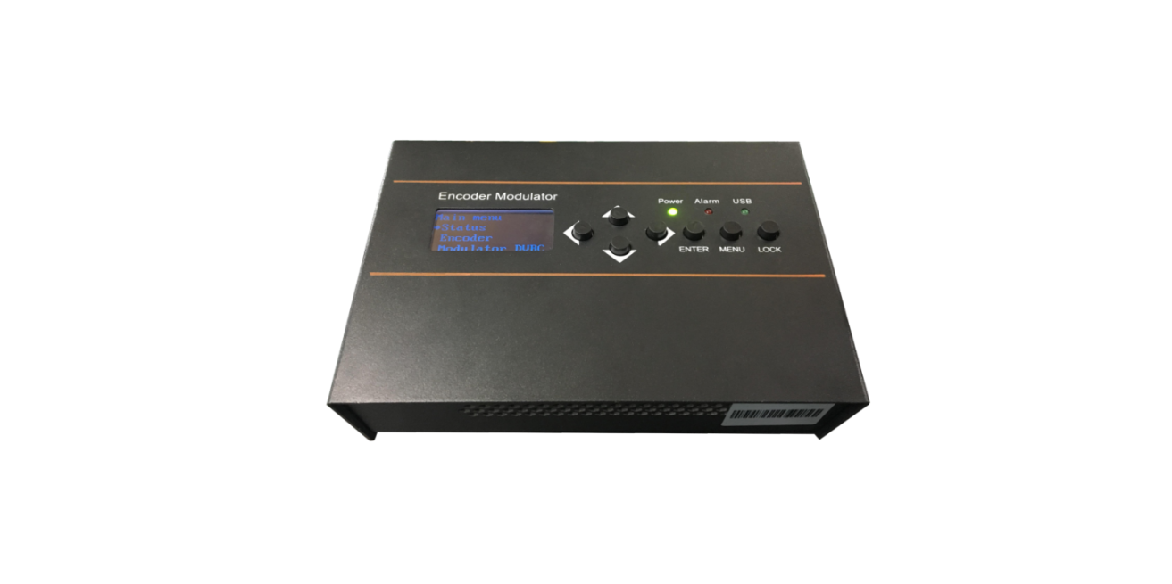
New Comer! 
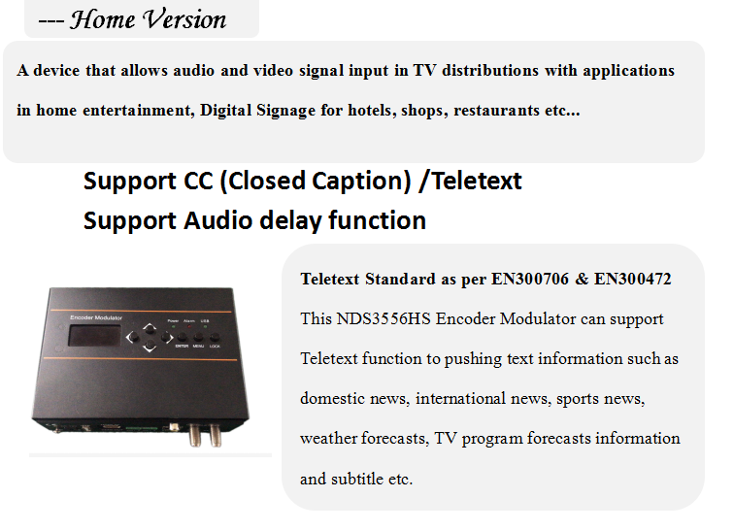

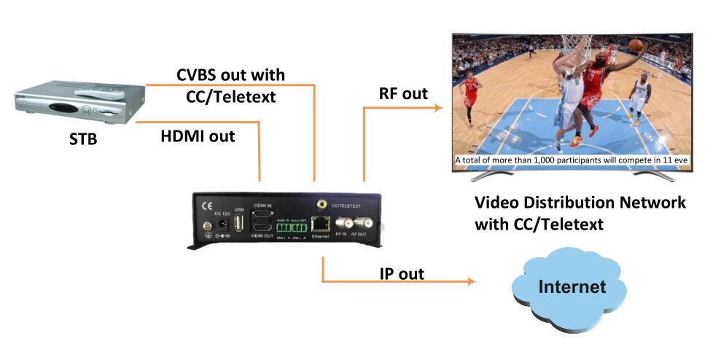
Product overview
The FUQ-4667XX is a professional encoder modulator featuring 1x HDMI input and dual RF/IP outputs. It processes 1080p60 signals via H.265/HEVC or H.264 encoding, then modulates to DVB-C/T, ATSC, or ISDB-T standards. This 1RU rack-mount device supports web-GUI and front-panel control. Ideal for cable TV headends, hospitality TV systems, and digital signage networks requiring multi-format distribution.
Key feature
Remote management via web-GUI with AC3 audio pass-through support
System Connection
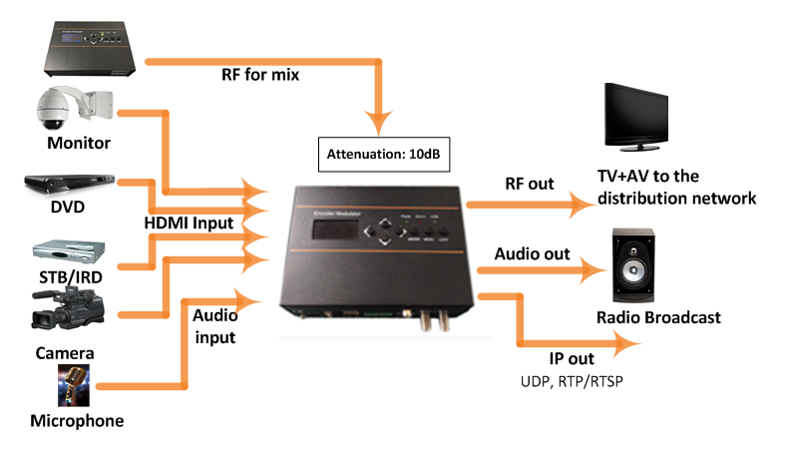

Appearance and Description

Technical Specs

HDMI Encoding Section
Video | Encoding | HEVC/ H.265 , MPEG 4 AVC/H.264
Video | Interface | HDMI*1. HDMI loop out*1
Video | Resolution |  |  | 1920*1080_60P,  1920*1080_50P;  1920*1080_59.94P,  1280*720_60p,  1280*720_59.94  1280*720_50P
Video | Chroma |  | 4:2:0
Video | Bitrate |  | 1Mbps~15Mbps
Video | Rate Control |  | CBR/VBR
Video | GOP Structure |  | IP
Audio | Encoding Format |  | MPEG-1 Layer 2,  LC-AAC, HE-AAC, HE-AAC V2;  AC3 Pass-through
Audio | Sample rate |  | 32KHz,44.1KHz,48KHz
Audio | Bit-rate |  | 48~384Kbps

IP output
IP out over UDP (Unicast/multicast), RTP/RTSP, (RJ45, 100M)
DVB-C Modulator Section
Standard |  |  | J.83A (DVB-C), J.83B
MER |  |  | ≥40dB
RF frequency |  |  | 100-1000MHz, 1KHz step
RF output level |  |  | -20~ -5dBm, 1dB step
Symbol rate |  |  | 5.000~7.000Msps adjustable
 | J.83A |  |  | J.83B
Constellation | 16/32/64/128/ 256 QAM |  |  | 64/ 256 QAM
Bandwidth | 8M |  |  | 6M
DVB-T Modulator Section
Standard |  | DVB-T COFDM
Bandwidth |  | 6M, 7M, 8M
Constellation |  | QPSK, 16QAM, 64QAM
Code rate |  | 1/2, 2/3, 3/4, 5/6, 7/8
Guard Interval |  | 1/32, 1/16, 1/8, 1/4
Transmission Mode: |  | 2K, 8K
MER |  | ≥35dB
RF frequency |  | 100-900MHz, 1KHz step
RF output level |  | -63~ -16dBm, 1dB step
ISDB-T Modulator Section (Optional)
Standard |  | ARIB STD-B31
Constellation |  | QPSK, 16QAM, 64QAM
Guard Interval |  | 1/32, 1/16, 1/8, 1/4
Transmission Mode |  | 2K, 4K, 8K
Code rate |  | 1/2, 2/3, 3/4, 5/6, 7/8
RF frequency |  | 100~900MHz, 1KHz step
RF output level |  | -63~ -16dBm, 1dB step
ATSC Modulator Section (Optional)
Standard |  | ATSC A/53
Constellation |  | 8 VSB
RF output level |  | -63~-16dBm (44~91 dBµV), 1dB step
MER |  | ≥35dB
RF frequency |  | 100~900MHz, 1KHz step
RF output level |  | -63~ -16dBm, 1dB step
System
Management |  | Web-GUI, LED+Keyboard
Language |  | English
Upgrade |  | Web update
General
Power supply |  | DC 12V
Dimensions |  | 160*120*52mm
Weight |  | < 1kg

OSD (Logo/QR Code/Caption) Insertion

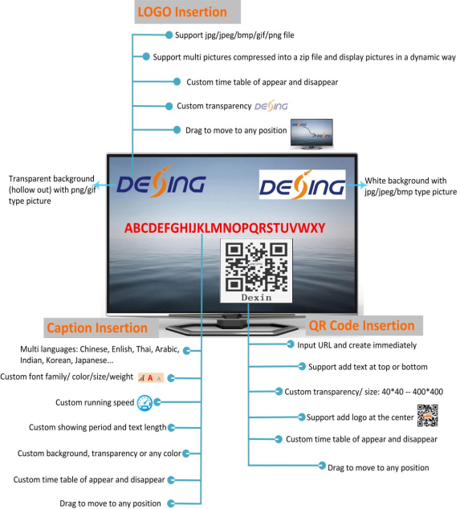

Typical Applications
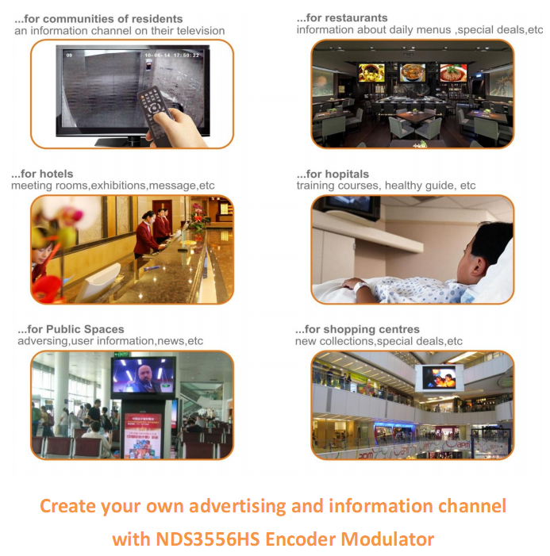

About Us
FMUSER is a company specializing in broadcasting and television transmission systems and integrating hotel IPTV systems. The company was established in 2009 and has served over 180 countries worldwide. More than 20,000 television stations, radio stations, and hotel clients from different.

Contact:Tomleequan Email：sales@fmuser.com whatsapp: +8613922702227

