FMUSER FUQ-467B Series SD IRD Dual RF-ASI-IP Inputs 2 ASI-IP-CVBS Outputs DVB-C DVB-T-T ISDB-T DVB-S-S2-S2X Demodulation Descrambling Decoding Broadcast Reception 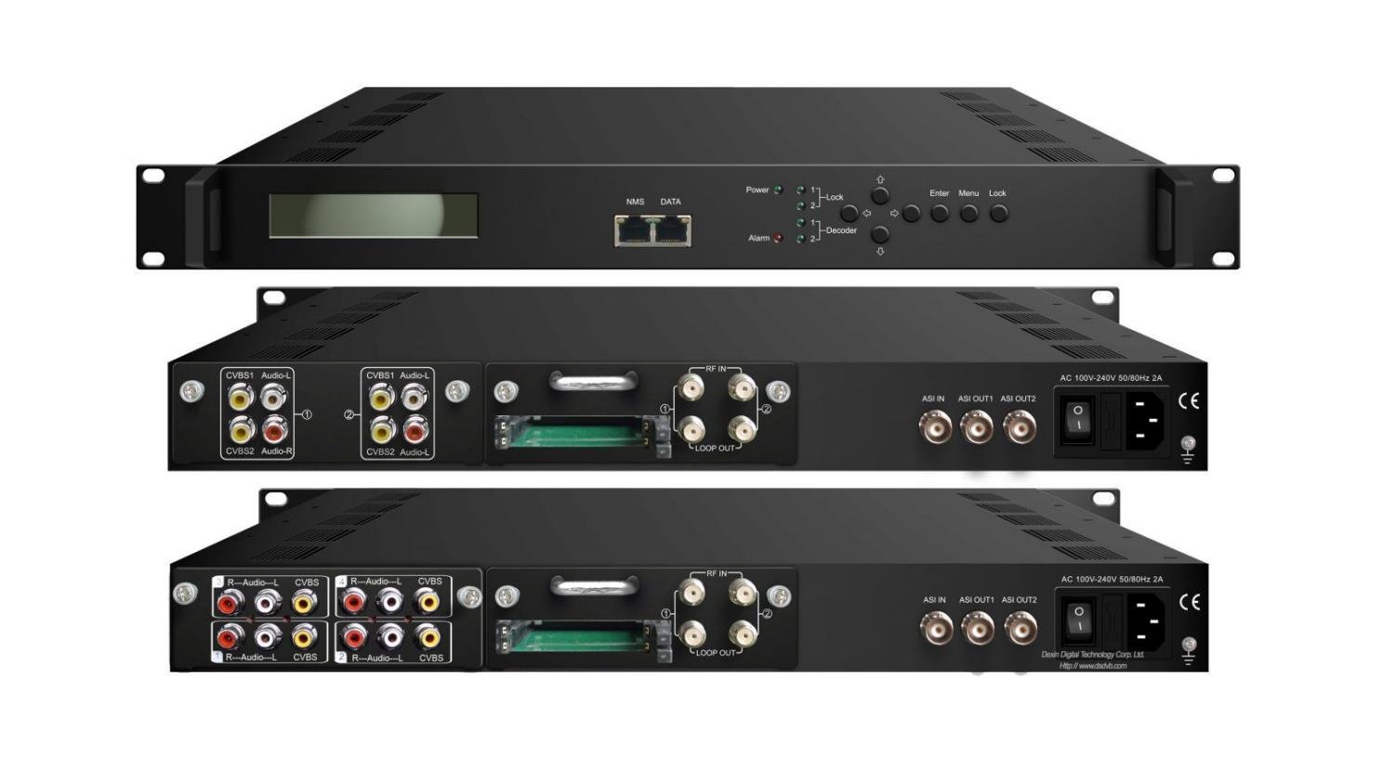Its production is stopped temporarily, and the date for resuming production is not fixed yet.

Demodulation Module = 2*RF/Loop out + 2*CAM + 2*Smartcard

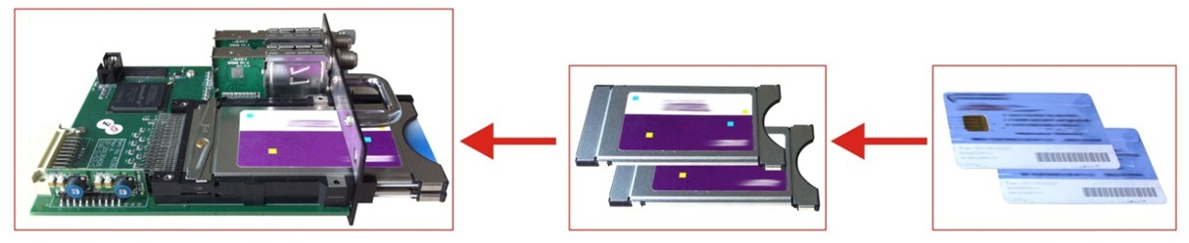

Product overview
The FMUSER FUQ-467Y Series SD IRD integrates demodulation, descrambling, and decoding in a 1U chassis, with dual tuner inputs for RF, ASI, and IP sources. It processes signals by converting RF inputs to CVBS output, supporting standards like DVB-S/S2/S2X. The pluggable module design enables component customization. Ideal for broadcast distribution and television signal transmission.
Key feature
Integrated demodulation, descrambling, and decoding in one unit.
Supports dual tuner inputs with DVB-S/S2/S2X, DVB-C, DVB-T/(T), and ISDB-T.
Features BISS and CAM/CI descrambling for encrypted content.
Pluggable modules for easy replacement of demodulator and decoder components.
Delivers CVBS, ASI, and IP (UDP/RTP/RTSP) outputs.
Principle Chart
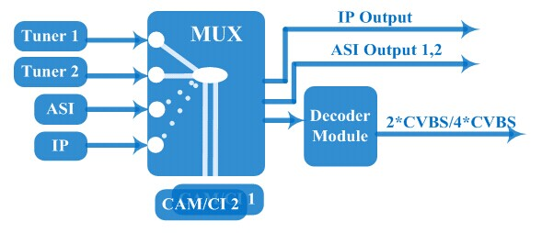
Technical Specifications

Input | 2 *Tuner(DVB-C, T/(T), ISDBT, S/S2/S2X optional), F type  1*ASI input for re-mux, BNC interface  1*IP input for re-mux (UDP)
Tuner Section | Multi-mode tuners switchable  (New) |  | DVB-C | Input Frequency |  | 60 ~890 MHz
Tuner Section |  |  | DVB-C | Standard |  | J.83A, J.83C | J.83B
Tuner Section |  |  | DVB-C | Constellation |  | 16/32/64/128/256 QAM | 64/256 QAM
Tuner Section |  |  | DVB-T/(T) | Input Frequency |  | 60 ~890 MHz
Tuner Section |  |  | DVB-T/(T) | Bandwidth |  | 6/7/8 M
Tuner Section |  |  | ISDB-T | Input Frequency |  | 60 ~890 MHz
Tuner Section | Version 1 |  | DVB-S | Input Frequency |  | 950~2150MHz
Tuner Section |  |  | DVB-S | Symbol rate |  | 1~45 Msps
Tuner Section |  |  | DVB-S | FEC |  | 1/2, 2/3, 3/4, 5/6, 7/8
Tuner Section |  |  | DVB-S | Constellation |  | QPSK
Tuner Section |  |  | DVB-S | Signal Strength |  | - 65~-25dBm
Tuner Section |  |  | DVB-S | Max input bitrate |  | ≤120 Mbps
Tuner Section |  |  | DVB-S2 | Input Frequency |  | 950~2150MHz
Tuner Section |  |  | DVB-S2 | Symbol rate |  | 1~45 Msps
Tuner Section |  |  | DVB-S2 | FEC |  | 1/2, 3/5, 2/3, 3/4, 4/5, 5/6, 8/9, 9/10
Tuner Section |  |  | DVB-S2 | Constellation |  | QPSK, 8PSK
Tuner Section |  |  | DVB-S2 | Max input bitrate |  | ≤120 Mbps
Tuner Section | Version 2  (New) |  | DVB-S | Input Frequency |  | 950~2150MHz
Tuner Section |  |  | DVB-S | Symbol rate |  | 0.5~45Msps
Tuner Section |  |  | DVB-S | Signal Strength |  | - 65- -25dBm
Tuner Section |  |  | DVB-S | FEC |  | 1/2, 2/3, 3/4, 5/6, 7/8
Tuner Section |  |  | DVB-S | Constellation |  | QPSK
Tuner Section |  |  | DVB-S | Max input bitrate |  | ≤160 Mbps
Tuner Section |  |  | DVB-S2 | Input Frequency |  | 950~2150MHz
Tuner Section |  |  | DVB-S2 | Symbol rate |  | QPSK/8PSK /16APSK :0.5~45 Msps  32APSK: 0.5~40Msps;
Tuner Section |  |  | DVB-S2 | FEC |  | QPSK: 1/2, 3/5, 2/3, 3/4, 4/5, 5/6, 8/9, 9/10  8PSK: 3/5, 2/3, 3/4, 5/6, 8/9, 9/10  16APSK: 2/3, 3/4, 4/5, 5/6, 8/9, 9/10  32APSK: 3/4, 4/5, 5/6, 8/9, 9/10
Tuner Section |  |  | DVB-S2 | Constellation |  | QPSK, 8PSK, 16APSK, 32APSK
Tuner Section |  |  | DVB-S2 | Max input bitrate |  | ≤160 Mbps
Tuner Section |  |  | DVB-S2X | Input Frequency |  | 950~2150MHz
Tuner Section |  |  | DVB-S2X | Symbol rate |  | QPSK/8PSK /16APSK :0.5~45 Msps  8APSK: 0.5~40Msps  32APSK: 0.5~40Msps
Tuner Section |  |  | DVB-S2X | FEC |  | QPSK: 1/2, 3/5, 2/3, 3/4, 4/5, 5/6, 8/9, 9/10, 13/45, 9/20, 11/20  8PSK: 3/5, 2/3, 3/4, 5/6, 8/9, 9/10  8APSK: 5/9-L, 26/45-L  16APSK: 2/3, 3/4, 4/5, 5/6, 8/9, 9/10, 1/2-L, 8/15-L, 5/9-L, 26/45, 3/5, 3/5-L, 28/45, 23/36 , 2/3-L, 25/36, 13/18, 7/9, 77/90  32APSK: 3/4, 4/5, 5/6, 8/9, 2/3-L, 32/45, 11/15, 7/9
Tuner Section |  |  | DVB-S2X | Constellation |  | QPSK, 8PSK, 8APSK, 16APSK, 32APSK
Tuner Section |  |  | DVB-S2X | Max input bitrate |  | ≤160 Mbps
Descrambling |  | CAM/CI Quantity |  | 2
 |  | BISS Mode |  | Mode 1, Mode E (up to 120Mbps)
Output |  | IP (1*MPTS & 8*SPTS) out over UDP, RTP/RTSP.  100Base-T Ethernet interface (unicast / multicast)
 |  | 2×ASI mirrored out, BNC interface
2*CVBS optional
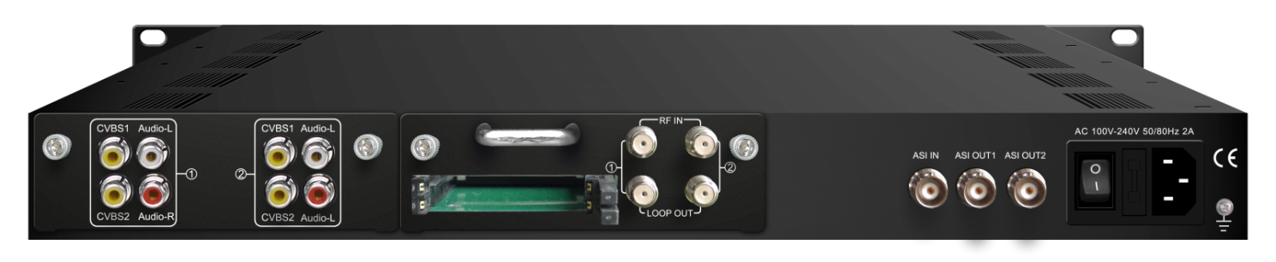
 |  | Decode Out |  | Video Interface: 2xCVBS (RCA)  Audio Interface: 2xStereo/4xMono (RCA)  Resolution: PAL 576i, NTSC 480i  Video Decode: MPEG-2, MPEG-4 AVC/H.264(optional)  Audio Decode: MPEG 1 Layer II
4*CVBS optional
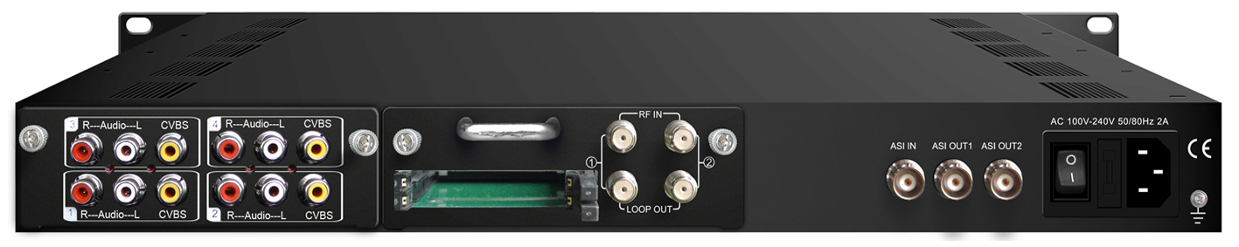
 |  | Decode Out |  |  | Video Interface: 4xCVBS (RCA)  Audio Interface: 4xStereo/8xMono (RCA)  Resolution: PAL 576i, NTSC 480i  Video Decode: MPEG-2, MPEG-4 AVC/H.264  Audio Decode: MPEG 1 Layer II
System |  | Local interface |  |  | LCD + control buttons
 |  | Remote management |  |  | Web-server Management
 |  | Language |  |  | English
 |  | Upgrade |  |  | USB, web management
Miscellaneous |  | Dimension |  |  | 482*300*44.5mm (W×L×H)
 |  | Approx weight |  |  | 3.5kg
 |  | Environment |  |  | 0~45℃(work)；-20~80℃（Storage）
 |  | Power requirements |  |  | 100~240VAC, 50/60Hz
 |  | Power consumption |  |  | 20W

System Connection Sample

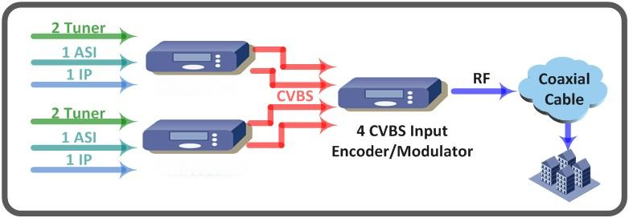

Ordering Guide
FU-467X, ‘X’ should be interpreted as different digits which indicate tuners of different standard.
* FU-4671 DVB-C SD IRD
* FU-4674 DVB-(T) SD IRD
* FU-4675 DVB-S/S2 SD IRD
Multiple decoding boards are optional:
Option 1: 2 A/V output (MPEG-2 Decoding)- FU-467X
Option 2: 2 A/V output (MPEG-2 & MPEG-4 Decoding) – FU-467X-A
Option 3: 4 A/V output (MPEG-2 & MPEG-4 Decoding) – FU-467X-C

About Us
FMUSER is a company specializing in broadcasting and television transmission systems and integrating hotel IPTV systems. The company was established in 2009 and has served over 180 countries worldwide. More than 20,000 television stations, radio stations, and hotel clients from different.

Contact:Tomleequan Email：sales@fmuser.com whatsapp: +8613922702227

