FMUSER FUQ-4696 CI Receiver 2-4 Tuner Inputs DVB-C-T-ISDB-T DVB-S-S2-S2X ATSC ASI-IP Output Multi-Standard Demodulation Descrambling Re-muxing for Broadcast Headends 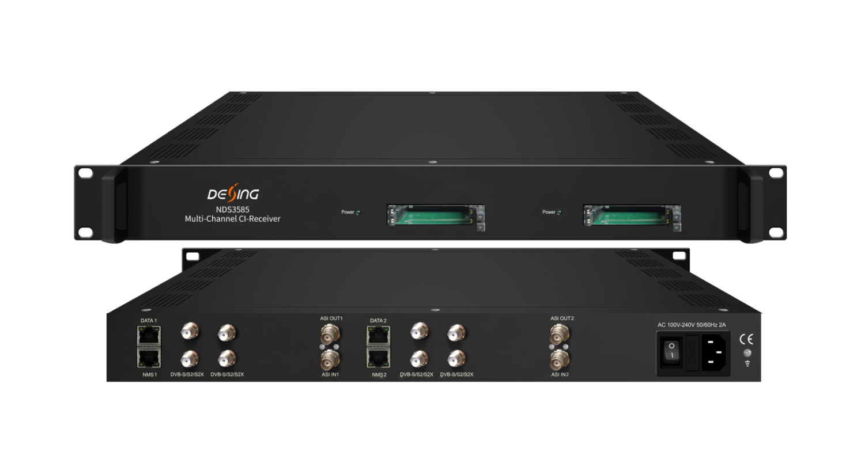Each Demodulation Module = 2 or 4 *RF/Loop out + 2*CAM + 2*Smartcard

Product Overview
The FMUSER FUQ-4696 CI Receiver integrates demodulation and descrambling in a 1U chassis, supporting 2 or 4 tuner inputs and outputs via ASI or IP. It converts RF signals to TS output after re-mux, with CAM/CI decryption and web NMS management. Designed for broadcast systems, cable headends, and IPTV distribution.

Key feature
Supports 2 or 4 tuner inputs with switchable DVB-C/T/ISDB-T or optional DVB-S/S2/S2X/ATSC.
Features 1 ASI & 16 IP inputs for re-mux with UDP/RTP and BISS descrambling.
Includes CAM/CI slots for decrypting programs from RF, ASI, or IP without external power.
Provides output flexibility: 1 MPTS via ASI/IP and 16 SPTS over IP (UDP/RTP).
Offers web NMS management with remote control, firmware updates, and 256 PID mapping.

Principle Chart (each demodulation module)
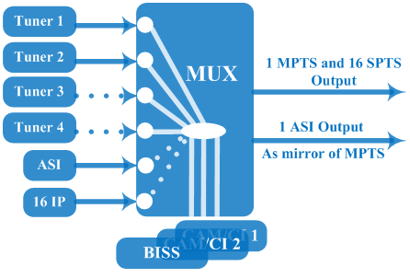

Technical Specifications
Input(per demodulation module) | 2 or 4* tuner inputs (DVB-C/T/ISDB-T switchable or DVB-S/S2/S2X or ATSC optional), F type  1*ASI input for re-mux, BNC interface  16*IP input for re-mux (UDP/RTP)
Tuner Section | Multi-mode tuners switchable  (New) | DVB-C | Input Frequency |  |  | 60 ~890 MHz
Tuner Section | Multi-mode tuners switchable  (New) | DVB-C | Standard |  |  | J.83A, J.83C | J.83B
Tuner Section | Multi-mode tuners switchable  (New) | DVB-C | Constellation |  |  | 16/32/64/128/256 QAM | 64/256 QAM
Tuner Section | Multi-mode tuners switchable  (New) | DVB-T | Input Frequency |  |  | 60 ~890 MHz
Tuner Section | Multi-mode tuners switchable  (New) | DVB-T | Bandwidth |  |  | 6/7/8 M
Tuner Section | Multi-mode tuners switchable  (New) | ISDB-T | Input Frequency |  |  | 60 ~890 MHz
Tuner Section | Satellite | DVB-S | Input Frequency |  |  | 950~2150MHz
Tuner Section | Satellite | DVB-S | Symbol rate |  |  | 0.5~45Msps
Tuner Section | Satellite | DVB-S | Signal Strength |  |  | - 65- -25dBm
Tuner Section | Satellite | DVB-S | FEC |  |  | 1/2, 2/3, 3/4, 5/6, 7/8
Tuner Section | Satellite | DVB-S | Constellation |  |  | QPSK
Tuner Section | Satellite | DVB-S | Max input bitrate |  |  | ≤170 Mbps
Tuner Section | Satellite | DVB-S2 | Input Frequency |  |  | 950~2150MHz
Tuner Section | Satellite | DVB-S2 | Symbol rate |  |  | QPSK/8PSK /16APSK :0.5~45 Msps  32APSK: 0.5~40Msps;
Tuner Section | Satellite | DVB-S2 | FEC |  |  | QPSK: 1/2, 3/5, 2/3, 3/4, 4/5, 5/6, 8/9, 9/10  8PSK: 3/5, 2/3, 3/4, 5/6, 8/9, 9/10  16APSK: 2/3, 3/4, 4/5, 5/6, 8/9, 9/10  32APSK: 3/4, 4/5, 5/6, 8/9, 9/10
Tuner Section | Satellite | DVB-S2 | Constellation |  |  | QPSK, 8PSK, 16APSK, 32APSK
Tuner Section | Satellite | DVB-S2 | Max input bitrate |  |  | ≤170 Mbps
Tuner Section | Satellite | DVB-S2X | Input Frequency |  |  | 950~2150MHz
Tuner Section | Satellite | DVB-S2X | Symbol rate |  |  | QPSK/8PSK /16APSK :0.5~45 Msps  8APSK: 0.5~40Msps  32APSK: 0.5~40Msps
Tuner Section | Satellite | DVB-S2X | FEC |  |  | QPSK: 1/2, 3/5, 2/3, 3/4, 4/5, 5/6, 8/9, 9/10, 13/45, 9/20, 11/20  8PSK: 3/5, 2/3, 3/4, 5/6, 8/9, 9/10  8APSK: 5/9-L, 26/45-L  16APSK: 2/3, 3/4, 4/5, 5/6, 8/9, 9/10, 1/2-L, 8/15-L, 5/9-L, 26/45, 3/5, 3/5-L, 28/45, 23/36 , 2/3-L, 25/36, 13/18, 7/9, 77/90  32APSK: 3/4, 4/5, 5/6, 8/9, 2/3-L, 32/45, 11/15, 7/9
Tuner Section | Satellite | DVB-S2X | Constellation |  |  | QPSK, 8PSK, 8APSK, 16APSK, 32APSK
Tuner Section | Satellite | DVB-S2X | Max input bitrate |  |  | ≤170 Mbps
 | ATSC | ATSC | Input Frequency |  |  | 54-858MHz
 | ATSC | ATSC | Bandwidth |  |  | 6 M
 | ATSC | ATSC | Constellation |  |  | 8 VSB
Descrambling |  | CAM/CI Quantity |  |  | 2 (per demodulation module)
 |  | BISS Mode |  |  | Mode 1, Mode E
Output (per demodulation module) |  | 1*MPTS & 16*SPTS over UDP, RTP.  1000 Base-T Ethernet interface (unicast / multicast)
 |  | 1×ASI mirrored out of MPTS, BNC interface
System |  | Remote management |  | Web-server Management
 |  | Language |  | English
 |  | Upgrade |  | web management
Miscellaneous |  | Dimension |  | 482*300*44mm (W×L×H)
 |  | Environment |  | 0~45℃(work)；-20~80℃（Storage）
 |  | Power requirements |  | 100~240VAC, 50/60Hz
 |  | Power consumption |  | 15W

Order Guide
Please specify both Demodulation module and Tuner Input options when you place order:

Demodulation Module | Option 1 | 1*Demodulation module, 2 CAM/CI Slots
Demodulation Module | Option 2 | 2*Demodulation modules, 4 CAM/CI Slots

Tuner Input (per demodulation module) | Option 1 | 2*DVB-S/S2/S2X tuner
Tuner Input (per demodulation module) | Option 2 | 2*DVB-C/T/ISDB-T tuner
Tuner Input (per demodulation module) | Option 3 | 2*ATSC tuner
Tuner Input (per demodulation module) | Option 4 | 4*DVB-S/S2/S2X tuner
Tuner Input (per demodulation module) | Option 5 | 4*DVB-C/T/ISDB-T tuner
Tuner Input (per demodulation module) | Option 6 | 4*ATSC tuner
Tuner Input (per demodulation module) | Option 7 | 2*DVB-S/S2/S2X tuner + 2*DVB-C/T/ISDB-T tuner
Tuner Input (per demodulation module) | Option 8 | 2*DVB-S/S2/S2X tuner + 2* ATSC tuner
Tuner Input (per demodulation module) | Option 9 | 2*DVB-C/T/ISDB-T tuner + 2*ATSC tuner

About Us
FMUSER is a company specializing in broadcasting and television transmission systems and integrating hotel IPTV systems. The company was established in 2009 and has served over 180 countries worldwide. More than 20,000 television stations, radio stations, and hotel clients from different.

Contact:Tomleequan Email：sales@fmuser.com whatsapp: +8613922702227

