FMUSER FUQ-4696 CI Receiver 8 Tuner Inputs DVB-S-S2-S2X DVB-C-T-ISDB-T ATSC IP ASI Outputs BISS Descrambling Broadcast IPTV Headend 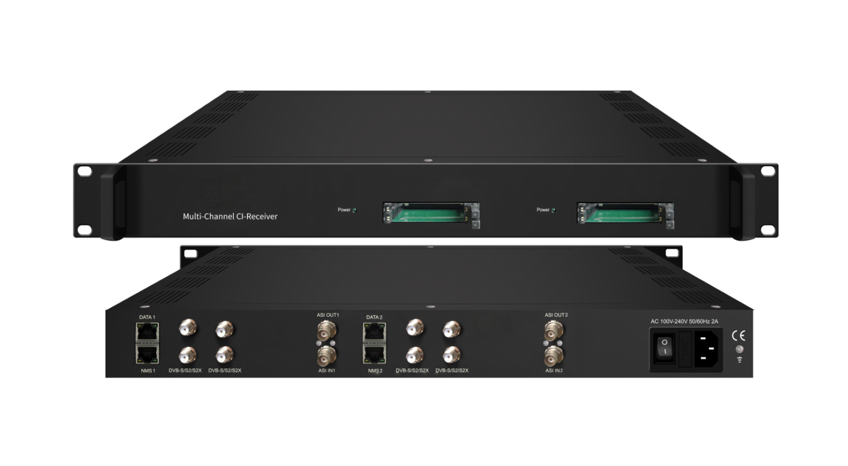Each Demodulation Module = 2 or 4 *RF/Loop out + 2*CAM + 2*Smartcard

Product overview
The FUQ-4696 is a CI receiver integrating demodulation and descrambling, with inputs including 2/4 tuners for RF signals, 1 ASI input, and 16 IP inputs, and outputs such as 1 ASI output and IP TS streams ( 1 MPTS and 16 SPTS). It processes signals by demodulating inputs, descrambling encrypted content using CAM/CI slots and BISS, and re-muxing into transport streams. This 1-U rack-mountable device supports web-based management. Ideal for broadcast headend applications like content distribution and signal processing.

Key feature
Supports multi-standard tuner inputs for DVB-C/T/ISDB-T, DVB-S/S2/S2X, ATSC with 2/4 tuners,
Features re-mux flexibility with 1 ASI input and 16 IP inputs (UDP/RTP),
Provides decryption via 2 CAM/CI slots and BISS descrambling,
Offers versatile outputs including 1 MPTS, 16 SPTS over IP, and ASI output,
Enables web-based management for remote control and updates.

Principle Chart (each demodulation module)
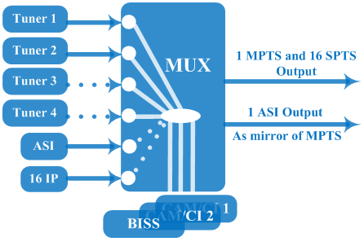

Technical Specifications
Input(per demodulation module) | 2 or 4* tuner inputs (DVB-C/T/ISDB-T switchable or DVB-S/S2/S2X or ATSC optional), F type  1*ASI input for re-mux, BNC interface  16*IP input for re-mux (UDP/RTP)
Tuner Section | Multi-mode tuners switchable  (New) | DVB-C | Input Frequency |  |  | 60 ~890 MHz
Tuner Section | Multi-mode tuners switchable  (New) | DVB-C | Standard |  |  | J.83A, J.83C | J.83B
Tuner Section | Multi-mode tuners switchable  (New) | DVB-C | Constellation |  |  | 16/32/64/128/256 QAM | 64/256 QAM
Tuner Section | Multi-mode tuners switchable  (New) | DVB-T | Input Frequency |  |  | 60 ~890 MHz
Tuner Section | Multi-mode tuners switchable  (New) | DVB-T | Bandwidth |  |  | 6/7/8 M
Tuner Section | Multi-mode tuners switchable  (New) | ISDB-T | Input Frequency |  |  | 60 ~890 MHz
Tuner Section | Satellite | DVB-S | Input Frequency |  |  | 950~2150MHz
Tuner Section | Satellite | DVB-S | Symbol rate |  |  | 0.5~45Msps
Tuner Section | Satellite | DVB-S | Signal Strength |  |  | - 65- -25dBm
Tuner Section | Satellite | DVB-S | FEC |  |  | 1/2, 2/3, 3/4, 5/6, 7/8
Tuner Section | Satellite | DVB-S | Constellation |  |  | QPSK
Tuner Section | Satellite | DVB-S | Max input bitrate |  |  | ≤170 Mbps
Tuner Section | Satellite | DVB-S2 | Input Frequency |  |  | 950~2150MHz
Tuner Section | Satellite | DVB-S2 | Symbol rate |  |  | QPSK/8PSK /16APSK :0.5~45 Msps  32APSK: 0.5~40Msps;
Tuner Section | Satellite | DVB-S2 | FEC |  |  | QPSK: 1/2, 3/5, 2/3, 3/4, 4/5, 5/6, 8/9, 9/10  8PSK: 3/5, 2/3, 3/4, 5/6, 8/9, 9/10  16APSK: 2/3, 3/4, 4/5, 5/6, 8/9, 9/10  32APSK: 3/4, 4/5, 5/6, 8/9, 9/10
Tuner Section | Satellite | DVB-S2 | Constellation |  |  | QPSK, 8PSK, 16APSK, 32APSK
Tuner Section | Satellite | DVB-S2 | Max input bitrate |  |  | ≤170 Mbps
Tuner Section | Satellite | DVB-S2X | Input Frequency |  |  | 950~2150MHz
Tuner Section | Satellite | DVB-S2X | Symbol rate |  |  | QPSK/8PSK /16APSK :0.5~45 Msps  8APSK: 0.5~40Msps  32APSK: 0.5~40Msps
Tuner Section | Satellite | DVB-S2X | FEC |  |  | QPSK: 1/2, 3/5, 2/3, 3/4, 4/5, 5/6, 8/9, 9/10, 13/45, 9/20, 11/20  8PSK: 3/5, 2/3, 3/4, 5/6, 8/9, 9/10  8APSK: 5/9-L, 26/45-L  16APSK: 2/3, 3/4, 4/5, 5/6, 8/9, 9/10, 1/2-L, 8/15-L, 5/9-L, 26/45, 3/5, 3/5-L, 28/45, 23/36 , 2/3-L, 25/36, 13/18, 7/9, 77/90  32APSK: 3/4, 4/5, 5/6, 8/9, 2/3-L, 32/45, 11/15, 7/9
Tuner Section | Satellite | DVB-S2X | Constellation |  |  | QPSK, 8PSK, 8APSK, 16APSK, 32APSK
Tuner Section | Satellite | DVB-S2X | Max input bitrate |  |  | ≤170 Mbps
 | ATSC | ATSC | Input Frequency |  |  | 54-858MHz
 | ATSC | ATSC | Bandwidth |  |  | 6 M
 | ATSC | ATSC | Constellation |  |  | 8 VSB
Descrambling |  | CAM/CI Quantity |  |  | 2 (per demodulation module)
 |  | BISS Mode |  |  | Mode 1, Mode E
Output (per demodulation module) |  | 1*MPTS & 16*SPTS over UDP, RTP.  1000 Base-T Ethernet interface (unicast / multicast)
 |  | 1×ASI mirrored out of MPTS, BNC interface
System |  | Remote management |  | Web-server Management
 |  | Language |  | English
 |  | Upgrade |  | web management
Miscellaneous |  | Dimension |  | 482*300*44mm (W×L×H)
 |  | Environment |  | 0~45℃(work)；-20~80℃（Storage）
 |  | Power requirements |  | 100~240VAC, 50/60Hz
 |  | Power consumption |  | 15W

Order Guide
Please specify both Demodulation module and Tuner Input options when you place order:

Demodulation Module | Option 1 | 1*Demodulation module, 2 CAM/CI Slots
Demodulation Module | Option 2 | 2*Demodulation modules, 4 CAM/CI Slots

Tuner Input (per demodulation module) | Option 1 | 2*DVB-S/S2/S2X tuner
Tuner Input (per demodulation module) | Option 2 | 2*DVB-C/T/ISDB-T tuner
Tuner Input (per demodulation module) | Option 3 | 2*ATSC tuner
Tuner Input (per demodulation module) | Option 4 | 4*DVB-S/S2/S2X tuner
Tuner Input (per demodulation module) | Option 5 | 4*DVB-C/T/ISDB-T tuner
Tuner Input (per demodulation module) | Option 6 | 4*ATSC tuner
Tuner Input (per demodulation module) | Option 7 | 2*DVB-S/S2/S2X tuner + 2*DVB-C/T/ISDB-T tuner
Tuner Input (per demodulation module) | Option 8 | 2*DVB-S/S2/S2X tuner + 2* ATSC tuner
Tuner Input (per demodulation module) | Option 9 | 2*DVB-C/T/ISDB-T tuner + 2*ATSC tuner

About Us
FMUSER is a company specializing in broadcasting and television transmission systems and integrating hotel IPTV systems. The company was established in 2009 and has served over 180 countries worldwide. More than 20,000 television stations, radio stations, and hotel clients from different.

Contact:Tomleequan Email：sales@fmuser.com whatsapp: +8613922702227

