FMUSER FUQ-4713 DVB-ASI Distributor 2-Input 24-Output DVB-ASI Signal Hub LCD Display SNMP NMS Control Broadcast CATV Headend 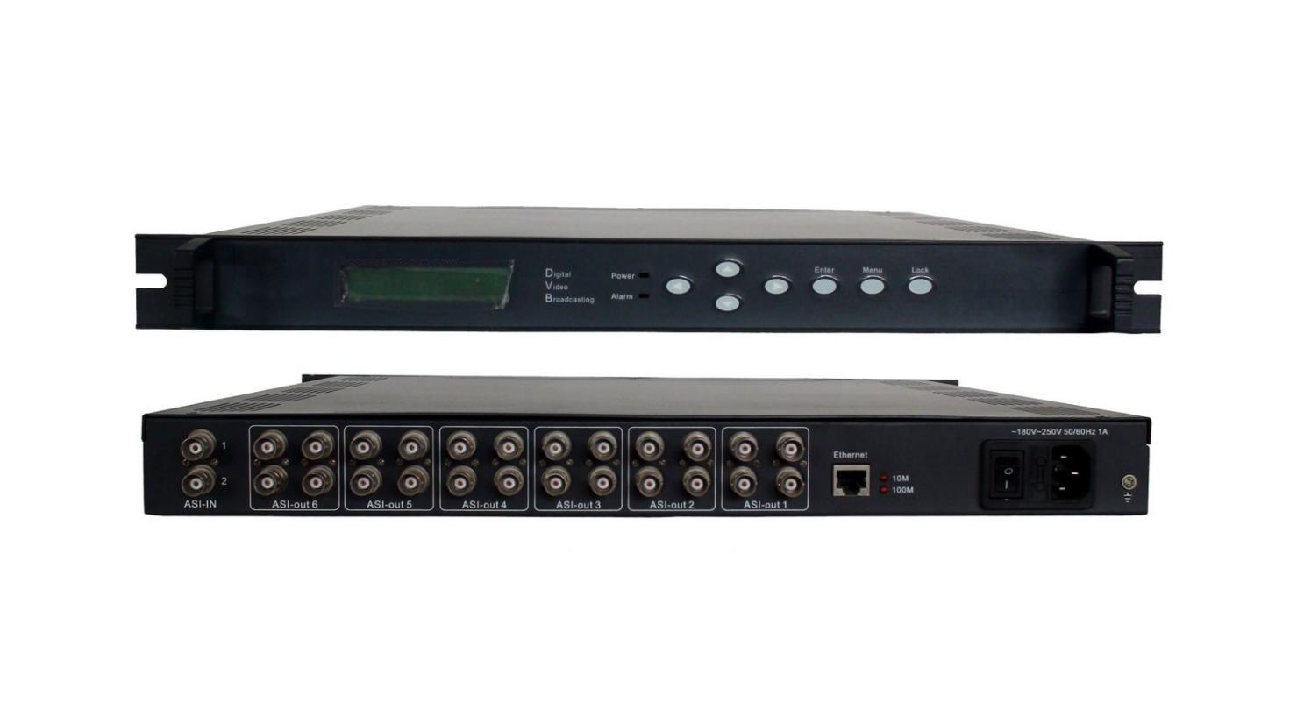
Product overview
The FMUSER FUQ-4713 is a DVB-ASI distribution hub with 2 inputs and 24 outputs (6×4 groups) for digital TV signal routing. It processes 1-216Mbps ASI signals with synchronized output replication. Features LCD display, front-panel keyboard, and SNMP-based NMS for remote monitoring. Ideal for broadcast headends and CATV systems requiring multi-device signal distribution.
Key feature
Operates at 220VAC±10%, 50Hz with 0-45°C operating temperature range

Specifications
Interface | Input interface | DVB ASI
Interface | Input interface number | 2
Interface | Output interface | DVB ASI
Interface | Output interface number | 24
Interface Specification | ASI | DVB Standard
Code rate | 1-216Mbps
Miscellaneous | Dimension | 44mm x 482mm x 410mm
Miscellaneous | Temperature | 0-45℃(Operation); -20 – 80℃ (Storage)
Miscellaneous | Power | 220VAC± 10%, 50Hz, 10W

About Us
FMUSER is a company specializing in broadcasting and television transmission systems and integrating hotel IPTV systems. The company was established in 2009 and has served over 180 countries worldwide. More than 20,000 television stations, radio stations, and hotel clients from different.

Contact:Tomleequan Email：sales@fmuser.com whatsapp: +8613922702227

