FMUSER FUQ-4823C Multiplexer Scrambler 8 ASI Inputs 64 IP Inputs UDP Protocol ASI Gigabit Ethernet ISO13818 EN300 468 Compliant TS Multiplexing Scrambling CATV Headend Systems 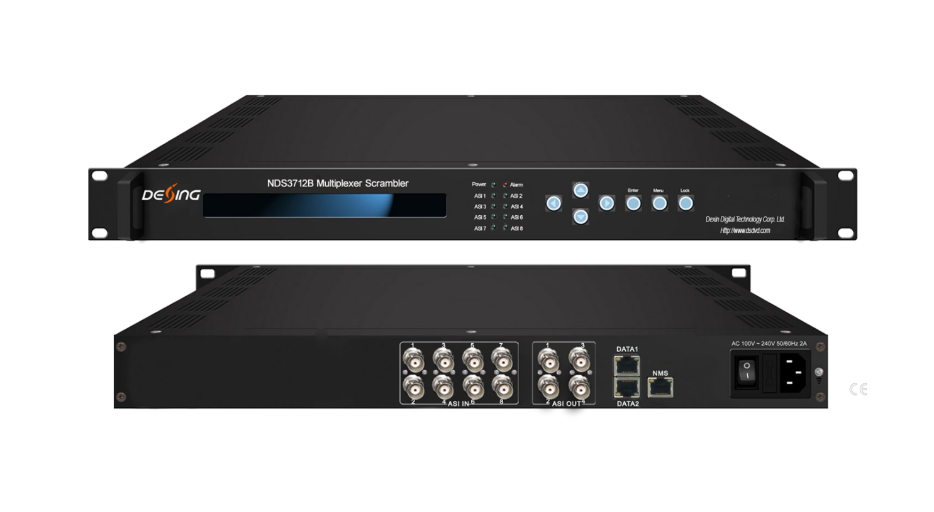Product overview
The FMUSER FUQ-100B is a multiplexer and scrambler supporting 8 ASI and 64 IP inputs. It processes signals with PID re-mapping and EPG insertion, outputting TS streams via ASI and IP ports. With web-based NMS management, it suits digital TV head-end systems and CATV broadcasting.
Key feature
Supports 8 ASI inputs and 64 IP inputs via UDP protocol.
Features multiplexing, scrambling, PID re-mapping, and PSI/SI editing.
Compliant with ISO13818, EN300 468, and simulcrypt standards.
Includes 2 groups of ASI outputs (each with 2 channels) and IP outputs.
Offers web-based NMS management for easy control.

Principle Chart
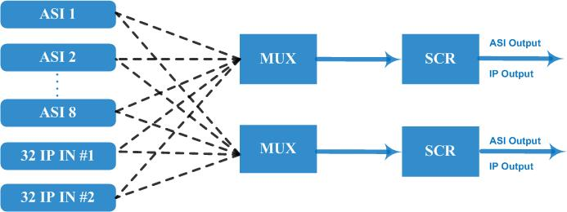

Specifications
Input | 8 ASI input+64 IP input DATA 1 and DATA 2 over UDP protocol
Re-multiplex | PID re-mapping
Re-multiplex | PCR accurate adjusting
Re-multiplex | PSI/SI (PAT, PMT) tables auto generation and edition
Scrambling | Simul-crypt CA | 6
Scrambling | Standard | ETR289, ETSI 101 197, ETSI 103 197
Scrambling | Connection | Local/Remote connect
Output port | ASI | 2 groups separate outputs (each group has 2 channels)
Output port | IP | MPTS over UDP, RTP/RTSP output (RJ45), 1000Mbps Ethernet, DATA 1 and DATA 2
PID | Output range | 0x0000—0x1FFF
PID | PID transparent | Any PID transparent and mapping achievable
PID | Amount of output PID | 512
NMS port | Ethernet port | 10/100M/1000M self adaption
General | Dimensions | 482mm×300mm×44mm (WxLxH)
General | Weight | 3.5kg
General | Temperature | 0~45℃(operation), -20~80℃(storage)
General | Power supply | AC 110V±10%, 50/60Hz Or AC 220V±10%, 50/60Hz

About Us
FMUSER is a company specializing in broadcasting and television transmission systems and integrating hotel IPTV systems. The company was established in 2009 and has served over 180 countries worldwide. More than 20,000 television stations, radio stations, and hotel clients from different.

Contact:Tomleequan Email：sales@fmuser.com whatsapp: +8613922702227

