FMUSER FUQ-4823C Multiplexer Scrambler 4 Tuner Inputs 5 MPTS Outputs DVB-S-DVB-S2-DVB-S2X UDP-RTP PID Remapping Web-Based NMS Satellite Broadcast IPTV
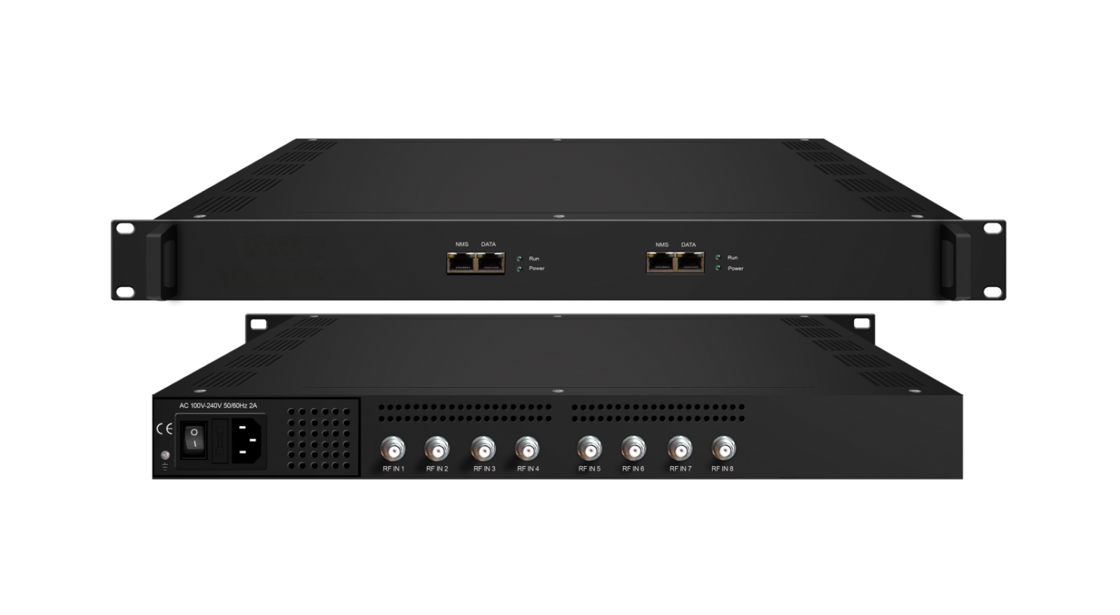
Product overview
The FMUSER FUQ-4823C Multiplexer Scrambler processes DVB-S/S2/S2X signals through 4 tuner inputs and outputs 5 MPTS streams (4 bypassed + 1 multiplexed) via UDP/RTP. It remaps PIDs and multiplexes signals for efficient broadcast transmission. Features include web-based NMS and DiSEqC support for satellite control. Ideal for broadcast, satellite communication, and media distribution applications.
Key Features
- Supports multi-standard tuner inputs for DVB-S/S2/S2X signals across 950-2150MHz with ≤170 Mbps throughput.
- Delivers flexible MPTS output with 4 bypassed and 1 multiplexed streams via UDP/RTP multicast/unicast.
- Enables granular PID control with remapping of up to 256 PIDs per channel.
- Features integrated management via web-based NMS and DiSEqC support.
- Provides high-capacity processing for QPSK/8PSK/16APSK/32APSK constellations and FEC rates.
Inner Principle Chart (Per Card)
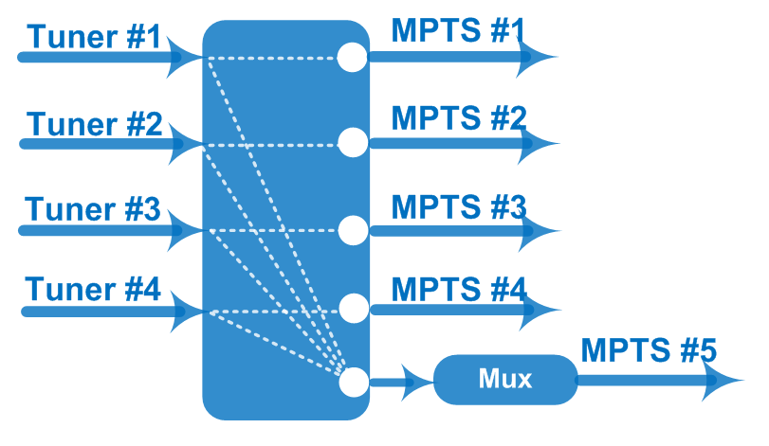
Specifications
Input / Output | 4 Tuner input, F Type  5 MPTS (4 MPTS out thru bypassing, 1 MPTS multiplexing) out over UDP/RTP thru Data port, 100/1000Mself-adaption, unicast/multicast
Mux | Max number of managing PID: 256 (for 1 MPTS out thru multiplexing)
Mux | Functions | PID remapping (automatically/ manually)
Mux | Functions | PID pass-through
Tuner Section | DVB-S | Input Frequency |  | 950-2150MHz
Tuner Section | DVB-S | Symbol Rate |  | 0.5~45 Msps
Tuner Section | DVB-S | Constellation |  | QPSK
Tuner Section | DVB-S | FEC |  | 1/2, 2/3, 3/4, 5/6, 7/8
Tuner Section | DVB-S2 | Input Frequency |  | 950-2150MHz
Tuner Section | DVB-S2 | Symbol Rate |  | QPSK/8PSK/16APSK: 0.5~45 Msps  32APSK:0.5~40 Msps
Tuner Section | DVB-S2 | Constellation |  | QPSK/8PSK/16APSK/32APSK
Tuner Section | DVB-S2 | FEC |  | QPSK: 1/2, 3/5, 2/3, 3/4, 4/5, 5/6, 8/9,9/10  8PSK: 3/5, 2/3, 3/4, 5/6, 8/9, 9/10  16APSK: 2/3, 3/4, 4/5, 5/6, 8/9, 9/10  32APSK: 3/4, 4/5, 5/6, 8/9
Tuner Section | DVB-S2 | Max input bitrate per tuner |  | ≤170 Mbps
Tuner Section | DVB-S2X | Symbol Rate |  | QPSK/8PSK/16APSK: 0.5~45 Msps;  8APSK/32APSK: 0.5~40 Msps
Tuner Section | DVB-S2X | Constellation |  | QPSK/8PSK/16APSK/8APSK/32APSK
Tuner Section | DVB-S2X | FEC |  | QPSK: 1/2, 3/5, 2/3, 3/4, 4/5, 5/6, 8/9, 9/10, 13/45, 9/20, 11/20  8PSK: 3/5, 2/3, 3/4, 5/6, 8/9, 9/10, 23/36, 25/36, 13/18  8APSK: 5/9-L, 26/45-L  16APSK: 2/3, 3/4, 4/5, 5/6, 8/9, 9/10,1/2-L, 8/15-L, 5/9-L, 26/45, 3/5, 3/5-L, 28/45, 23/36, 2/3-L, 25/36, 13/18, 7/9, 77/90  32APSK: 3/4, 4/5, 5/6, 8/9, 2/3-L, 32/45, 11/15, 7/9
Tuner Section | DVB-S2X | Max input bitrate per tuner |  | ≤170 Mbps
Tuner Section | Signal Strength | -65 ~ -25dBm
System | Web management:100M NMS port
System | Language: English and Chinese
System | Ethernet software upgrade
General | Dimensions |  | 482mm×328mm×44mm (WxLxH)
General | Weight |  | 3.5kg
General | Temperature |  | 0~45℃(operation), -20~80℃(storage)
General | Power supply |  | AC 110V±10%, 50/60Hz Or AC 220V±10%, 50/60Hz
General | Consumption |  | ≤40W

About Us
FMUSER is a company specializing in broadcasting and television transmission systems and integrating hotel IPTV systems. The company was established in 2009 and has served over 180 countries worldwide. More than 20,000 television stations, radio stations, and hotel clients from different.

Contact:Tomleequan Email：sales@fmuser.com whatsapp: +8613922702227

