FMUSER FUQ-4823D Multiplexer Scrambler 8 ASI 64 IP Inputs Dual ASI Outputs UDP-RTP-RTSP Streaming PID Re-mapping PSI-SI Editing Digital TV Headend 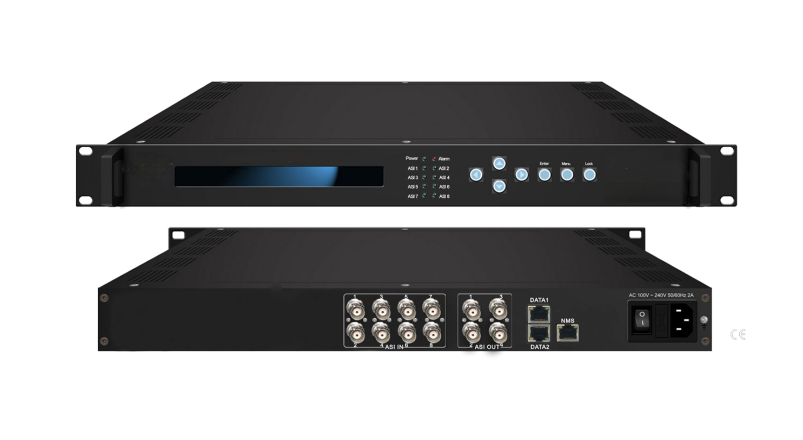Product overview
The FUQ-4823D Multiplexer Scrambler processes 8 ASI and 64 IP inputs for transport stream multiplexing, scrambling, and PSI/SI table editing. It delivers processed streams via dual ASI output groups (2 channels each) and IP streaming (UDP/RTP/RTSP) through Gigabit Ethernet ports. This 1U rack-mount unit supports web-based NMS and front-panel LCD/keyboard control. Ideal for digital TV headends, CAS integration, and multi-platform content distribution.
Key feature
Web NMS & LCD/keyboard control with buffer memory protection
Principle Chart
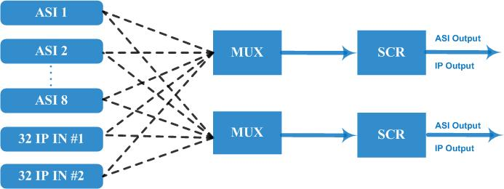

Specifications
Input | 8 ASI input+64 IP input DATA 1 and DATA 2 over UDP protocol
Re-multiplex | PID re-mapping
Re-multiplex | PCR accurate adjusting
Re-multiplex | PSI/SI (PAT, PMT) tables auto generation and edition
Scrambling | Simul-crypt CA | 6
Scrambling | Standard | ETR289, ETSI 101 197, ETSI 103 197
Scrambling | Connection | Local/Remote connect
Output port | ASI | 2 groups separate outputs (each group has 2 channels)
Output port | IP | MPTS over UDP, RTP/RTSP output (RJ45), 1000Mbps Ethernet, DATA 1 and DATA 2
PID | Output range | 0x0000—0x1FFF
PID | PID transparent | Any PID transparent and mapping achievable
PID | Amount of output PID | 512
NMS port | Ethernet port | 10/100M/1000M self adaption
General | Dimensions | 482mm×300mm×44mm (WxLxH)
General | Weight | 3.5kg
General | Temperature | 0~45℃(operation), -20~80℃(storage)
General | Power supply | AC 110V±10%, 50/60Hz Or AC 220V±10%, 50/60Hz

About Us
FMUSER is a company specializing in broadcasting and television transmission systems and integrating hotel IPTV systems. The company was established in 2009 and has served over 180 countries worldwide. More than 20,000 television stations, radio stations, and hotel clients from different.

Contact:Tomleequan Email：sales@fmuser.com whatsapp: +8613922702227

