FMUSER FUQ-4825B IP Decoder 8 IP Inputs to 4 HDMI Outputs UDP-RTP MPEG-2-H.264-H.265-AVS Decoding Web-Based Control for Broadcast and Digital Signage
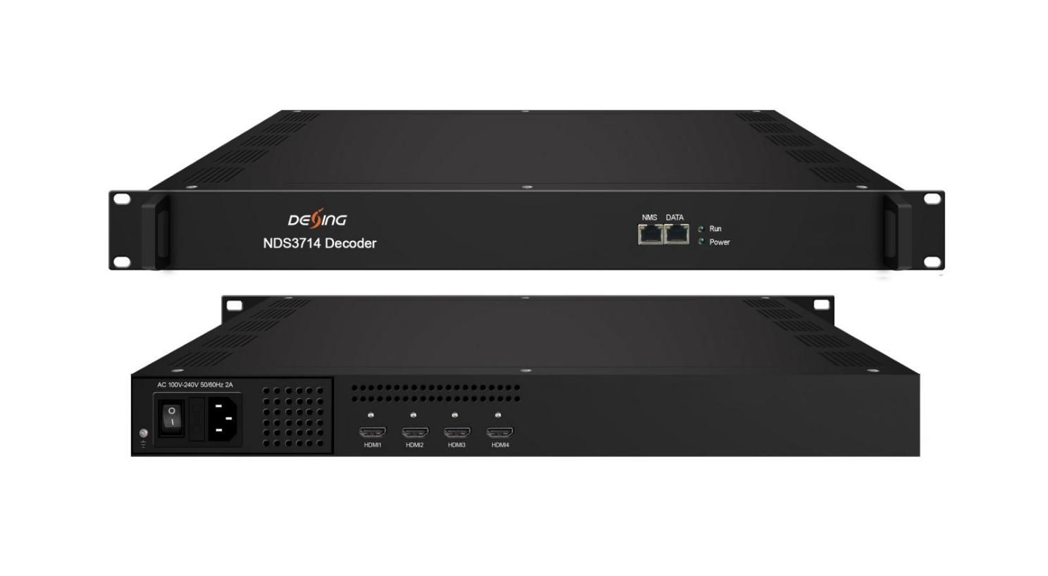
Product Overview
The FMUSER FUQ-4825B decodes 8 IP inputs via UDP/RTP, supporting MPEG-2/H.264/H.265/AVS/AVS+ formats. It outputs signals to 4 HDMI channels with embedded stereo audio, enabling manual resolution scaling up to 1080p. Controlled through web-based interface, this decoder is ideal for flexible program distribution in broadcasting and digital signage applications.
Key feature
Supports 8 IP inputs over 100M/1000Mbps Ethernet using UDP/RTP for MPTS/SPTS streams,
Decodes MPEG-2/H.264/H.265/AVS/AVS+ video with MPEG1 Layer 2/LC-AAC/HE-AAC audio (optional),
Outputs 4 HDMI channels with embedded stereo audio, supporting resolutions from 480i to 1920×1080_60p,
Enables manual resolution scaling and web-based control for system integration

Principle Chart
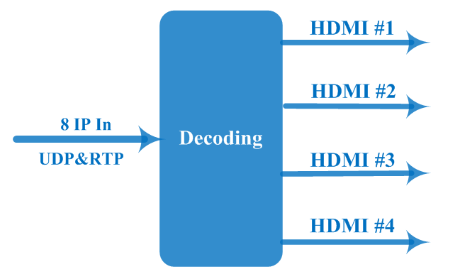

Specification
Input | 8 IP (100M/1000Mbps Ethernet, RJ45, UDP&RTP protocol, Unicast/multicast)
Input | Max bitrate | ≤900Mbps
Decode | Video Format | MPEG-2, MPEG-4 AVC/H.264, HEVC/H.265, AVS, AVS+
Decode | Interface | 4* HDMI
Decode | Video Resolution | 480i, 480p, 576i, 576p,  1280×720_50p, 1280×720_60p, 1920×1080_50i, 1920×1080_50p 1920×1080_60i, 1920×1080_60p
Decode | Audio Format | MPEG 1 Layer2, LC-AAC, HE-AAC
Decode | Audio Channel | One stereo audio embedded in each port
Output | 4 HDMI decoding out
General | Operation | Web-server
General | Language | Chinese/English
General | Dimension | 328 mm×482 mm×45mm (LxWxH)
General | Environment | 0~45℃(Work)；-20~80℃(Storage)
General | Power Supply | 220VAC±10%，50Hz
General | Consumption | <25W

About Us
FMUSER is a company specializing in broadcasting and television transmission systems and integrating hotel IPTV systems. The company was established in 2009 and has served over 180 countries worldwide. More than 20,000 television stations, radio stations, and hotel clients from different.

Contact:Tomleequan Email：sales@fmuser.com whatsapp: +8613922702227

