FMUSER FUQ-5315K Encoder 4-8-12 HDMI Inputs IP Output MPEG-4 AVC-H264 LC-AAC-HE-AAC Web Management for IP Broadcasting
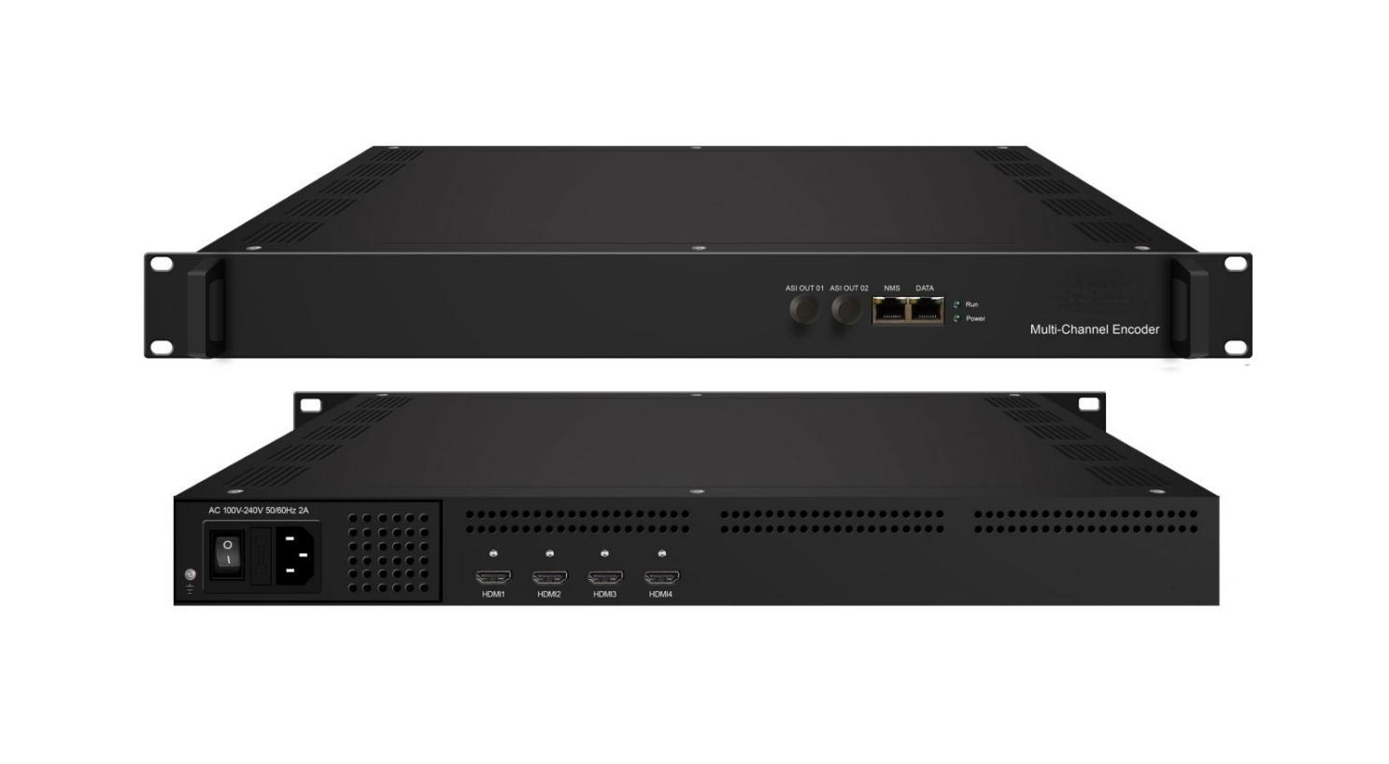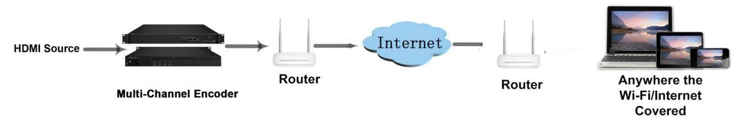
Product Overview
The FMUSER FUQ-5315K is a multi-channel encoder with 4/8/12 HDMI inputs, supporting MPEG-4 AVC/H.264 video and LC-AAC/HE-AAC audio encoding. It streams content via UDP, RTSP, RTMP, HTTP, and HLS protocols for reception on PCs and mobile devices. Controlled through web-based management, it enables easy updates. Ideal for professional IP broadcasting in live streaming and digital media distribution.
Key feature
Allows control and updates via web-based management.* Support MPEG-4 AVC/H.264 video encoding and LC-AAC or HE-AAC Audio encoding
Inner Principle Chart (Per Module)

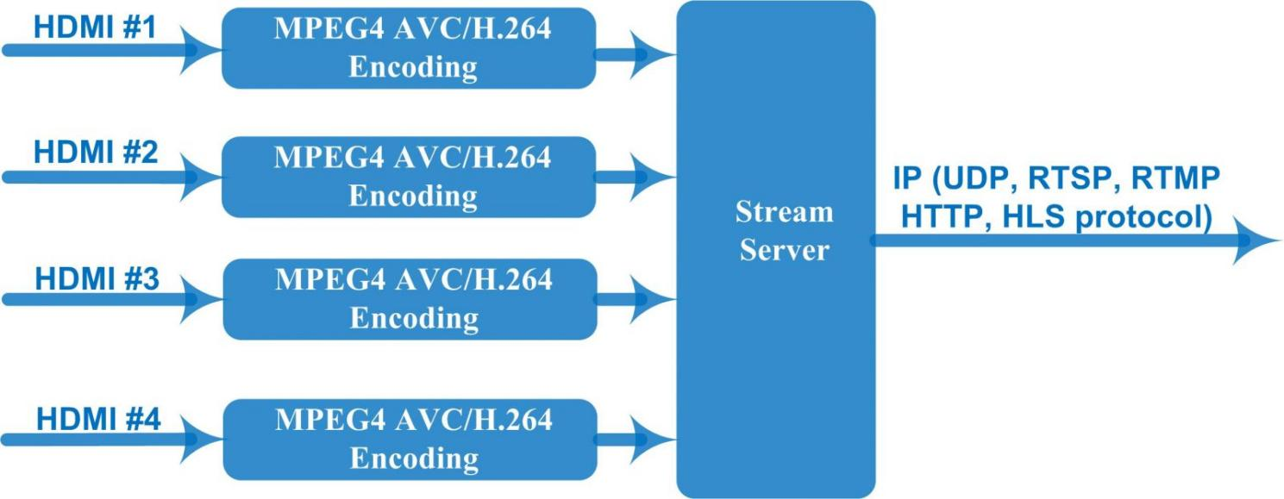

Specifications
Input | 4/8/12 HDMI inputs
Encoder  Section | Video | Resolution |  | Input | Output
Encoder  Section | Video |  |  | 1920x1080_60p, 1920x1080_60i | 1920x1080_30p
Encoder  Section | Video |  |  | 1920x1080_50p, 1920x1080_50i | 1920x1080_25p
Encoder  Section | Video |  |  | 1280x720_60p | 1280x720_30p
Encoder  Section | Video |  |  | 1280x720_50p | 1280x720_25p
Encoder  Section | Video |  |  | 720x480_60i | 720x480_30p
Encoder  Section | Video |  |  | 720x576_50i | 720x576_25p
Encoder  Section | Video | Encoding |  | MPEG-4 AVC/H.264 (Baseline profile, Main profile, High profile)
Encoder  Section | Video | Bit rate |  | 1Mbps~13Mbps
Encoder  Section | Video | Rate Mode |  | CBR, VBR
Encoder  Section | Video | GOP Size |  | 25~50
Encoder  Section | Audio | Encoding |  | LC-AAC or HE-AAC
Encoder  Section | Audio | Sampling rate |  | 48KHz input, 44.1KHz output
Encoder  Section | Audio | Bitrate |  | LC-AAC : 48, 64, 96, 128, 256 kbps  HE-AAC : 48, 64 kbps
Stream out | IP out over UDP (Unicast/Multicast) , RTSP, RTMP, HTTP, HLS (RJ45, 100M )  ASI output port and Data port are not applicable currently
System | Remote control |  | Network management (WEB)
System | Language |  | Chinese and English
System | Upgrade |  | Ethernet software upgrade
General | Operation temperature |  | 0~45℃(work), -20~80℃（Storage）
General | Power supply |  | AC 100-240V 50/60Hz 2A
General | Dimensions |  | 482mm×328mm×44mm

About Us
FMUSER is a company specializing in broadcasting and television transmission systems and integrating hotel IPTV systems. The company was established in 2009 and has served over 180 countries worldwide. More than 20,000 television stations, radio stations, and hotel clients from different.

Contact:Tomleequan Email：sales@fmuser.com whatsapp: +8613922702227

