FMUSER FUQ-8313 DVB-T Digital Transmitter 800W-1000W-1200W RF Output 470-806MHz LDMOS Amplifier AGC Control MFN-SFN Compatible Terrestrial TV Broadcasting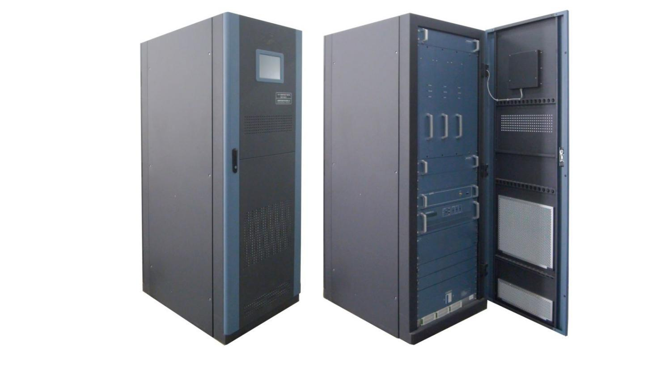
Product overview
The FUQ-8313 is a high-power DVB-T transmitter with selectable 800W/1000W/1200W RF output. It processes broadband signals in the 470–806MHz range using LDMOS amplification and AGC stabilization. The 2U rack-mount unit supports MFN/SFN topologies via modular design. Ideal for terrestrial TV broadcasting and emergency alert systems requiring low-distortion transmission.
Key feature
Provides front-panel LED/LCD for real-time fault monitoring
Technical Specifications

Input | System standard | DVB-(T)
Input | frequency | 470MHz~806MHz
Input | Input Level | -20 dBm±3dB (87dbuv ±3dB)
Input | Input reflection loss | ≥15dB
Input | Input Interface | ‘N’
Output | RF output power | 800W/1000W/1200W optional
Output | Output frequency | 470MHz~806MHz  (For Single Channel: Every 8M available;  For Broadband Channel: consecutive 60M available)
Output | Output impedance | 50Ω
Output | frequency response | ±0.5dB
Output | Shoulder level | ≥36dB@central freqnencyIF±4.2MHz
Output | MER | ≥33dB
Output | output reflection loss | ≥20dB
Output | variation of output power | ±0.25dB
Output | In-band stray | ≤-60dBc
Output | Out-of-band suppression | ≥65dBc
Output | Output interface | 1-5/8
General Parameters | Working temperature | -20~+50℃
General Parameters | Storage temperature | -30~+75℃
General Parameters | Relatively humidity | ＜95% (25℃ no condensation)
General Parameters | Cooling mode | inside cooling fan
General Parameters | atm press | 86~106kPa
General Parameters | power supply | AC, 220V±10%/50Hz
General Parameters | Machine room requirement | less dust, no shake
General Parameters | Dimension(L×W×H) | 850mm×600mm×1695mm

System Diagram

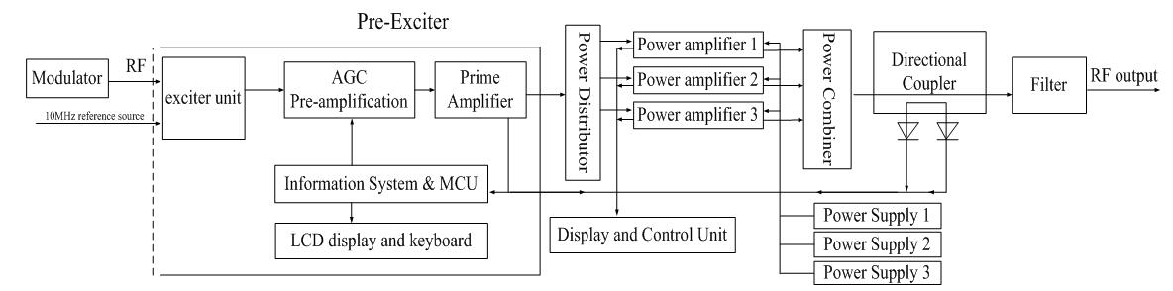
PS: This diagram is a reference for 800W and 1000W transmitter.
For 1200W transmitter, there are 4 power amplifiers and 4 power supplier included.

Main Components List
S/N | Component Name |  | Specs | Qty | Remarks
 | Final Power Amplifier |  | 300W | 3 pcs | For 800W
 |  |  | 400W | 3 pcs | For 1000W
 |  |  | 400W | 4 pcs | For 1200W
 | Pre-Exciter |  |  | 1 pc
 | Monitor Unit |  |  | 1 pc | With LCD monitor on front door
 | Power Supply for  Final Amplifier |  |  | 3 pcs | For 800W/1000W
 |  |  |  | 4 pcs | For 1200W
 | Filter |  |  | 1 pc | As per order. (In case multiple single-channel transmitters are involved, a power combiner is required.)
 | Cabinet |  |  | 1 pc
 | Cooling Fan |  |  | 1 set | 2 sets (with 1 set for backup) optional as order or needed
Accessaries
 |  | Hard Feeder | Φ40, 2 meter long | 1 | These parts are standard configuration. If there are special requirement, please indicate when place order.
 |  | Elbow |  | 3
 |  | Hoop |  | 3
 |  | Hose Clamp |  | 13
 |  | Central Pin |  | 3
 |  | Flange | Φ40 | 1
 |  | antenna |  | 1 | As per order
 |  | Feeder |  |  | As per order
 |  | Combiner |  | 1 | As per order

Order Info
Model Number | Description
DUT-8313(800W-I) | 800W Indoor
DUT-8313(1000W-I) | 1000W Indoor
DUT-8313(1200W-I) | 1200W Indoor

About Us
FMUSER is a company specializing in broadcasting and television transmission systems and integrating hotel IPTV systems. The company was established in 2009 and has served over 180 countries worldwide. More than 20,000 television stations, radio stations, and hotel clients from different.

Contact:Tomleequan Email：sales@fmuser.com whatsapp: +8613922702227

