FMUSER FUQ-8322 DVB-T Digital Transmitter 1 Input 1 Output 470-806MHz Frequency Range 4-64 QAM Modulation LDMOS Amplifier Technology High Linearity AGC Control Terrestrial TV Broadcast Emergency Backup
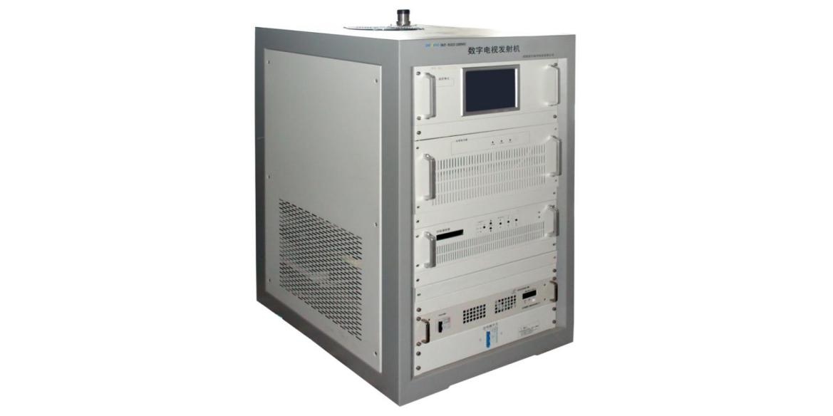
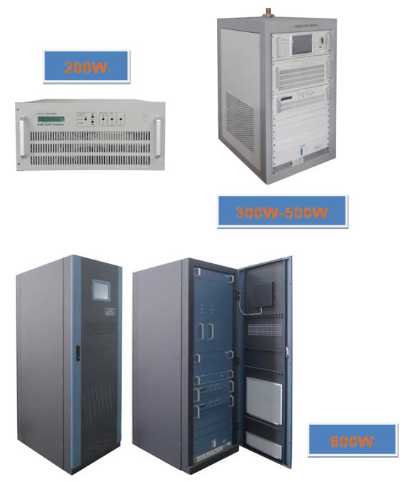

Product overview
The FUQ-8322 is a DVB-T digital transmitter with configurable 200W-600W RF output, featuring LDMOS amplifier technology for high linearity. It processes HD/SD signals with 4/16/32/64 QAM modulation, supporting both SFN (±1Hz sync) and MFN (±100Hz) network modes via 470-806MHz frequency range. This 2U rack-mount unit integrates AGC control, modular redundancy, and intelligent air cooling for 24/7 broadcast operations. Ideal for terrestrial TV transmission and emergency backup systems.
Key feature
Features low-noise cooling and multi-stage lightning protection
Specifications

Item |  | Technical Spec
Basic Parameter | Standard | DVB-(T)
Basic Parameter | Modulation Mode | support 4/16/32/64 QAM mode
Basic Parameter | Working frequency | 470MHz～806MHz
Basic Parameter | Output rating | 200W/300W/400W/500W/600W Optional
Basic Parameter | Frequency accuracy | MFN: ≤±100Hz / SFN：≤±1Hz
Basic Parameter | L.O. Phase Noise | ≤ - 70dBc@10Hz
Basic Parameter | L.O. Phase Noise | ≤ - 90dBc@100Hz
Basic Parameter | L.O. Phase Noise | ≤ - 100dBc@1kHz
Basic Parameter | L.O. Phase Noise | ≤ - 105dBc@10kHz
Basic Parameter | L.O. Phase Noise | ≤ - 115dBc@100kHz
Basic Parameter | L.O. Phase Noise | ≤ - 130dBc@1MHz
Basic Parameter | variation of output power | ±0.2dB
Basic Parameter | Inband spectrum ripple | ±0.5dB（fc±3.591MHz）
Basic Parameter | Shoulder Level | ≤-40dB@ Central frequency, IF±4.2MHz
Basic Parameter | MER | ≥36dB
Output Character | Output impedance | 50Ω
Output Character | output reflection loss | ≥20dB
Output Character | Output interface | 200W/300W/400W: L29-K;  500W/600W: 1-5/8'', directly-fed
Environment Condition | Working temperature | -20~+50℃
Environment Condition | Storage temperature | -30~+75℃
Environment Condition | Relatively humidity | ＜95% (25℃ no condensation)
Environment Condition | Cooling mode | inside cooling fan
Environment Condition | atm press | 86~106kPa
Environment Condition | power supply | AC, 220±20%, 50Hz  AC, 380±20%, 50Hz
Environment Condition | Machine room requirement | less dust, no friction

Principle Chart

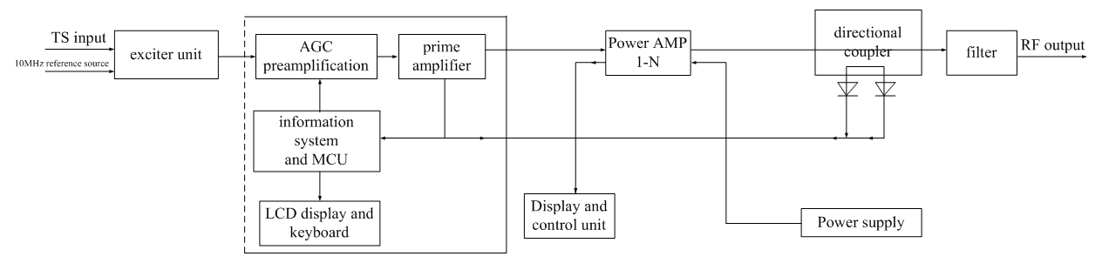

Main Components List (Standard Configuration)

S/N | Component | 200W | 300W | 400W | 500W | 600W | Remarks
S/N | Component | Qty (piece)
1 | Cabinet/Rack | N/A | 1 | 1 | 1 | 1 | These configuration is standard. If customer need certain redundancy component, it is available and negotiable.
2 | Power Supply | 1 (Built-in) | 1 | 1 | 1 | 2
3 | Exciter | 1 (Built-in) | 1 | 1 | 1 | 1
4 | Power Amplifier | 1 (Built-in) | 1 | 1 | 1 | 2
5 | Monitor Unit | N/A | 1 | 1 | 1 | 1
6 | Filter | 1 (Built-in) | 1 | 1 | 1 | 1

About Us
FMUSER is a company specializing in broadcasting and television transmission systems and integrating hotel IPTV systems. The company was established in 2009 and has served over 180 countries worldwide. More than 20,000 television stations, radio stations, and hotel clients from different.

Contact:Tomleequan Email：sales@fmuser.com whatsapp: +8613922702227

