FMUSER FUQ-8322 200W-600W DVB-T Transmitter Adjustable Output Power LDMOS Amplifier SFN-MFN Operation Professional Broadcast Terrestrial TV
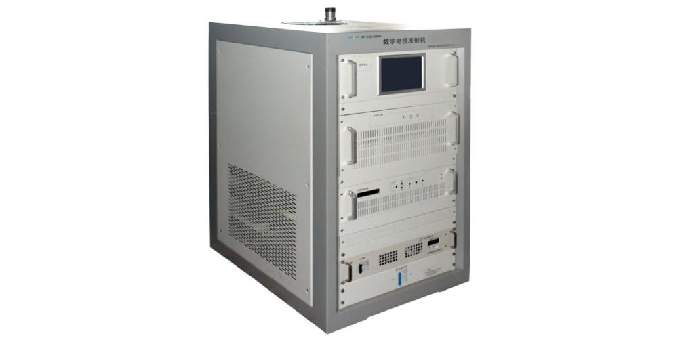
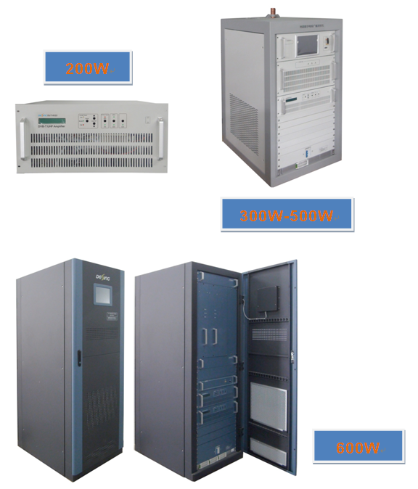

Product overview
The FMUSER FUQ-8322 is a professional-grade DVB-T transmitter with 200W-600W adjustable output. It processes RF signals through LDMOS amplifier technology, supporting both SFN (±1Hz accuracy) and MFN (±100Hz) operation modes. The 2U rack-mount unit features intelligent AGC control and multi-stage lightning protection, ideal for terrestrial TV broadcasting and single-frequency network deployments.
Key feature
2U rack design with efficient cooling system
Specifications

Item |  | Technical Spec
Basic Parameter | Standard | DVB-(T)
Basic Parameter | Modulation Mode | support 4/16/32/64 QAM mode
Basic Parameter | Working frequency | 470MHz～806MHz
Basic Parameter | Output rating | 200W/300W/400W/500W/600W Optional
Basic Parameter | Frequency accuracy | MFN: ≤±100Hz / SFN：≤±1Hz
Basic Parameter | L.O. Phase Noise | ≤ - 70dBc@10Hz
Basic Parameter | L.O. Phase Noise | ≤ - 90dBc@100Hz
Basic Parameter | L.O. Phase Noise | ≤ - 100dBc@1kHz
Basic Parameter | L.O. Phase Noise | ≤ - 105dBc@10kHz
Basic Parameter | L.O. Phase Noise | ≤ - 115dBc@100kHz
Basic Parameter | L.O. Phase Noise | ≤ - 130dBc@1MHz
Basic Parameter | variation of output power | ±0.2dB
Basic Parameter | Inband spectrum ripple | ±0.5dB（fc±3.591MHz）
Basic Parameter | Shoulder Level | ≤-40dB@ Central frequency, IF±4.2MHz
Basic Parameter | MER | ≥36dB
Output Character | Output impedance | 50Ω
Output Character | output reflection loss | ≥20dB
Output Character | Output interface | 200W/300W/400W: L29-K;  500W/600W: 1-5/8'', directly-fed
Environment Condition | Working temperature | -20~+50℃
Environment Condition | Storage temperature | -30~+75℃
Environment Condition | Relatively humidity | ＜95% (25℃ no condensation)
Environment Condition | Cooling mode | inside cooling fan
Environment Condition | atm press | 86~106kPa
Environment Condition | power supply | AC, 220±20%, 50Hz  AC, 380±20%, 50Hz
Environment Condition | Machine room requirement | less dust, no friction

Principle Chart

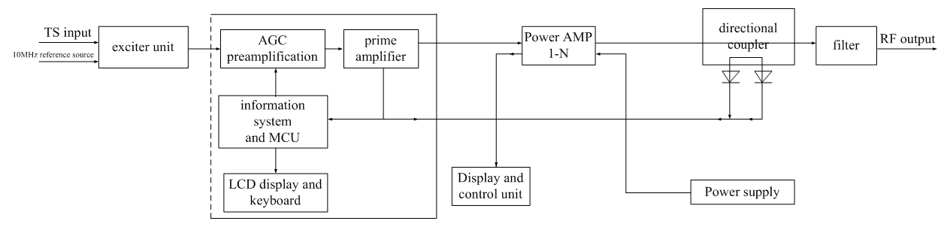

Main Components List (Standard Configuration)

S/N | Component | 200W | 300W | 400W | 500W | 600W | Remarks
S/N | Component | Qty (piece)
1 | Cabinet/Rack | N/A | 1 | 1 | 1 | 1 | These configuration is standard. If customer need certain redundancy component, it is available and negotiable.
2 | Power Supply | 1 (Built-in) | 1 | 1 | 1 | 2
3 | Exciter | 1 (Built-in) | 1 | 1 | 1 | 1
4 | Power Amplifier | 1 (Built-in) | 1 | 1 | 1 | 2
5 | Monitor Unit | N/A | 1 | 1 | 1 | 1
6 | Filter | 1 (Built-in) | 1 | 1 | 1 | 1

About Us
FMUSER is a company specializing in broadcasting and television transmission systems and integrating hotel IPTV systems. The company was established in 2009 and has served over 180 countries worldwide. More than 20,000 television stations, radio stations, and hotel clients from different.

Contact:Tomleequan Email：sales@fmuser.com whatsapp: +8613922702227

