FMUSER FUQ-8323 DVB-T Transmitter 1-Channel Input-Output DVB-T Digital RF Signal MFN-SFN Ready High-Power LDMOS Amplifier for Terrestrial Broadcast 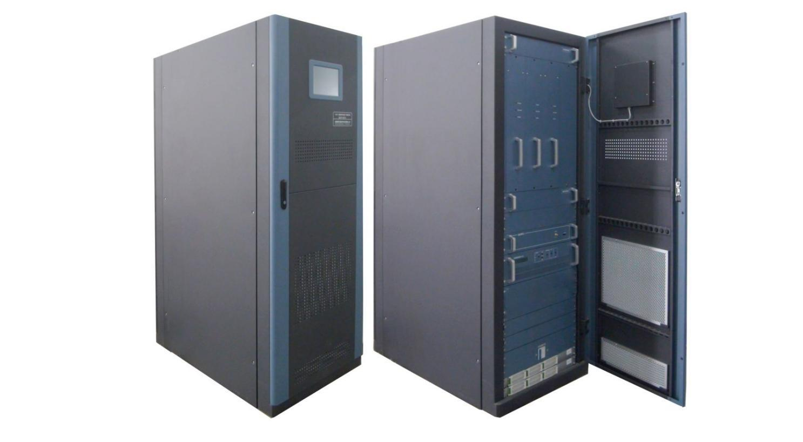
Product overview
The DUT-8323 is a high-power DVB-T transmitter delivering 1.5kW-3kW output through modular LDMOS amplifiers. It processes digital signals across 470-806MHz with AGC stability and supports both MFN and SFN network configurations. The 19" rack-mount unit features front-panel controls and LED monitoring for real-time diagnostics. Ideal for terrestrial TV broadcasting and large-scale digital transmission networks requiring scalable power output.
Key feature
Multi-stage lightning protection and wide-voltage PSU (220V±10%)
Technical Specifications

Input | System standard | DVB-(T)
Input | frequency | 470MHz~806MHz
Input | Input Level | -20 dBm±3dB (87dbuv ±3dB)
Input | Input reflection loss | ≥15dB
Input | Input Interface | ‘N’
Output | RF output power | 1500W/2000W/2500W/3000W optional
Output | Output frequency | 470MHz~806MHz  (For Single Channel: Every 8M available;  For Broadband Channel: consecutive 60M available)
Output | Output impedance | 50Ω
Output | frequency response | ±0.5dB
Output | Shoulder level | ≥36dB@central freqnencyIF±4.2MHz
Output | MER | ≥33dB
Output | output reflection loss | ≥20dB
Output | variation of output power | ±0.25dB
Output | In-band stray | ≤-60dBc
Output | Out-of-band suppression | ≥65dBc
Output | Output interface | 1-5/8
General Parameters | Working temperature | -20~+50℃
General Parameters | Storage temperature | -30~+75℃
General Parameters | Relatively humidity | ＜95% (25℃ no condensation)
General Parameters | Cooling mode | inside cooling fan
General Parameters | atm press | 86~106kPa
General Parameters | power supply | AC, 220V±10%/50Hz
General Parameters | Machine room requirement | less dust, no shake
General Parameters | Dimension(L×W×H) | 1050mm×600mm×1695mm

System Diagram
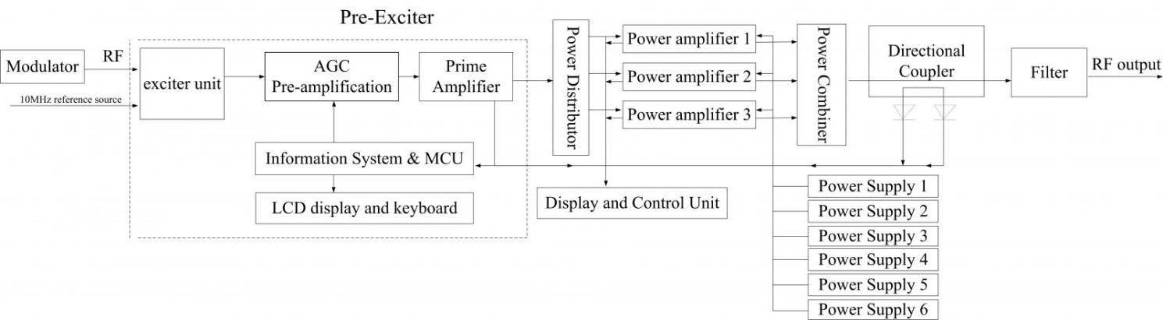

PS: This diagram is a reference for 1500W and 2000W transmitter. For 2500W and 3000W transmitter,
there are 4 power amplifiers and 8 power supplier included.

Main Components List
S/N | Component Name | Specs | Qty | Remarks
 | Final Power Amplifier | 800W | 3 pcs | For 2000W
 | Final Power Amplifier | 800W | 4 pcs | For 3000W
 | Final Power Amplifier | 2000W and 3000W are standard power, 1500W and 2500W are customized version
 | Pre-Exciter |  | 1 pc
 | Monitor Unit |  | 1 pc | With LCD monitor on front door
 | Power Supply for  Final Amplifier |  | 6 pcs | For 1500W/2000W
 | Power Supply for  Final Amplifier |  | 8 pcs | For 2500W/3000W
 | Filter |  | 1 pc | As per order. (In case multiple single-channel transmitters are involved, a power combiner is required.)
 | Cabinet |  | 1 pc
 | Cooling Fan |  | 1 set | 2 sets (with 1 set for backup) optional as order or needed
Accessaries
 | Hard Feeder | Φ40, 2 meter long | 1 | These parts are standard configuration. If there are special requirement, please indicate when place order.
 | Elbow |  | 3
 | Hoop |  | 3
 | Hose Clamp |  | 13
 | Central Pin |  | 3
 | Flange | Φ40 | 1
 | antenna |  | 1 | As per order
 | Feeder |  |  | As per order
 | Combiner |  | 1 | As per order

About Us
FMUSER is a company specializing in broadcasting and television transmission systems and integrating hotel IPTV systems. The company was established in 2009 and has served over 180 countries worldwide. More than 20,000 television stations, radio stations, and hotel clients from different.

Contact:Tomleequan Email：sales@fmuser.com whatsapp: +8613922702227

