FMUSER FUQ-8351 Digital Transmitter 10W-100W Output DVB-T-ATSC-ISDB-T Input-Output Compliance LDMOS Amplifier AGC Control SFN-MFN Terrestrial Broadcasting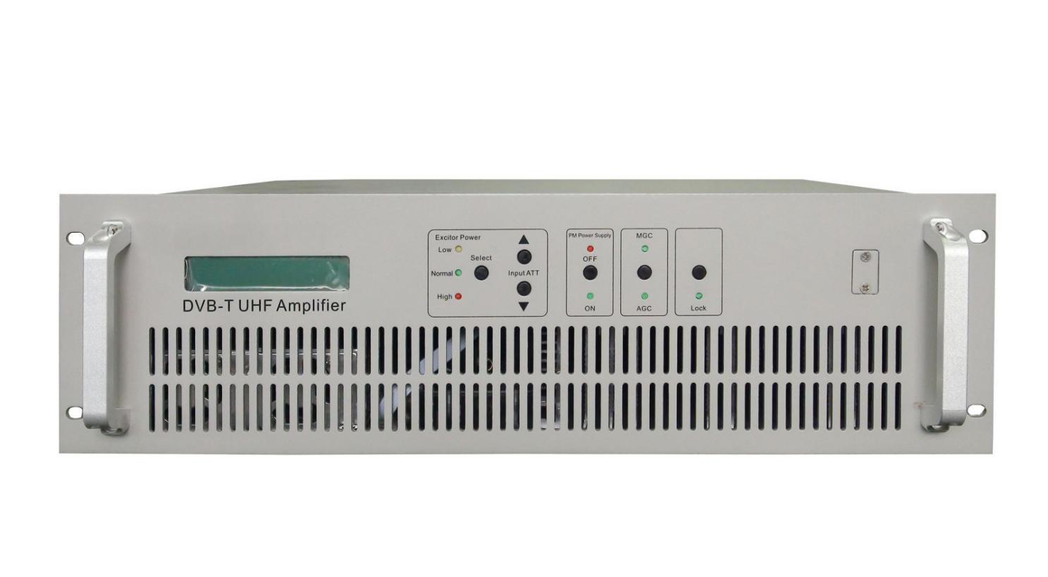
Product overview
The FUQ-8351 is a DVB-T/ATSC/ISDB-T compliant digital transmitter with 10W-100W adjustable output via LDMOS amplification. It processes MPEG-2/4 signals with AGC stability, housed in a 482x504x132mm rack-mount chassis. Designed for SFN/MFN deployments, it supports 470-806MHz frequency range with LED alarm monitoring, ideal for terrestrial TV broadcasting and emergency backup systems.
Key feature
Features real-time monitoring via LED alarms and fault self-diagnosis

Monitoring Objects and Alarm Status

Monitoring Objects | Alarm Status
Power Supply | abnormal
Overheating | alert
Amplifier | abnormal
Antenna feed system | abnormal
Phase noise

Center frequency deviation (Hz) | Local oscillator (dBc/Hz)
@10 | ≤ - 70
@100 | ≤ - 85
@1k | ≤ - 95
@10 k | ≤ - 100
@100 k | ≤ - 111
@1 M | ≤ - 125

Electrical Parameters

Item |  | Technical specs
Basic Parameters | TV Standard | DVB-T/ATSC/ISDB-T
Basic Parameters | Modulating mode | 4/16/32/64 QAM
Basic Parameters | Frequency stability  (3 months) | External Frequency Range: ≤10⁻¹⁰
Basic Parameters | Frequency stability  (3 months) | Internal Frequency Range: ≤10⁻⁷
Basic Parameters | Frequency accuracy | MFN: ±100Hz / SFN: ±1Hz
Basic Parameters | Local oscillator phase noise | See table above
Basic Parameters | In-band stray | ≤-60dBc
Basic Parameters | In-band ripple  （fc±3.591MHz） | ±0.5dB
Basic Parameters | Out-of-band rejection | ≤-65dBc
Input | Frequency range | 470MHz～806MHz (any 100MHz bandwidth)
Input | level | -20±3dBm
Input | Input reflection loss | ≥15dB
Input | connector | N-K
Output | Output power | 10W, 20W, 30W, 50W, 100W Optional
Output | Frequency range | 470MHz～806MHz (any 100MHz bandwidth)
Output | Output impedance | 50Ω
Output | In-band ripple (fc±3.591MHz) | ±0.5dB
Output | Shoulder level | ≥40dB@central frequency FC±4.2MHz (after correction, single channel)
Output | MER | ≥35dB (after correction, single channel)
Output | output reflection loss | ≥26dB
Output | Output power variation | ±0.25dB
Output | Inner adjacent channel transmission power | Inner adjacent channel transmission power : in-band transmission power≤-60dB,  meet that Inner adjacent channel transmission power≤13mW
Output | External adjacent channel transmission power | External adjacent channel transmission power : in-band transmission power≤-65dB,  meet that Inner adjacent channel transmission power≤13mW
Environment condition | Working temperature | -20~+50℃
Environment condition | Storage temperature | -30~+75℃
Environment condition | Relatively humidity | ＜95%（no condensation at 25℃）
Environment condition | atm press | 86~106kPa
Environment condition | power supply | AC, 220V±10%/50Hz
Environment condition | Case size (L/W/H) | 482x504x132mm

Optical Signal Parameters

Item | Unit | Technical Specs
Optical wavelength | nm | 1100-1600
nominal optical input power | dBm | -1
Input optical power range | dBm | -15~+2
Max input optical power | dBm | +3
Optical interface |  | FC/APC
optical reflection loss | dB | 45

About Us
FMUSER is a company specializing in broadcasting and television transmission systems and integrating hotel IPTV systems. The company was established in 2009 and has served over 180 countries worldwide. More than 20,000 television stations, radio stations, and hotel clients from different.

Contact:Tomleequan Email：sales@fmuser.com whatsapp: +8613922702227

