FMUSER FUQ-B EPG Server 2044 TS Inputs ATSC-Compliant IP Output Client-Service Mode 16-Day EIT Digital TV Broadcasting 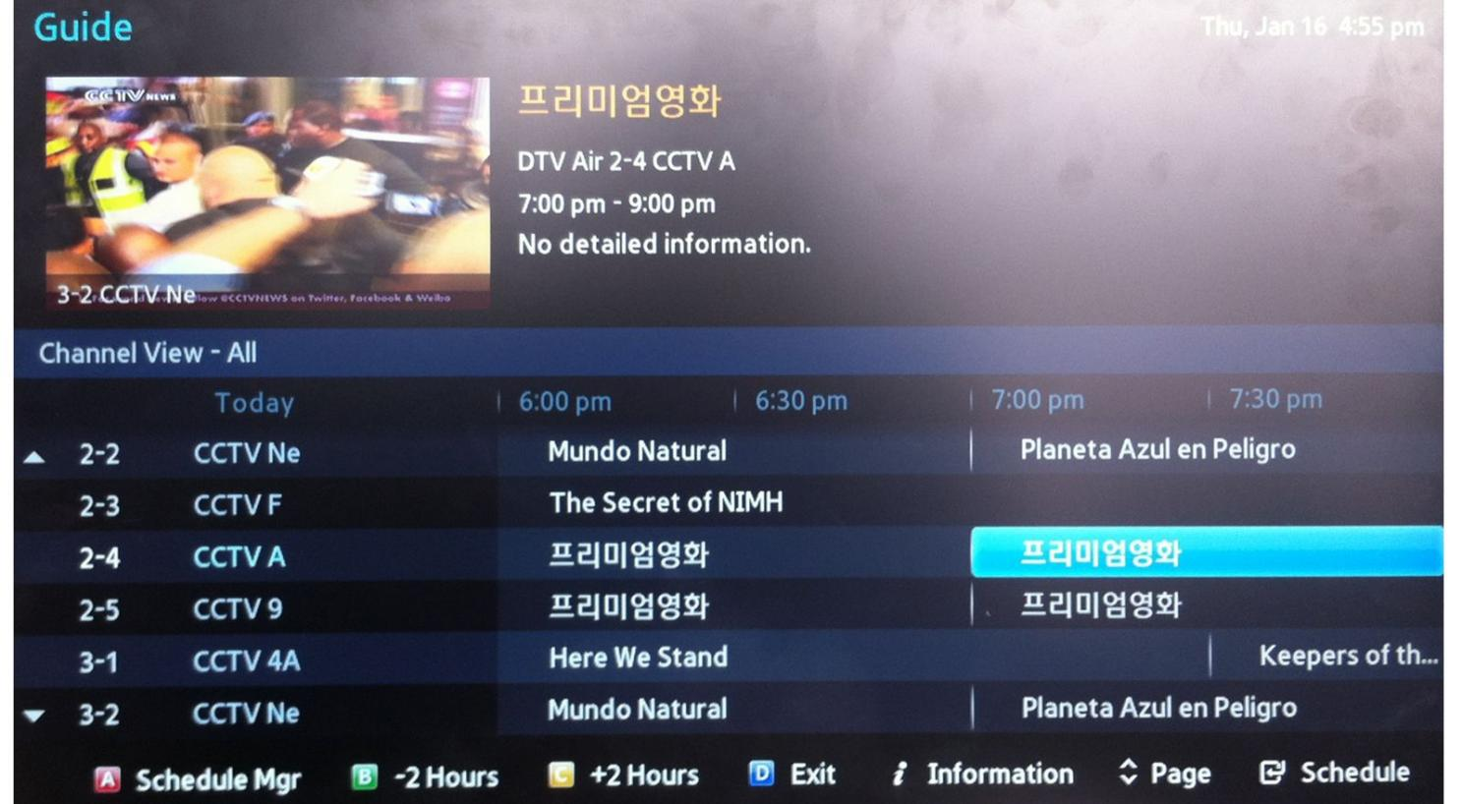
Product Overview
The FMUSER FUQ-B System is an ATSC-compliant electronic program guide solution supporting 2044 transport streams and 69,905 programs. It generates PSI/SI standard tables with private descriptor support through Client/Service System mode. The 1U rack-mount unit features web-based control and supports 16-day EIT events. Ideal for digital TV headends, cable operators, and IPTV service providers requiring compliant EPG management.
Key feature
Web-based control interface for remote configuration

Inner Principle

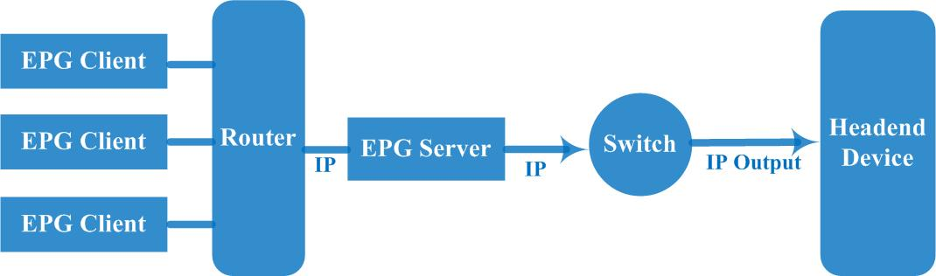

Solution Guide

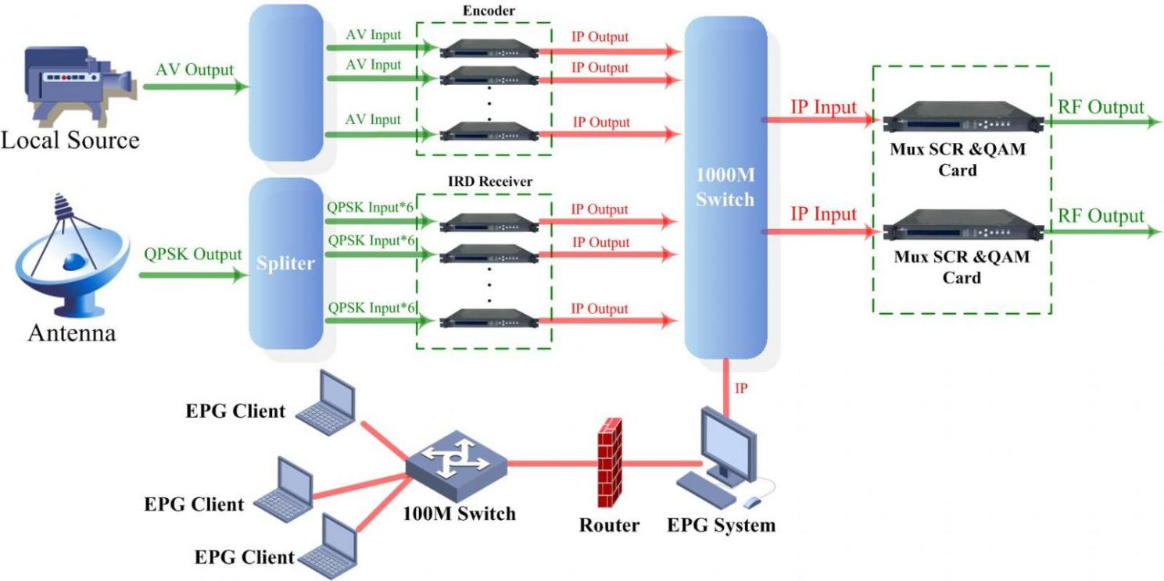

Main Function

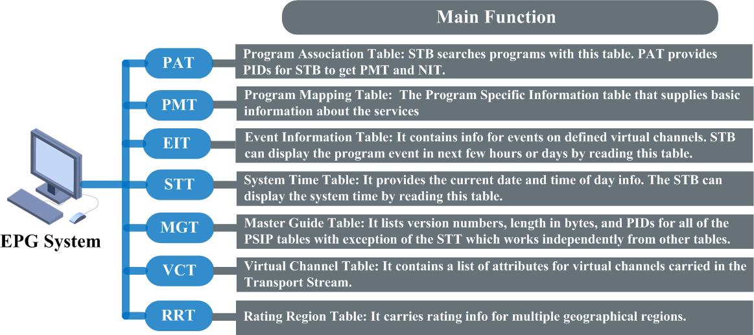

Running Specs

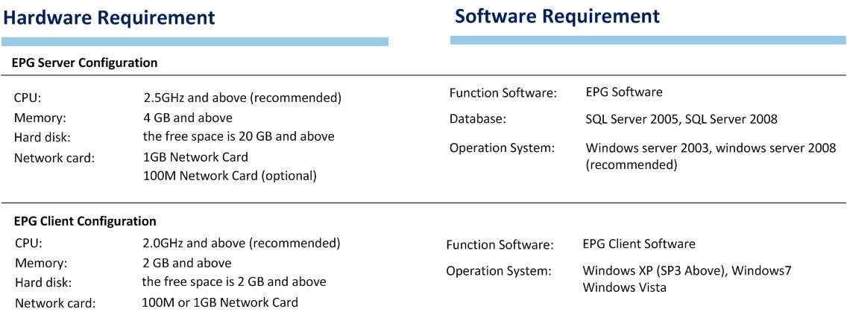

About Us
FMUSER is a company specializing in broadcasting and television transmission systems and integrating hotel IPTV systems. The company was established in 2009 and has served over 180 countries worldwide. More than 20,000 television stations, radio stations, and hotel clients from different.

Contact:Tomleequan Email：sales@fmuser.com whatsapp: +8613922702227

