FMUSER FUQ-XB DVB Transport Stream Analyzer 1x ASI-1x RF DVB-C Input USB 2.0 Real-Time 160Mbps TS Analysis Field Diagnostic Tool 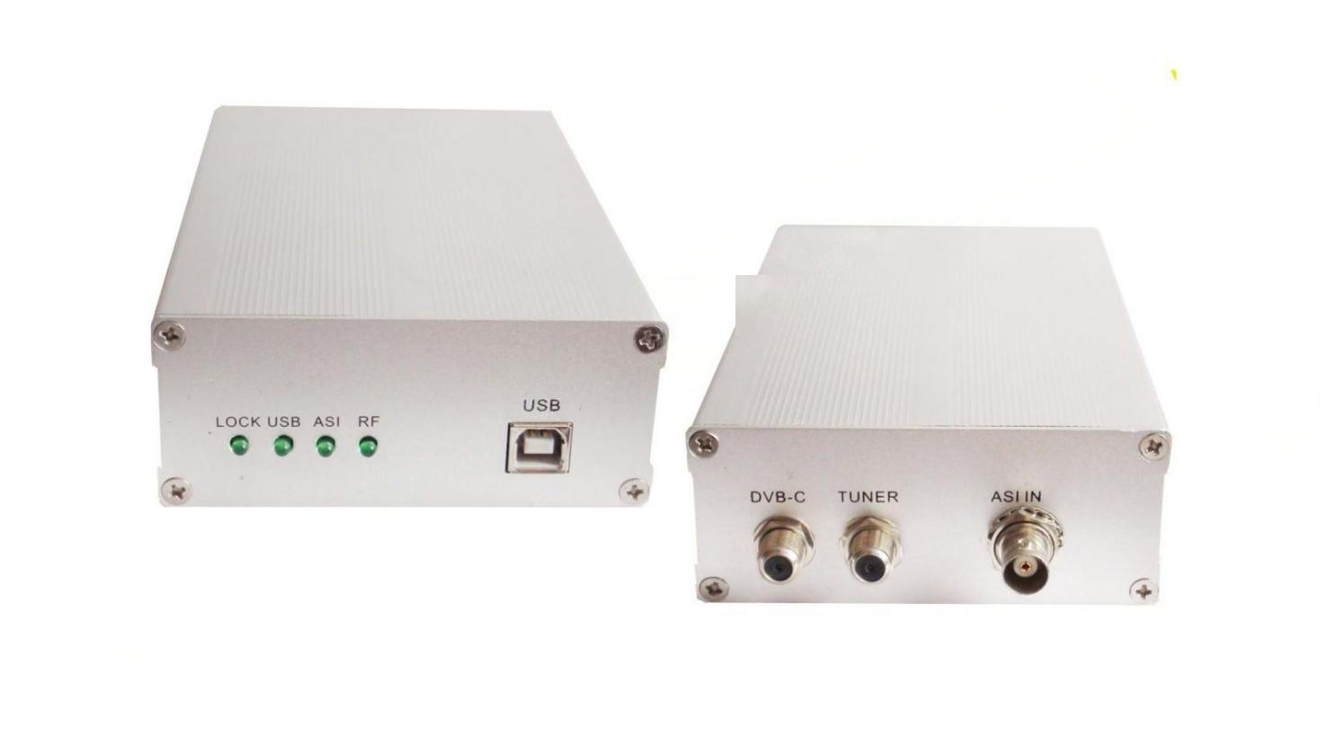
Product overview
The FMUSER FUQ-XB is a DVB Transport Stream analyzer with 1x ASI and 1x RF (DVB-C) input, delivering real-time TS analysis at 160Mbps. It processes 188/204-byte packets automatically and supports offline capture up to 120Mbps. Compact (160mm×114mm×33mm) and USB 2.0-powered, it features LED status indicators for field diagnostics. Ideal for broadcast quality control, headend monitoring, and field engineering.
Key feature
LED indicators for signal lock and system status visibility
About Us
FMUSER is a company specializing in broadcasting and television transmission systems and integrating hotel IPTV systems. The company was established in 2009 and has served over 180 countries worldwide. More than 20,000 television stations, radio stations, and hotel clients from different.

Contact:Tomleequan Email：sales@fmuser.com whatsapp: +8613922702227

